Responding to Domestic Abuse Policy and Guidance

What is Domestic Abuse?
Domestic abuse is a pattern of behaviour which is characterised by the exercise of control and the misuse of power by one person over another by using threatening behaviour, physical violence or other controlling behaviours including psychological, sexual, financial, or emotional abuse – known as coercive control. Domestic abuse can take many forms and isn’t limited to one form of abuse like physical violence.
Abusive relationships can be between intimate partners or family members, irrespective of age, gender, or sexual orientation. It affects all socioeconomic, racial, faith and cultural backgrounds. Domestic abuse is a crime in Ireland and Northern Ireland and the behaviour is never acceptable.

Types of Domestic Abuse
Domestic abuse Is not limited to one type of behaviour, as perpetrators will often use multiple control tactics against their victims. Listed below are some of the more common types of domestic abuse experienced by victims and survivors.
Physical: Physically hurts the individual in any way or throws items in their direction to scare or threaten them which can Include:
- Damaging items physically in the direction of the victim like a wall or a door.
- Physically assaulting the victim claiming that 'they made them do It'.
- Raising their voice to scare and intimate in the victim.
Emotional: A form of manipulation that can harm a person’s mental health and wellbeing designed to control aspects of the victim's life by cutting of their support networks. Examples Include:
- Makes the victim feel guilty when they spend time with others - 'If you love me you won't go out.'
- Love bombs them with gifts and attention, so they feel indebted to them.
Psychological: Coercive Control is an ongoing pattern of behavior in which the perpetrator insults, humiliates, and instills fear in an individual in order to control them.
- Isolating the victim from their family and friends - 'they don't really care about you.'
- Demands they dress a certain way or deems them when they wear something the perpetrator does like ‘you look ugly in that dress’ ‘I like it better when you don’t wear makeup, you should stop wearing it.’
- Gaslights their victim- ‘I never said/did that, you are crazy.’
Financial: Constantly wants the individual to justify what they spend money on & tries to take control of all finances.
- Tells the victim they aren't good with money, and they can help them 'manage' it.
- Takes out loans and credit in their name and doesn't make the payments.
- Prevents the victim from working and having financial Independence
Sexual: Is a form of abuse which includes jealously, possessiveness and continually accuses the individual of being unfaithful. Demands sex, or pressures victims into unwanted sexual activities. Can also include:
- Threatening to publish intimate images as a method of control
- Sexually humiliating the victim by publishing intimate images
- Forcing the victims into sexual situations they don’t feel comfortable
Stalking: Demands to know where the individual is at all times including constantly messaging, calling & tracking of their movements.
- Demands they share their location with the perpetrator.
- Show up to places they know the victim will be like their workplace or a child’s school during pickup time.
- Places hidden spying equipment on the victim like trackers or spyware on their devices.
- Telephones the victim’s workplace asking to speak to them or if they are there.
Cyber Harassment: When a perpetrator uses technology to extend their control over the victim. Like coercive control, it can feel more Insidious to the victim as It's still terrifying without the perpetrator being physically there.
- Demands access to their social media and email accounts.
- Tells the victim they aren't allowed social media accounts- usually following accusations of cheating.

The Impact of Domestic Abuse
Victims and survivors of domestic abuse can experience varying degrees of trauma because of what perpetrated on them. It's Important how we understand how this trauma can manifest and be respectful and understanding to victims and survivors when seeing these behaviours. Common impacts Include:
- Post traumatic stress disorder
- Anxiety
- Depression
- Lifelong Injuries from the physical or sexual violence experienced
Responding to Domestic Abuse
If concerned that an adult colleague (coach/volunteer) or club parent is living with domestic abuse, then the first thing you should do is seek advice for yourself either through your club safeguarding /welfare officer or the Women’s Aid Federation NI/ Women’s Aid RoI The control within domestic violence situations is often about shame and creating guilt so terms like “our secret our story” and “I don’t want everyone knowing my business”, are common. It is important you seek the advice of Women’s Aid staff to ensure any communication with the adult does not push the person and whole family away and it may not be suitable for a club representative at initial stage, to raise this concern with the adult. You do not know the risk level in house; therefore, you should seek immediate advice from Women’s Aid or report to the Domestic and Sexual Violence Helpline (NI) or Domestic Violence Helpline for Republic of Ireland (contact details under useful contacts).
DA is such a complex issue and so many things heighten danger. If it can be done safely talk to the adult and check how things are. Via the club social media sites openly promote the Domestic and Sexual Violence (D&SV)/ DV Helplines, Women’s Aid contact details along with Childline for anyone who may need help and to know they are not alone.
Following discussion with Women’s Aid or D&SV/DV Helpline the club welfare/ safeguarding officer can decide to refer the information to PSNI/ Garda specialist Domestic Violence team or Social Services/TUSLA if there is a child in the house. The police could arrange for a welfare check to be undertaken and social services/TUSLA will check if the family are known to them or there are concerns at the child’s school/nursery before deciding what action to take.
Children do not just witness domestic abuse they experience it as they live in an environment of fear and threat of violence. The emphasis of control by the person perpetrating the violence and the lack of voice for the child can make home a very frightening place to live and impact on the child’s emotional development and view on the world. Domestic Abuse has an impact on their family relationships and can also affect future relationships. The club should promote Childline to encourage any young person effected to have someone to talk to about their situation or they can also be directed to Hide out web site for specific support around Domestic Abuse http://thehideout.org.uk/ .
Key summing up
• Identify risk and how situation can escalate quickly
• Don’t want to push family away
• Don’t try to sort it out yourself – always talk to some e.g. welfare officer/safeguarding officer
• Any sign of harm/stress to child call Social Services, inform parent if possible but only if it does place the chid at further risk

Knowing signposting options available in resource book e.g.
• Women’s Aid
• NSPCC Helpline
• Childline
• 24 Hour Domestic & Sexual Abuse Helpline

You may feel you are not able to make a referral to social services with the concern/evidence you have, but it is about support for the family currently which can be challenging to be able to deliver. DA is such a complex issue and so many things heighten danger. If it can be done safely talk to the adult you are worried is being harmed and check how things are. Just because it is not happening within the club does not mean that domestic abuse can be ignored you. Everyone at a sports club have a moral duty to protect an adult or chid impact by abuse.

Seeking support
Domestic abuse is a crime in Ireland and Northern Ireland. It is never acceptable, and any relationship you’ve had with the person doesn’t excuse their behaviour. If you are in danger, call the Police by dialling ‘999.' If it’s not safe for you to speak, you can hit ‘55’ on your keypad to let the operator know. You can also report what is happening on the PSNI’s Non-Emergency number by dialling ‘101’ on your phone.
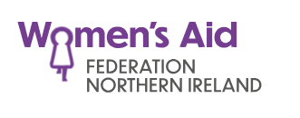 | Services throughout Northern Ireland offer specialist support for women, children and young people affected by domestic abuse.  You can find your local Women’s Aid group by visiting: www.womensaidni.org
Women’s Aid 24-Hr Domestic Violence Helpline for Republic of Ireland | Tel: 1800 341900  Visit: https://www.womensaid.ie/
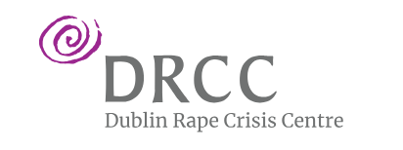 | 24-Hour Sexual Violence Helpline  Tel: 1800 778888  Visit: https://www.drcc.ie/
 | The Men’s Advisory Project (MAP) exists to provide counselling services for men experiencing domestic abuse.  Support and counselling services are also available to men who have previously left a violent or abusive relationship and who are still experiencing the effects. www.mapni.co.uk info@mapni.co.uk  Belfast: (028) 9024 1929  Foyl﻿e: (028) 7116 0001
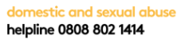  Northern Ireland | Available to anyone who has concerns about domestic or sexual abuse, now or in the past. It is open to all women and men affected by domestic and sexual violence
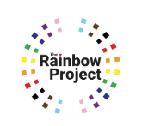 | The Rainbow Project provides Northern Ireland’s only co-cultural gay affirmative counselling service.  info@rainbow-project.org  www.rainbow-project.org  Belfast: (028) 9031 9030  Foyle: (028) 7128 3030
 | HERe NI is a community organisation and registered charity supporting lesbian and bisexual women and their families to improve the lives across Northern Ireland.  www.hereni.org  Tel: 028 9024 9452
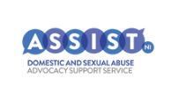 | ASSISTNI are the Northern Ireland wide advocacy service passionate about supporting victims of domestic and sexual abuse crime who primarily are engaging with the criminal justice system.  They provide guidance and support, information, work with other service providers and advocate on victim’s behalf, tailoring our service to their needs.  www.assistni.co.uk  info@assistni.org.uk.
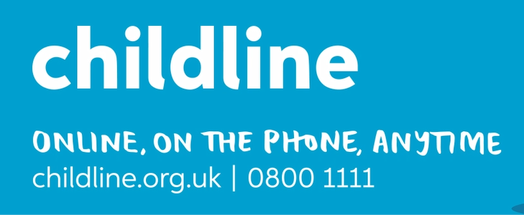 | Childline UK  Tel: 0808 11 11  Visit: https://www.childline.org.uk/
 | Childline Republic of Ireland  Tel: 1800 66 66 66  Visit: https://www.childline.ie/
Health and Social Care Trusts in NI - Children | Each trust will have a Gateway team to deal with reports of child abuse and more local contacts for ongoing professional liaison for advice on concerns.
Northern HSC Trust | Tel: 03001234333
South Eastern HSC Trust | Tel: 03001000300
Southern HSC Trust | Tel: 08007837745
Belfast HSC Trust | Tel: 028 90 507000
Western HSC Trust | Tel: 028 71314090
 | Regional Emergency Social Work service. Available 5.00 PM – 9.00 AM Monday to Thursday and 5.00 PM on Friday to 9.00 AM on Monday. There is a 24-hour cover over public holidays. 028 9504 9999
Health and Social Care Trusts in NI - Adult Safeguarding | The Adult Safeguarding Gateway teams can be contacted at the following numbers:
Northern Trust | 028 256 35512
Western Trust | 028 716 11366
South Eastern Trust | 028 925 01227
Belfast Trust | 028 950 41744
Southern Trust | 028 374 12015 or 028 374 12354
 | Emergency (Out of Hours) Social Work 028 9504 9999
TUSLA-Child & Family Agency | If in the Republic of Ireland and you have any concerns about a child you should report it to the Child & Family Agency please see website for contact details  Click here - Contact a Social Worker  Tusla - Child and Family Agency  Any query or concern in relation to children out of hours should be reported immediately to An Garda Siochana

NI reference to coercive control https://www.justice-ni.gov.uk/news/new-domestic-abuse-offence-comes-force-long
PSNI useful information on DA https://www.psni.police.uk/safety-and-support/keeping-safe/domestic-abuse#:~:text=24%20Hour%20Domestic%20and%20Sexual%20Abuse%20Helpline&text=Please%20phone%200808%20802%201414.

