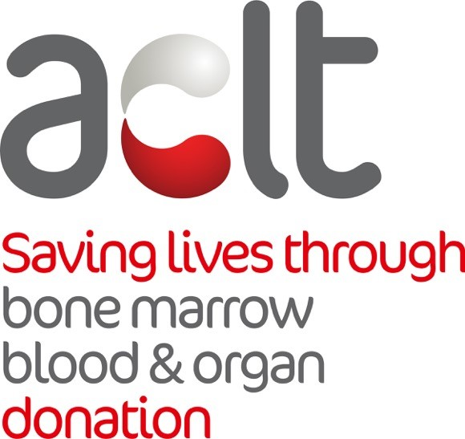
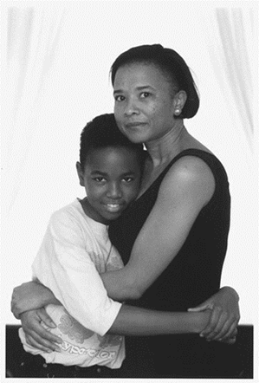

Address
2A Garnet Road Thornton Heath Croydon CR7 8RD

Contact
Tel: 020 3757 7700
Email: info@aclt.org
Web: www.aclt.org

Charity Number
1119516
Company Number
04956925

Patrons
Eleanor Smith MP
Colin Salmon
John Barnes MBE
Duchess of York
David Haye

Board of Trustees
Charlotte Dawkins
Paula Sofowora
Tim Campbell MBE
Laverne Walker

ACLT’s inspiration - Daniel De-Gale
14 March 1987 – 8 October 2008

CHARITY PROFILE

The ACLT (African Caribbean Leukaemia Trust) is a 37 times award winning leading Cancer charity dedicated to raising the awareness of the shortage of Black and Ethnic Minority donors on the UK stem cell (bone marrow), blood and organ registers and recruits potential donors to come forward at ACLT registration drives via (saliva samples, cheek swabs or blood) and be involved in the process of offering hope and a healthy future to someone whose disorder may otherwise prove fatal.

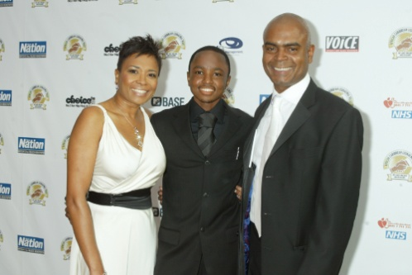
The trust was catapulted into existence in 1996 by Beverley De-Gale and Orin Lewis, the parents of leukaemia sufferer Daniel De-Gale in a desperate search for a matching stem cell donor for Daniel in 1996 and learning that there were just 550 Black or Mixed Race people on the UK stem cell registers meaning Daniel had 1 in 250,000 chance of finding a donor compared to at best a 1 in 5 for a White person.

The parents made it their mission to increase the number of donors from Black and Mixed Race people and to help others like their son. Finding a stem cell match is greater if the donor is from the same racial background due to the fact that Bone Marrow contains racially specific characteristics, therefore a compatible donor for Daniel could only be found within the Black or Mixed Race population.

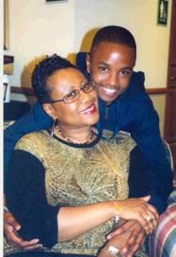Eventually Daniel finally won his battle against leukaemia when on 16th June 1999 at the age of 12 he received a stem cell transplant from an unrelated American donor, Doreene Carney, at Great Ormond Street Hospital in London. This enabled Daniel to live a full and fruitful life including successfully passing his exams at school and commencing a Sports Physiotherapy degree at University.
Daniel was in full remission and free of cancer, but due to complications with his health that led to multiple organ failure he died aged 21 on the 8th October 2008 in hospital surrounded by his family.
What the ACLT has achieved

- Raised the number of Black and Mixed Race people on the UK stem cell register. Adding over 95,000 new potential stem cell donors of all ethnicities, mainly black and mixed race.

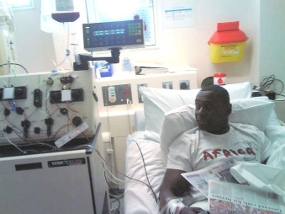
- Helped save well over 95 lives by finding matching stem cell donors such as “Homeland” Actor David Harewood (below), Dr Kamisha Guthrie, Ex-Footballer Clive Wilson, Debra Forth, Helen Robinson, Naomi Williams, Johanna Charles and Francesca Clarke, etc

- Sarah Thompson (below right), London who received a match from Michelle Duncan in 2006; “I’m forever indebted to the ACLT. Without it, I might not have received a donor with a match and probably would not be alive today” she said.
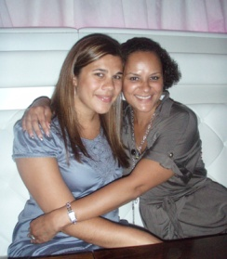

- Promoted the need for regular blood donation and the carrying of organ donor cards within the Black and Ethnic Minority communities. Thousands of new blood and organ donors signed up through ACLT charity
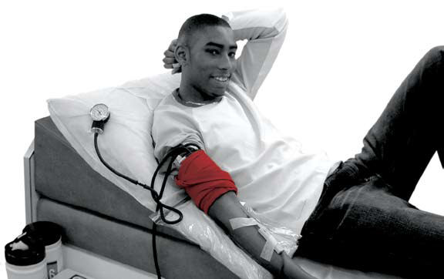

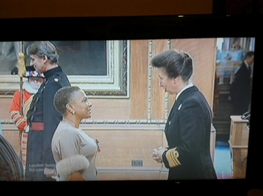
- Beverley De-Gale and Orin Lewis have each been awarded with OBE’s (Officer of the Order of the British Empire) in the Queen’s Honours List by the Prime Minister and Cabinet Secretary in recognition for services to Healthcare.
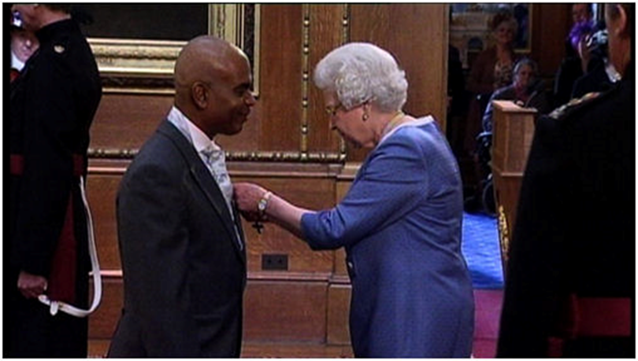
Why the ACLT?
During the last 22 years, we have learned lessons through experience and in collaborating with the BAME community. We have worked with community and faith leaders. We have worked hard to dispel myths and to equip the community with the facts. We have a nationwide reach and are recognised as the leading charity working within the BAME community to address the shortage of blood, stem cell and organ donors.
- We are trusted.
- We are respected.
- We have improved outcomes for patients.
Black and Ethnic Minority sufferers who need a stem cell or organ Transplant are still at a severe disadvantage due to the lack of awareness and communication of the problem in the community and consequently the lack of suitable Black Minority Ethnic donors. This is also compounded by the vast array of myths, fears and taboos on the subject matter of giving blood and donating organs for transplant purposes, & the odds of a finding suitable stem cell matches are still less than a 20% chance of finding a suitable match
The mission of the ACLT is to promote an accessible, high-quality medical stem cell, blood and organ awareness donation service for people of all ages and ethnicities.

In closing, I sincerely look forward to hearing back from you in relation to our request to host our Gift of Life Fundraising Ball in tribute to Daniel De-Gale.

Yours sincerely,

Orin Lewis. OBE
ACLT Co-Founder & Chief Executive

