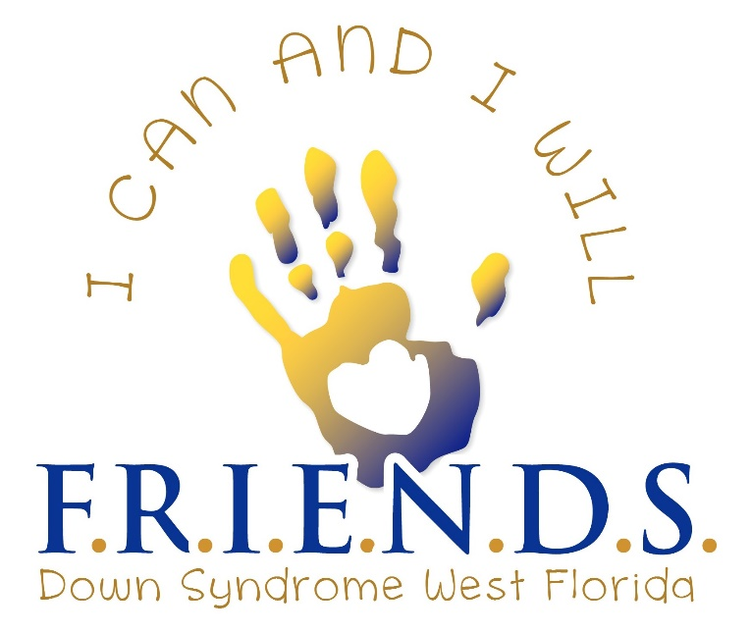

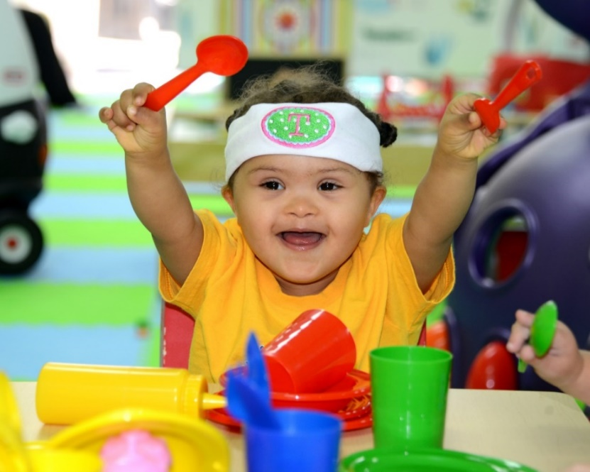

I CAN AND I WILL

Families
Raising
Inspiring
Educating
Networking for
Down
Syndrome
West Florida

F.R.I.E.N.D.S. (FDSWF) was founded in 2007 as a Down syndrome support group and 501c3 nonprofit private operating foundation. It was formed to provide support and information to families who had or were expecting babies with Down syndrome. We are proud to be the leading voice for Down syndrome in the Tampa Bay area and serve Hillsborough, Pasco and Pinellas counties.
FDSWF MISSION - Our Mission is to provide educational and support services to new parents and families. To empower all special needs individuals, help them to become more independent, and let their voices be heard. We promote community integration and together celebrate the lives of people impacted by Down syndrome.

FDSWF GOALS - To create a community that embraces, supports and inspires individuals with Down Syndrome to live happy, healthy, full-filling lives.

OUR VALUES
- We are TRUSTWORTHY in our daily responsibilities.
- We use EMPATHY in our interactions and show RESPECT toward others in all that we do.
- We COLLABORATE and create PARTNERSHIPS within our community.
- We are DEVOTED, investing our time, effort and energy to our mission.

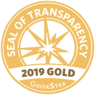
GUIDESTAR GOLD SEAL OF TRANSPARENCY 2019
FDSWF has been awarded a 2019 Gold Seal of Transparency from GuideStar.
GuideStar is the world’s largest source of information on nonprofit organizations. FDSWF is completely transparent and posts each year’s tax documents and Internal Revenue 990 Forms on our website for your inspection.
Our Florida Tax EIN #65-1261646.

AFFILIATES, PARTNERS, COLLEAGUES & FRIENDS

- AmeriDisability Magazine
- Bailey Psychology Group
- BayCare Women’s Hospital
- Boundless Global, LLC
- Brandon Swim & Aquatic Club
- Buddy Baseball
- Buddy Cruise
- Buddy Up Tennis
- Down Syndrome Affiliates in Action
- Dyer Media Group, LLC
- Guardian Haven Academy
- GiGi’s Playhouse Tampa
- GuideStar
- JS Creative Concepts & Marketing
- Julie Hirsch Photography
- Krewe of Sir Francis Drake, Inc.
- Laurie Ohall, PA
- Livingstone Academy Schools
- Pinellas Chamber of Commerce
- Special Olympic Healthy Community
- Specially Fit Foundation
- St. Joseph’s Children’s Hospital
- The Hitchcock Law Group
- The Brandon Chamber of Commerce
- The Community Roundtable
- The Global Down Syndrome Foundation
- The National Down Syndrome Society
- USF Bay Early Steps
- USF Student Affairs Services

OUR CURRENT FDSWF PROGRAMS

FDSWF PARENT PACKETS PROGRAM – We provide free FDSWF PARENT PACKETS. The packets come with Down syndrome and special needs resource materials for new and expectant parents and a copy of the book, “Babies with Down Syndrome, A New Parents Guide” is included. The packets are available in English and Spanish.
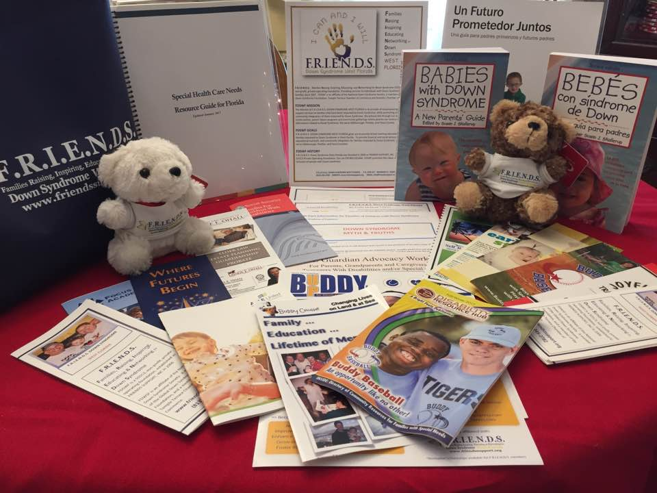
The packets are distributed to:

- St. Joseph’s Women’s Hospital
- St. Joseph’s Children’s Hospital
- Brandon Regional Hospital
- Tampa General Hospital
- Florida Hospital Tampa
- Florida Hospital North
- Mease Countryside Hospital
- All Children’s Hospital

PARENT LIAISON PROGRAM – FDSWF Parent Liaisons offer peer to peer counseling and support for new and expectant parents and grandparents. A bilingual Parent Liaison is available.

DOWN SYNDROME PRESENTATIONS - Down syndrome presentations can be given to medical residents, interns, and nursing students upon request.

* We are happy to send you a free FDSWF Parent Packet or schedule a Peer to Peer visit, send your request to info@friendssupport.org.

FDSWF SCHOLARSHIPS - FDSWF provides financial support to our members to help offset
the costs of:
- College tuition for individuals with Down syndrome.
- Educational programs
- Hardship Fund – for families in need/crisis.
- Medical Program – funds may be used for PT, OT, speech.
- Recreational Programs
- Special Needs Conferences
- Buddy Walk Registration

*You can find the FDSWF Scholarship form on our website, www.fdswf.org. Some restrictions apply and approval is at the discretion of the FDSWF Board of Directors.

FDSWF MEMBER CONNECTIONS PROGRAMS

We understand that a strong support system can make a great impact in the lives of parents raising a special needs child. We provide connection and support through our monthly playgroups, peer groups and social clubs.

BABY FRIENDS PROGRAM - Our birth to 5yrs playgroup that meets monthly in Brandon, Largo and Westchase. Meet and share with other parents, grandparents and FRIENDS. Check our FDSWF Events or website, www.fdswf.org for dates and times.

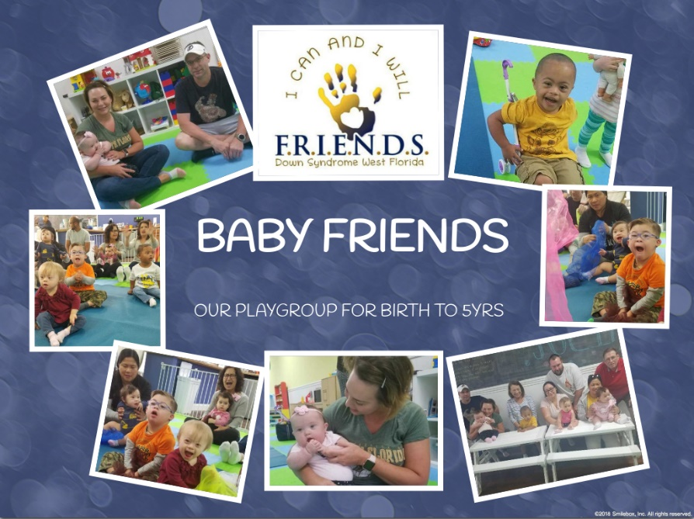
- BABY FRIENDS – BRANDON
LOLO’S PLAYPLACE – 9:30-11:30am
1040 E Bloomingdale Ave, Valrico, FL 33596.
Contact Kathy Boisseau (603)438-2886 or kathyboisseau@gmail.com

- BABY FRIENDS – SATURDAYS BRANDON
WE ROCK THE SPECTRUM - 10am-12pm
1076 E Brandon Blvd #102, Brandon, FL 33511. Contact Ashley Habarth (813)325-8981.

- BABY FRIENDS - PINELLAS
WE ROCK THE SPECTRUM – 1pm-3pm
12505 Starkey Rd, Largo, FL 33773.
Contact Heather Carpenter (813)433-4383.

- BABY FRIENDS – OLDSMAR
K PEAS PLACE – 12:00-2PM
13966 Lynmar Blvd, Tampa, FL 33626
Contact Renee Hurst (813)340-9160.

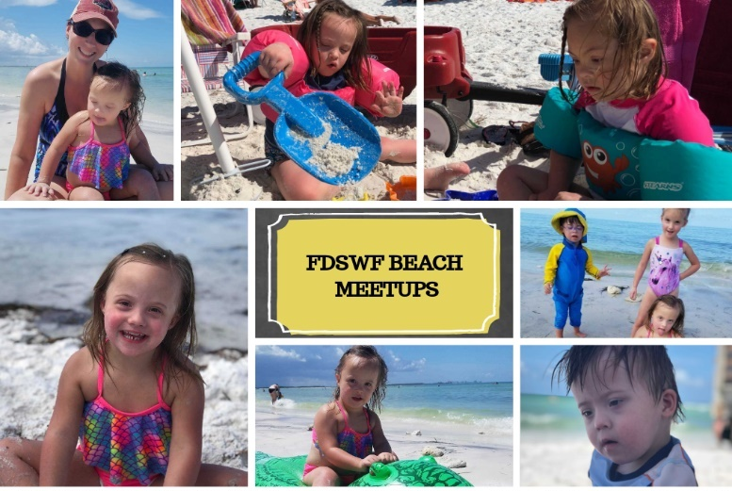

- FDSWF SUMMER BEACH FUN!

Meets at Honeymoon Island beach in Dunedin, check our website calendar, www.fdswf.org, for dates and times or contact Melissa Miner (727) 412-4788 or melmin@me.com

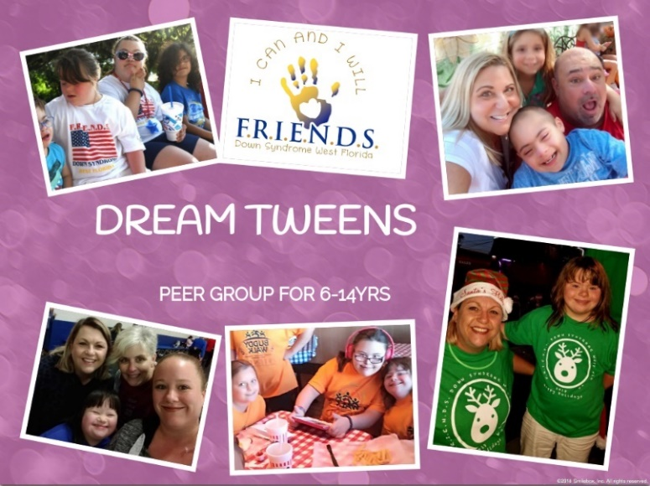
- DREAM TWEENS PROGRAM For our tweeners ages 6-14 yrs. Meets quarterly for fun outings, like trips to the Aquarium, the Movies, or Skyzone! Contact Sue Warady-Keene (630)914-4114, sue@friendssupport.org

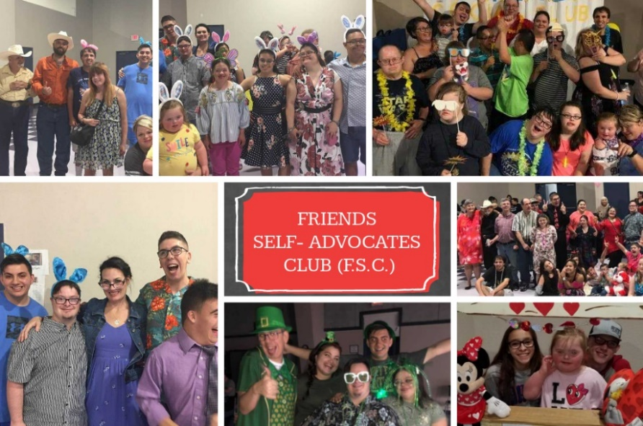
- FRIENDS SELF ADVOCATES CLUB (F.S.C.) F.S.C. “ALL ABILITIES DANCE” offers a safe, welcoming environment where adults (15yrs+) can create lasting friendships and experience the joy of getting together every month.
Livingstone Academy - 1649 Bloomingdale Ave. Valrico, FL 33596. Contact Julie McKenna (631)335-8464.
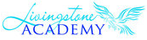

- FRIENDS DOWN SYNDROME ESPANOLA
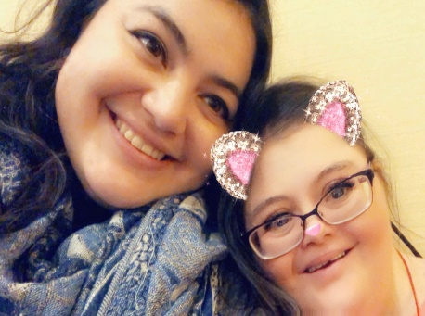
Bienvenido a la zona española de la Asociación FRIENDS Down Syndrom West Florida para el área de Pinellas, Tampa y Pasco. La misión de F.R.I.E.N.D.S. Down Syndrome West Florida proporcionará servicios educativos y de apoyo que abarquen a todas las familias afectadas por el Síndrome de Down; al tiempo que promueve la integración completa de la comunidad de las personas afectadas por el síndrome de Down. En esta área, queremos compartir los artículos y la información sobre el Síndrome de Down. Contact Margarita Padron at (813)842-5654.

Margarita and her sister Anna

DADS APPRECIATING DOWN SYNDROME

“To assist and support, through fellowship and action, the fathers and families of individuals with Down Syndrome
- Our Mission is simple but the impact profound
- See what D.A.D.S. is doing in our community.
- Enhancing a father’s knowledge and resources about children and individuals with Down Syndrome.
- Helping to build personal advocacy skills.
- Helping families cope with the unique challenges of raising a child with Down Syndrome.
- Creating a safe environment of support where men can openly share experiences.
- Building camaraderie and helping create genuine friendship between fathers and families of children with Down Syndrome.

FDSWF DOWN SYNDROME AWARENESS, ADVOCACY, AND
FUN FAMILY CONNECTIONS
FDSWF promotes and advocates for Down syndrome and special needs awareness while providing fun connections for our families. We offer a safe, welcoming environment, where families can create lasting friendships, feel accepted, and experience the joy of getting together. Join us for one of these great events!

FDSWF YEARLY EVENTS CALENDAR – FDSWF is an approved nonprofit for Hillsborough County Schools and we offer many opportunities for students to earn volunteer service hours.

*Dates in red have volunteer needs. Please go to our website to register as a volunteer, www.fdswf.org.

MAY
05/10/19 F.S.C. ALL ABILITIES DANCE
05/13/19 BUDDY WALK MEETING
05/17/19 BABY FRIENDS LOLO’S
05/18/19 BABY FRIENDS BRANDON WRTS
05/21/19 BABY FRIENDS OLDSMAR
05/25/19 MOTHER’S MAD HATTER’S TEA
05/26/19 MOVIE MEET UP- ALADDIN

JUNE
06/02/19 FLORIDA AQAURIUM
06/06/19 BEACH MEETUP DUNEDIN
06/07/19 F.S.C. ALL ABILITIES DANCE
06/7-6/9 FAMILY CAFÉ
06/11/19 BEACH MEETUP DUNEDIN
06/19/19 BEACH MEET UP DUNEDIN
06/22/19 DADS Pancake Breakfast
06/27/19 BEACH MEETUP DUNEDIN

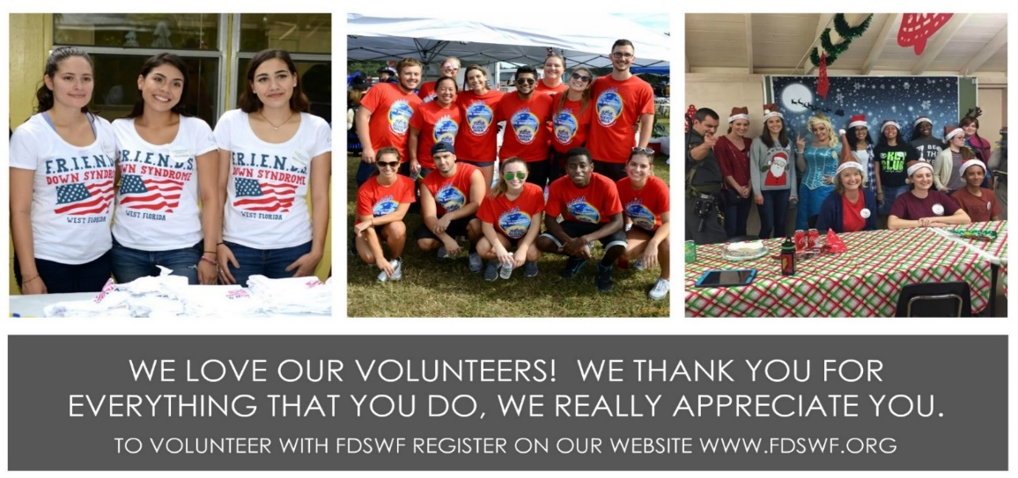
JULY
07/04/19 BRANDON 4TH OF JULY PARADE
07/05/19 F.S.C. ALL ABILITIES DANCE
07/08/19 BUDDY WALK MEETING
07/12/19 BEACH MEETUP DUNEDIN
07/20/19 FDSWF POOL PARTY
07/27/19 BEACH MEETUP DUNEDIN

AUGUST
08/02/19 F.S.C. ALL ABILITIES DANCE
08/05/19 FDSWF BOARD MEETING
08/25/19 DREAM TWEENS – BEACH

SEPTEMBER
09/01/19 PHOTO CONTEST
09/06/19 F.S.C. ALL ABILITIES DANCE
09/09/19 BUDDY WALK MEETING
09/28/19 Publix FH Fundraiser
09/29/19 Publix FH Fundraiser
09/22/19 DREAM TWEENS SKYZONE

OCTOBER – IS DOWN SYNDROME AWARENESS MONTH!
10/02/19 ORDERING BW T-SHIRTS
10/04/19 F.S.C. ALL ABILITIES DANCE
10/05/19 Publix –Valrico Fundraiser
10/14/19 BW T-SHIRT ROLL UP
10/17/19 BW T-SHIRT PICKUP
10/22/19 BW T-SHIRT PICKUP
10/24/19 BW T-SHIRT PICKUP
10/25/19 BW T-SHIRT PICKUP; TENT AND TABLE SET UP AT RAYMOND JAMES
10/26/19 4th FDSWF Buddy 3.21K FUN RUN & BUDDY WALK

NOVEMBER
11/01/19 F.S.C. ALL ABILITIES DANCE

DECEMBER
12/07/19 TAMPA CHRISTMAS PARADE
12/21/19 FDSWF HOLIDAY PARTY

VOLUNTEERS
Thank you for your interest in volunteering. You can earn your volunteer hours while meeting our wonderful families. We are thankful and appreciate people from our community who are willing to join us in making a difference for those impacted by Down Syndrome. Register to be a FDSWF Volunteer by logging onto www.fdswf.org.

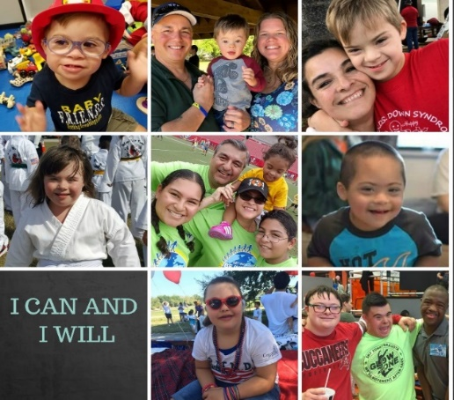

FDSWF MEMBERSHIP
Want to join FDSWF it’s free and easy! Log onto our website, www.fdswf.org and sign up to receive our emails and Newsletters. FDSWF is run by a dedicated group of volunteers made up of Down syndrome and other special needs parents, business and community leaders, and professionals in the community. If you would like to participate on our Board of Directors, Advisory Board, as a Volunteer, or become a Parent Liaison, we’d love to have you! Contact us via email at info@friendssupport.org.

FDSWF FUNDRAISING
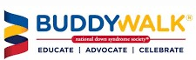
BUDDY 3.21 FUN RUN & BUDDY WALK

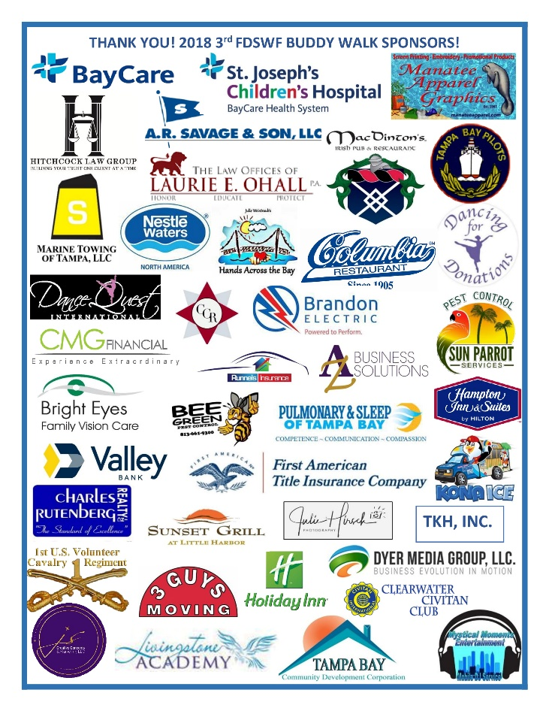
F.R.I.E.N.D.S. Down Syndrome West Florida together with the National Down Syndrome Society (NDSS) are happy to announce that the 4th FDSWF Buddy Run & Buddy Walk® at Raymond James Stadium will be held this October during Down Syndrome Awareness Month. Join over 4,000 participants who are made up of Down Syndrome families, friends, health care professionals, vendors, and other special needs affiliates to advocate, educate, and celebrate Down Syndrome. The Buddy Walk also helps FDSWF to raise funds for THE FRIENDS CENTER, develop and maintain our year-round programs, and enhance our position in West Florida special needs community.

BUDDY WALK SPONSORS
We Need You! Your company can reach a large, loyal fan-based audience, in a fun and upbeat atmosphere while supporting the mission of FDSWF. There are many ways your business or organization can be a part of the Buddy Walk. All sponsors receive commensurate acknowledgment for their support with recognition on our FDSWF Website, Facebook page, Twitter, FDSWF Newsletters, and FDSWF Event brochures. For more information contact Jamie Santillo, Marketing Director at jamie@friendssupport.org or call her at (239)297-6691.

IN-KIND DONATIONS

Thank you for your In-Kind Donations! We accept donated products and services from businesses, purchasing supplies, items for our raffle drawings, gift baskets, food cards, water, etc.

Your donations allow us to continue the important work we do to promote the value, acceptance and inclusion of people with Down syndrome and special needs.

Thank you for supporting the FDSWF mission! Please contact Jamie Santillo, Marketing Director for more information, jamie@friendssupport.org or (239)297-6691.

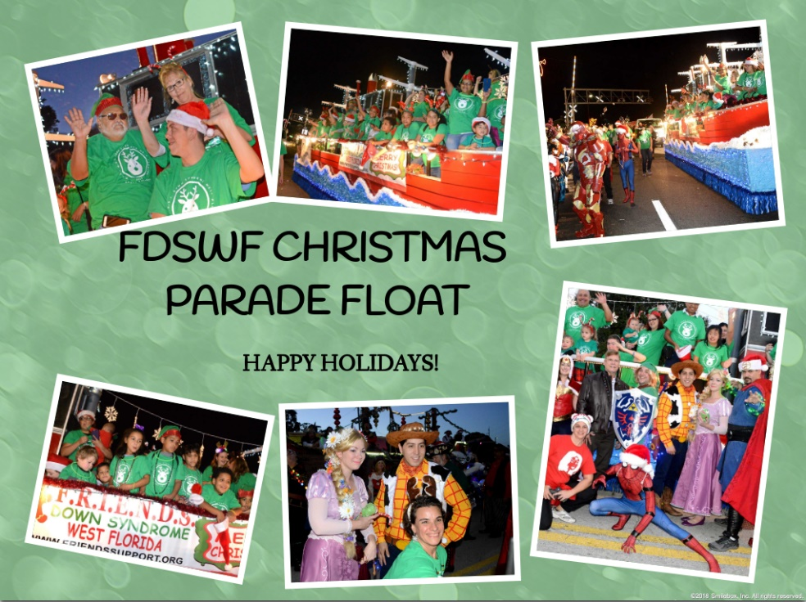
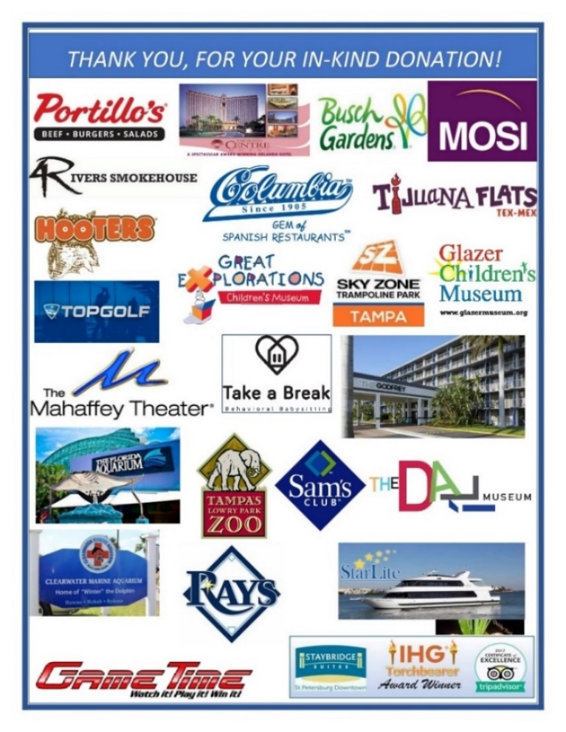
FLOAT SPONSORS

What better way to Advocate and Integrate our Down Syndrome community than by participating in a parade! FDSWF participates in the Brandon 4th of July Parade and the Tampa Christmas Parade. As we pass out candy, we also pass out information about our special need’s community.

We are seeking sponsors for our Brandon 4th of July and Christmas floats. During the parade. FDSWF advocates for Down Syndrome and special needs in the hope that the public learns a little more about us, our community, and about the abilities of people with special needs.

OCTOBER IS DOWN SYNDROME AWARENESS MONTH!
DOWN SYNDROME FACTS:

It’s a genetic disorder - Not a disease. No one knows why it happens, but it afflicts 1 out of every 691 births. It is estimated that there are 6,000 births a year in the U.S.

It is caused by two copies of the 21 chromosome which fails to separate during formation of the egg, resulting in an egg with two copies of the chromosome. When this egg is fertilized, the resulting baby ends up with three copies of 21st chromosome in each of its cells. A lot of words we know, it just means we have an extra piece of the 21st chromosome.

Down syndrome affects every race, nationality, and socioeconomic status. It does not discriminate.

90% of pregnant women in the U.S. who get a diagnosis of Down syndrome choose to terminate. The problem is with the blood test. The blood test has a small chance for error. The only true tests are a chorionic villus sampling (CVS) and amniocentesis.

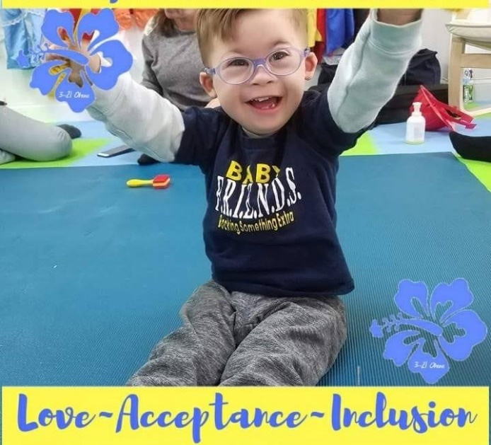
Outdated and inaccurate information about Down syndrome is being provided to pregnant women. Our children can and do learn just like everyone else, it just takes us a little longer. No one can predict what we can do.

Most have mild to moderate ranges of cognitive impairment, but we do have a wide variety of abilities and have made some major accomplishments.

Most will finish school, and some will advance to college. We proudly hold jobs, fall in love, get married, vote, and live fulfilling lives.

We are living longer; today’s average lifespan is 60yrs old.

Don’t get us wrong, sometimes life has its challenges. We are predisposed to certain medical conditions, like congenital heart defects, sleep apnea, and early Alzheimer’s disease.

On the plus side, it is rare for a person with Down syndrome to have a solid tumor cancer, cardiovascular disease, heart attack or stroke. Which means we may hold the key to the cures for some types of cancer and Alzheimer’s disease.

Appropriate medical care for children and adults with Down syndrome is very important. It can make a major difference for that person’s physical and intellectual development.

Early intervention for babies with Down syndrome is very important. The first five years can make a major difference for that child’s physical and intellectual development.

We are more alike than you think.
We need the same love and care as our peers.
We have the same aspirations and desires.
We can and want to live independently.
We can work, volunteer, and vote.
We want the equality and future that we deserve.

THANK YOU FOR YOUR SUPPORTING FDSWF

Thank you! Your donations help to provide:

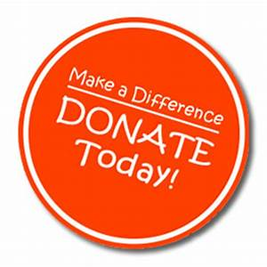
        - Printed materials and books for FRIENDS Parent Packets.
        - Special needs resource materials for our families.
        - Support for our playgroups and social clubs.
        - Special Needs workshops.
        - Our FDSWF Buddy Run & Walk.
        - Scholarship Funds.
        - Community activities, picnics, and parties.
        - Provide volunteer hours for Bright Future Scholarships & local college students looking for community hours.

To donate visit our website, www.fdswff.org.

MEETINGS & EVENTS
Check our website calendar and Facebook Events for the dates and time of meetings and events, www.fdswf.org.

NEWSLETTER - FDSWF Newsletter is published monthly and furnishes information on our programs, event’s and connections.

FACEBOOK - FRIENDS DOWN SYNDROME WEST FLORIDA
FACEBOOK PRIVATE PAGE: FRIENDSDOWNSYNDROME - a closed page just for our families.
FACEBOOK BUDDY WALK PAGE: 4TH FDSWF 3.21 FUN RUN & BUDDY WALK

TWITTER - https://twitter.com/Friends_DSWF

INSTAGRAM – friendsdownsyndrome

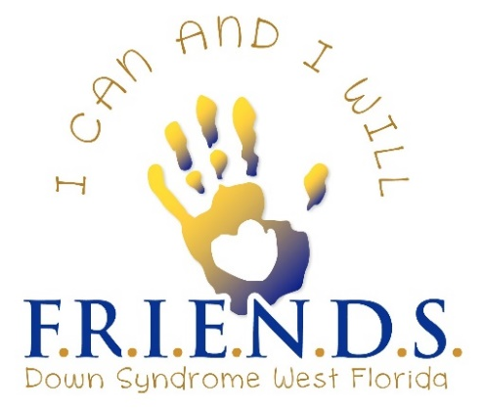
WHAT’S NEXT FOR FRIENDS
DOWN SYNDROME WEST FLORIDA?

THE FRIENDS CENTER

THE FRIENDS CENTER – Providing all special needs children and those children with
unique care requirements rewarding programs and services in a safe and warm environment.

COMPANY DESCRIPTION:
- The center serves children from birth to adult, including those with special medical needs.
- The child-to-staff ratio is 5-to-1 and all staff are required to have prior experience
caring/teaching for special-needs children.
- Medically needed – those who may require tube feedings, diabetes management, and
diets and other medical needs.
- An after-school program – transportation will be provided to pick up the children.
- An Adult Day program which consists of life skills, activities for daily living and possibly
classes to learn a trade (Cooking, Babysitting, etc).
- Sensory rooms, a kitchen that focuses on healthy diets, a medical room, a multi-purpose
room, a computer café, a movement studio, and a library.

PROGRAMS:
- Baby Friends (Birth to 6yrs) – potty training, motor skills through art, music, & play.
- Dream Tweens (6yrs-10yrs) & Tampa Bay Tweens (11-14yrs) – a safe place for socialization
skills, computer skills and activities of daily living training.
- F.S.C. Meetings – (15yrs and up) – Movie night, Hang out area.
- Students also can receive life and social skills instruction, speech and occupational therapies,
an individual education plan consultation, and other support.
- FRIENDS Self-Advocates Club (15yrs plus) – a place to meet up with friends, plan
recreational outings to the movies, mall, and a monthly dance.
- Respite Care – the daycare will open during the holiday breaks, during the summer and
other school breaks. Respite care for parents on weeknights and weekends.
- Fitness & Weight Training Class, Yoga Class, Zumba Class, Dance Class, Music/Art
Class, Homework/Computer Class, Cooking/ADL Classes.

Notable Statistics
- Between 1979 and 2003 the number of babies with down syndrome increased by 30%
- Average medical costs for a child 0-4yrs with Down Syndrome is 12 times higher.
- Almost 60% of families with Down Syndrome have provided health care at home.
- 40% of families of children with Down Syndrome had a family stop working.
- 50% of babies born with Down Syndrome also have congenital heart defects.

 |  | Hillsborough Country (July 1st, 2016)
 |  | Population |  | 1,376,238
 |  | Disability Percentage (Physical or Mental) |  | 8.30%
 |  | Disability Number |  | 114228
 |  | National Down Syndrome Number |  | 1927
 |  | Median Household Income |  | $50,579
 |  | Health Care & Social Assistance Receipts/Revenue, 2012 (1000) |  | $10,425,978
 |  | Persons Without Health Insurance |  | 14.70%
 |  | Pinellas Country (July 1st, 2016)
 |  | Population |  | 960,730
 |  | Disability Percentage (Physical or Mental) |  | 9.60%
 |  | Disability Number |  | 92230
 |  | National Down Syndrome Number |  | 1345
 |  | Median Household Income |  | $45,819
 |  | Health Care & Social Assistance Receipts/Revenue, 2012 (1000) |  | $7,744,448
 |  | Persons Without Health Insurance |  | 14.30%
 |  | Pasco County (July 1st, 2016)
 |  | Population |  | 512,064
 |  | Disability Percentage (Physical or Mental) |  | 11.10%
 |  | Disability Number |  | 56839
 |  | National Down Syndrome Number |  | 717
 |  | Median Household Income |  | $45,064
 |  | Health Care & Social Assistance Receipts/Revenue, 2012 (1000) |  | $2,142,452
 |  | Persons Without Health Insurance |  | 14%

EXECUTIVE BOARD OF DIRECTORS

BOARD OF DIRECTORS
Ann Foyt – President (813)245-2782 info@friendssupport.org
Liz Johnson – Vice President (727)463-1707 liz@friendssupport.org
Brenda Wando – Secretary (813)750-3943 brenda@friendssupport.org
Sue Warady-Keene – Executive Director (630)914-4114 sue@friendssupport.org

STAFF
Tish Knotek – Buddy Walk Committee (813)436-6872 Anglerair@msn.com
Kathy Boisseau – Playgroup Director (603)438-2886 kathyboisseau@gmail.com
Margarita Padron – Spanish Outreach (813)842-5654 Margarita@friendssupport.org
Jamie Santillo - Marketing Director (239)297-6691 jamie@friendssupport.org
Julie Mckenna – F.S.A. Dance (631)335-8464 Jules.mckenna34@gmail.com
Biz Central - Maria Caballero Account (407)857-9002 mcaballero@bizcentralusa.com
Tamera Dyer – Website Management (614)407-3937 tamera@dyermediagroup.com

ADVISORY BOARD COUNSIL
Want your voice heard and be in on the decision making? Our Advisory Board’s purpose is to provide council and to be available to advise the Board of Directors in relationship to the Buddy Walk, Development, Fundraising Initiatives, Public Relations and Programming issues. If you are interested in participating, please send an email to info@friendssupport.org.

ADVISORY BOARD
Jamie Santillo – JS Creative Concepts & Marketing LLC. jamie@jscreativemarketing.com
Sara Bataglia – Dancing for Donations sara_battaglia95@yahoo.com
Joe & Vicki Wright – Realtor thewrightchoice@verizon.net
Tim & Melissa Miner – Sun Parrot Services melmin@me.com
Chris Pello – Livingstone Schools cpello@livingstoneschools.org
Marky Oliver – Specially Fit Foundation speciallyfitfoundation@gmail.com
Daniel & Mary Stahl – The Palms Church marystahl1010@gmail.com
Dr. Melissa Bailey – Bailey Psychology Group drmelissabailey@gmail.com
Evan Johnson – Event Volunteer echolizard88@gmail.com
Paul Foyt – Event Volunteer pfoyt@arsavage.com
Julie Hirsch – Julie Hirsch Photography jhirsch4@tampabay.rr.com
Travis Pettengil - Realtor salesbytravis@gmail.com
Laurie Ohall, P.A. – Special Needs Attorney lohall@ohalllaw.com
Steve Hitchcock, P.A. – Special Needs Attorney steve@hitchcocklawyer.com
Aubrey Posey, P.A. – Special Needs Attorney Aubrey@hitchcocklawyer.com
Dr. Terry Larson-Messmer – Physical Therapist drterrylarson@gmail.com
Danny Esposito – Boundless Global danny@boundlessglobal.org
Tamera Dyer – Dyer Media Group tamera@dyermediagroup.com
Natalie Killebrew – Hyland IT Specialist Natalie.Killebrew@Hyland.com
Betsey & Geoff Tingey – Parent Liaisons tingeyg@gmail.com
Nakisha Varlack, CEO/President Guardian Haven info@guardianhaven.com
Peter Korcusko – Treasurer Peter.Korcusko@wellsfargoadvisors.com
Renee Adams – Queen Sir Francis Drake Reneejeanadams@gmail.com
Roland Woods – Captain Sir Francis Drake

SELF ADVOCATES AMBASSADORS
Zachary Foyt
Brooke Knotek
Ben Greer
Ana Maria Rueda

SPANISH LAISIONS
Margarita Padron (813)842-5654

BABY FRIENDS
Kathy Boisseau – Brandon (603)438-2886
Heather Carpenter - Pinellas (813)433-4383
Ashley Habarth – Brandon (813)325-8981
Renee Hurst – Westchase (813)340-9160

DREAM TWEENS
Sue Warady-Keene (630)914-4114

PARENT LIAISONS
Betsey & Geoff Tingey
Kathy Boisseau
Ann Foyt

CONTACT US
ADDRESS: P.O. Box 677, Brandon FL 33509
PHONE: (813) 245-2782 Hillsborough
(727) 463-1707 Pinellas
WEBSITE: www.fdswf.org

LISTED AS FRIENDS SUPPORT, INC. EIN # 65-1261645

THANK YOU FOR SUPPORTING FDSWF AND OUR
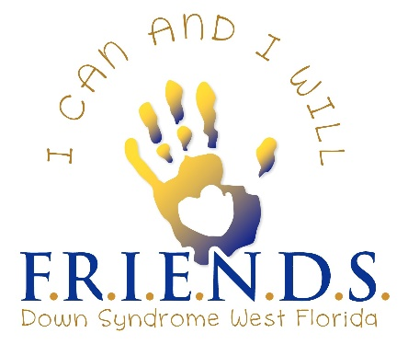
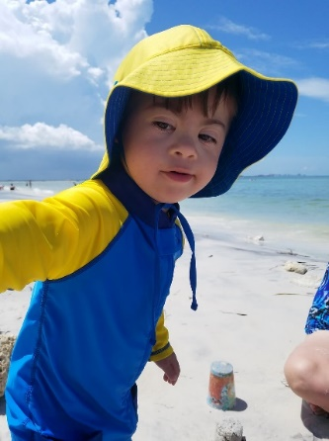
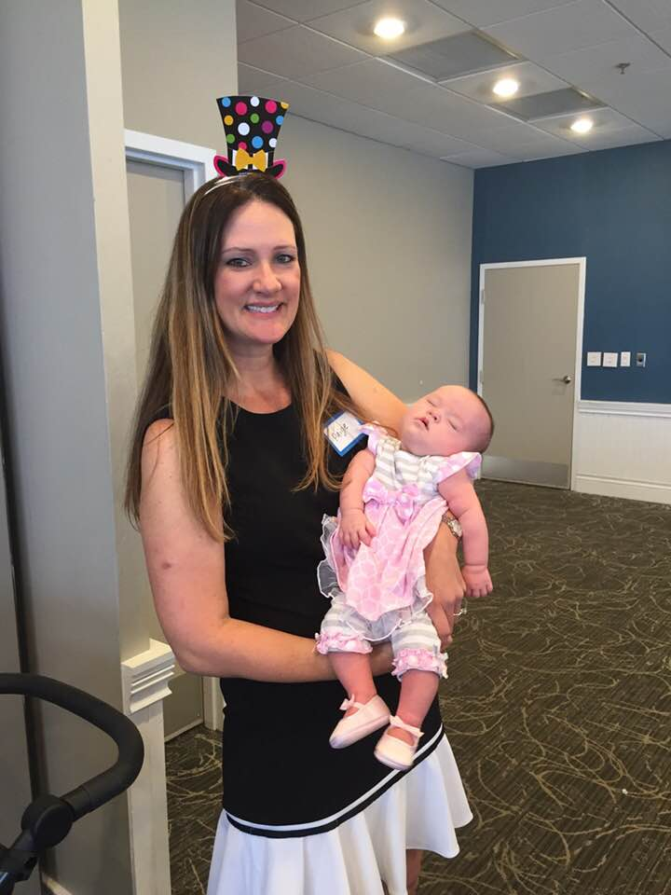
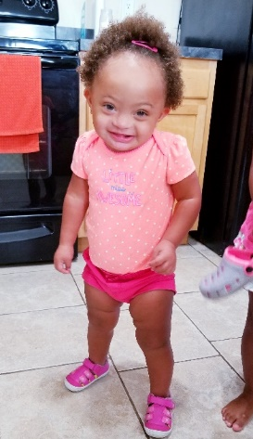
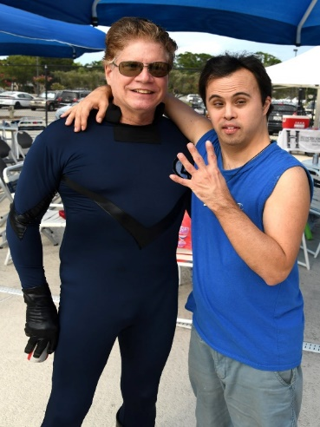
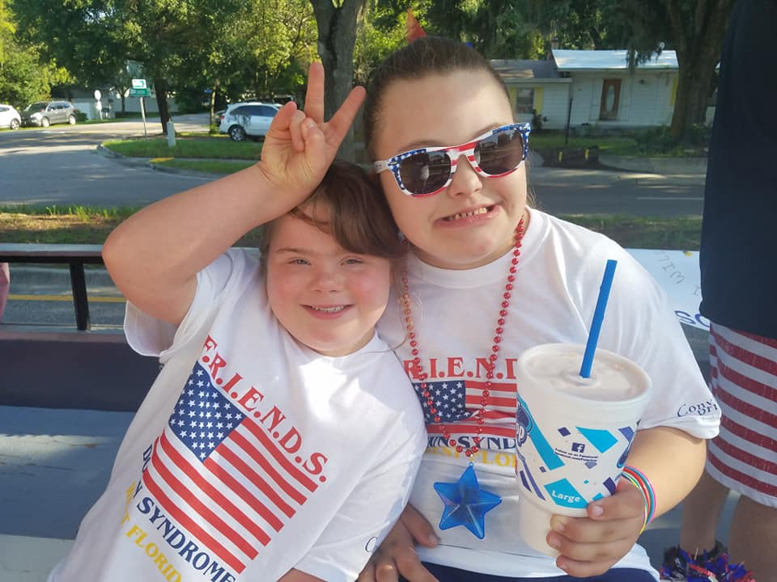
DOWN SYNDROME COMMUNITY!

