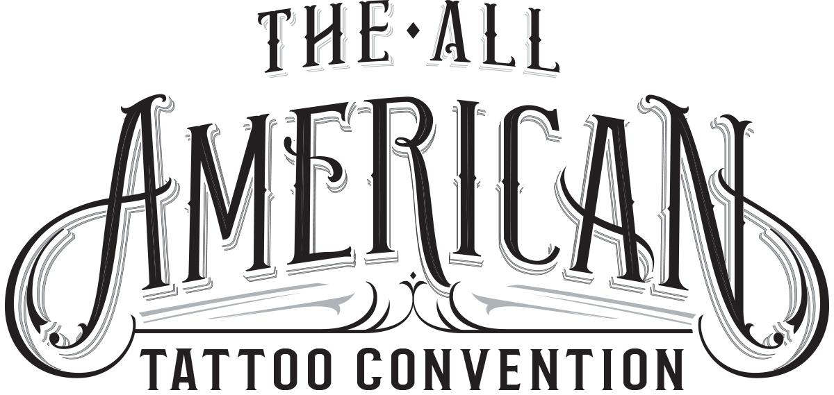
The All American Tattoo Convention
2712 Skye Dr Fayetteville NC 28303
910-850-2566
www.allamericantattooconvention.com

For Immediate Release
For more information contact:

William Ryan Harrell
910-494-8878
ryan@allamericantattooconvention.com

Best Ink TV Show Celebrity Signs Up To Appear At All American Tattoo Convention!
Alli Baker from the Oxygen TV show Best Ink will be attending the All American Tattoo Convention.

Fayetteville, NC (June 7, 2016) - The All American Tattoo Convention will be featuring yet another celebrity tattoo artist. Alli Baker from the Oxygen networks hit TV show “Best Ink” will be attending the All American Tattoo Convention April 14th-16th 2017.

Alli has been traveling the globe tattooing at conventions and appearing as a guest at some of the top tattoo spots and has chosen to call Fayetteville NC home for a weekend in 2017 to tattoo some of the US military’s finest soldiers!

Alli joins other TV celebrities, Joey Tattoo, Madison Loftis, the Half Pint Brawlers as well as some of the best tattoo artists not only locally, but in the United States. Never before has this much national tattoo talent been on display in Fayetteville NC.

The All American Tattoo Convention is being promoted by William Ryan Harrell of Creative Champion in conjunction with Veteran Tattoo Artist Robert “Chop” Francis of Chop Shop Tattoos. Both men have been in business in Fayetteville for 10+ years.

Leading up to and during the event the event's organizers will be raising money for local organizations that help soldiers with PTSD and their families. These organizations will be announced later as the agreements have been finalized.

Booth information, sponsorship opportunities, volunteer information and additional contact information can be found at www.allamericantattooconvention.com or contact Ryan Harrell at 910-850-2566.

###

