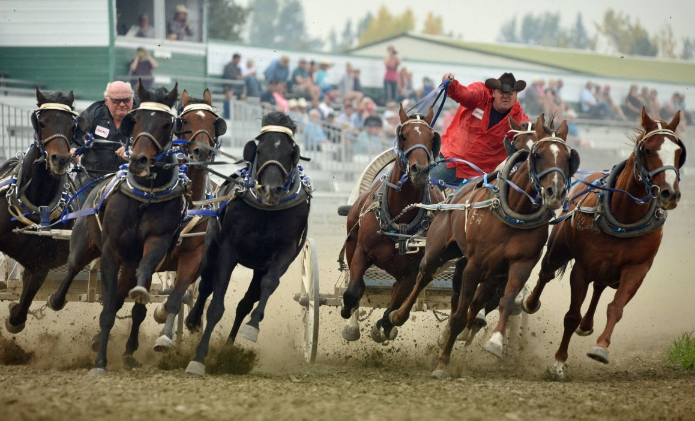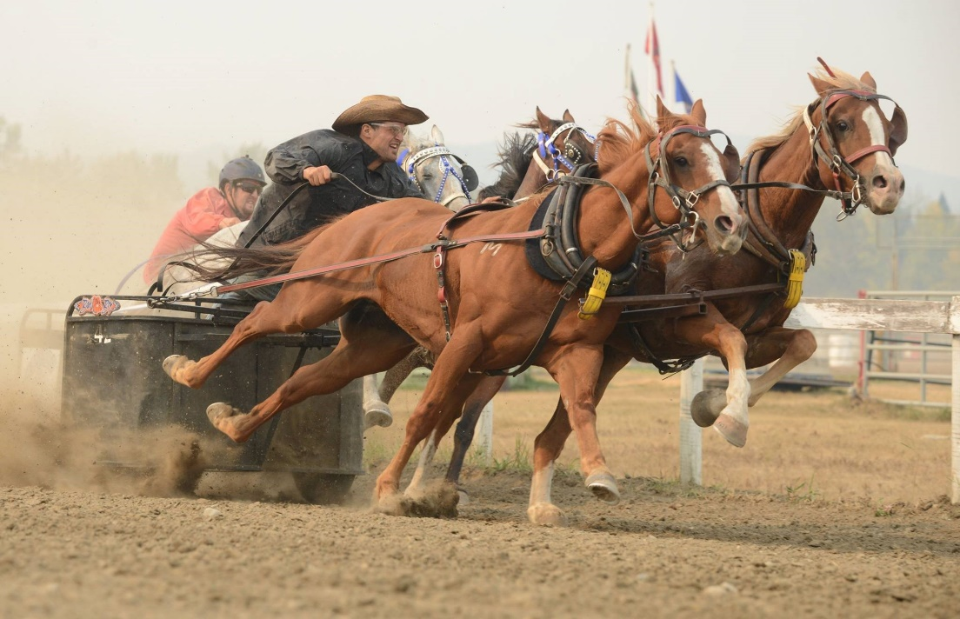

2018 Millarville Chuckwagon & Chariot Races FINAL!!!!!!

September 7th to 9th

Racing Times

Friday - 5PM

Saturday - 3PM

Sunday – 3PM

Family Friendly Beer Gardens & Cabaret

Supported by the Alberta Professional Chuckwagon & Chariot Association

Tickets Prices

Adults - $10

8 and under FREE