

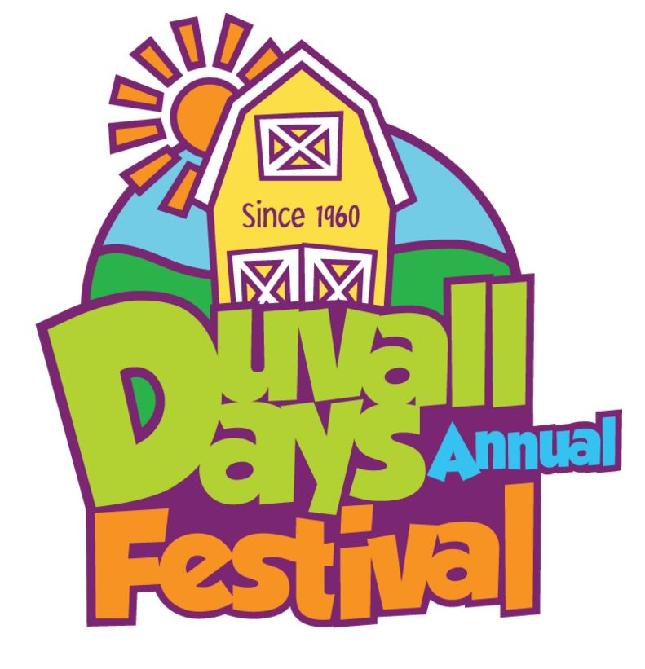

SPONSORSHIP PACKET

2018

www.duvalldays.org

Dear Duvall Days Sponsor,

We are excited to announce that on June 2, 2018, we will be holding our annual Duvall Days Festival. In 2017, with the support of your organization, we hosted over 6,000+ visitors from all over Puget Sound, 100+ vendors, and over 20 activities along Main Street, Depot Park and of course McCormick Park! We also were nominated and placed in the top 5 Best of Western Washington Events for 2017, which landed the Snoqualmie Valley at #4 ahead of several larger Seattle festivals!

Duvall Days will again this year include food and business vendors, carnival-like events, street performers, and live evening music in McCormick Park followed by a firework show!

Last year, we had lots of major business sponsors of Duvall Days so we wanted to give interested Sponsors “first access” of this year’s structure to support the event. Below are the sponsorship levels. Sponsors will receive a variety of recognition options on the event collateral, website, posters, and brochures, and social media. As we did last year we will have the support of a Sponsorship Coordination to ensure our sponsors are well taken care of!

We hope you will consider partnering with us to support the Duvall Days Festival Event. This year the Duvall Days Festival is working to secure it’s 501c3 designation, so your contribution can be tax deductible. We will work closely with the Duvall Chamber of Commerce, Cascade Community Theater, the City of Duvall and local businesses owners, and participants from last year to ensure a wonderful event.

If you would like to participate in this year’s event as a sponsor, please contact me with the amount of your donation. Thank you for your time and consideration.

Sincerely,

Kim Piira

Duvall Days Sponsor Coordinator

Duvall Days Festival

kim@duvallchamberofcommerce.org

|  |  |  |  |  |  |
| --- | --- | --- | --- | --- | --- |
| **Sponsor Benefit** | **Fireworks**  **(1)** | **Platinum**  **SOLD OUT** | **Shuttle Sponsor**  **(4)** | **Gold** | **Silver** |
| Main Stage/Street “Day” Platinum Sponsor (s) |  |  |  |  |  |
| Evening Stage Presenting Sponsor |  |  |  |  |  |
| Name as Sponsor (s) on Hwy 203 Banner for 2 weeks (Viewed by 10K cars) |  |  |  |  |  |
| Stage Appearance on The Podium at Event Ceremonies both Day and Evening |  |  |  |  |  |
| Mention from The Podium at Event Ceremony both Day and Evening. |  |  |  |  |  |
| Premium 10 X 10 Booth Location | Next to Evening Stage  |  |  |  |  |
| Full Page promotional advertisement in 2018 Duvall Visitor Guide *subject to Print deadlines* |  |  |  |  |  |
| Your Name and Logo on Shuttle Bus |  |  |  |  |  |
| Sponsor’s Name Included in All Electronic Communication to DCC members. |  |  |  |  |  |
| Facebook And Twitter Recognition (Fireworks = min of 8 mentions and posts, Premium = min of 6 mentions and posts) |  |  |  |  |  |
| 10 X 10 Booth Space |  |        |  |  |  |
| Sponsor’s Name Featured in Press Releases by Sponsor Type |  |  |  |  |  |
| Logo and Link and Duvall Days Website by Sponsor Type |  |  |  |  |  |
| Invitation to Duvall Days Thank You Sponsor Dinner |  |  |  |  |  |
| ***Please Note: Some Benefits Subject to Print Deadlines*** | **$5,000** | **$3,000** | **$1,500** | **$1,000** | **$500** |

## All our sponsorship levels include Media Exposure, On-Site Exposure, and Product Placement components that extend beyond the date of our event. Throughout the event planning process, your brand has a reach of 5,500 to over 20,000 views. Our dynamic audience consists of elite businessmen and women of major companies and organizations in our area including Microsoft, Boeing, Starbucks, and more, as well as the best-of-the-best throughout the Snoqualmie Valley and greater Puget Sound region.





**Sponsorship Form**

**\*We also have an online sponsorship form - please go directly to: www.duvalldays.org**

*Company / Individual Name:*

*Contact Person: Phone:*

*Address:*

*E-mail: Web Site:*

*Name as you would like it to appear in all publications:*

***$5,000 FIREWORKS SPONSOR (One available) \****

***$3,000 PLATINUM SPONSOR (Three available)***

***$1500 SHUTTLE BUS SPONSOR (Four available)***

***$1000 GOLD SPONSOR (Multiple available)***

***$500 SILVER SPONSOR (Multiple available)***

***$250 BRONZE SPONSOR (Multiple available)***

***Questions:*** *Contact Kim Piira at kim@duvallchamberofcommerce.com*

**THANK YOU FOR YOUR SUPPORT!**

Please make checks payable to:

***Duvall Days Festival***

To pay via credit card online, please go directly to: www.duvalldays.org