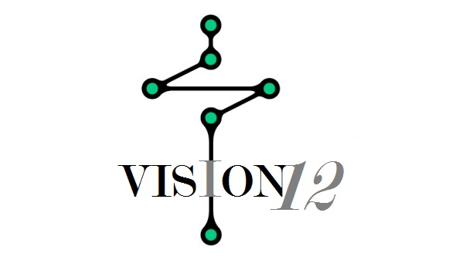
Sponsorship
Of
Millennial Movement
Expo

Hosted By: Vision Twelve Ministry

Vision Twelve Ministry is headquartered in Las Vegas, NV. As an organization, it mission is to develop a network of Charter Groups lead by The Millennial Generation. Vision Twelve, currently has @ 120 Charter Groups around the country. We are devoted to growing faith in generations and positively impacting our community.
Activism is quite simply taking action to effect social change; this can occur in a myriad of ways and in a variety of forms. Often it is concerned with ‘how to change the community’ through social, political, economic or environmental change. This can be led by individuals but is often done collectively through social and faith based movements.
Activism has been present throughout history, in every sort of political system. Yet it has never received the same sort of attention from historians as conventional politics, with its attention to rulers, wars, elections, and empires. Activists are typically challenger's to policies and practices, trying to achieve a social goal, not to obtain power themselves. Much activism operates behind the scenes.
Vision Twelve Charter Group Members are people who seek to create positive change. But not all people who work for change define themselves as activists. Vision Twelve Charter Group Members are based in scripture truth, and are devoted to reaching change in our communities through faith-based measures.
Members and friends of Vision Twelve Ministry come from a variety of backgrounds and beliefs. Our stories are different and our identities more so, but we believe that our spiritual journeys are enhanced by this diversity and that we learn from each other. We welcome:
…all faiths and beliefs
…all families – Single, married, same-gender, grandparent/child, interfaith
…all preferences
…all genders
…all ethnicities
…all ages
…all traditions
The members of Vision Twelve Charter Groups, adhere to the seven principles:
- The Inherent worth and dignity of every person
- Justice, equity and compassion in human relations
- Acceptance of one another and encouragement to spiritual growth in our Charter Groups
- A free and responsible search for truth and meaning
- The right of conscience and the use of the democratic process within our congregations and in society at large
- The goal of a community with peace, liberty, and justice for all
- Respect for the interdependent web of all existence of which we are a part

Vision Twelve Ministry envisions Clark County, NV. to be a dynamic county, recognized for its investment in its people, economic vitality, and rich quality of life, and to be a model for innovative leadership and supportive citizenry.
Our goal is to have everyone in Clark County recognize, embrace, and adopt this vision for our future and subsequently work to achieve it. This includes individuals and organizations – government, non-profits, education, business, clubs, industry… everyone.
The leadership of Vision Twelve Charter Group in Clark County and leadership of Clark County have recently adopted this vision as their organizations’ vision for the county. We are asking individuals and groups in Clark County to partner with us in embracing this vision.

As an organization of faith, it is imperative to engage, evangelize, and build our support community whether they be local, regional, national. Creating excitement and meaningful calls to action are important elements of effective outreach, however, growing the enthusiasm of our most active supporters is crucial. That is what "Millennial Movement Expo" is all about on May 2, 2017, held at the Thomas and Mack Center at 6:45 P.M.

We need your support. Your financial support helps to fund a variety of projects and activities, including: our internship program, community events, Las Vegas Charter Group projects, workshop, and finally our daily operations, such as materials and supplies.
To support Vision Twelve Ministry: Click HERE
To support Millennial Movement Expo: Click HERE

I sincerely thank you!
Until The Nets Are Full!

Rev. Brook Smith
President
Vision Twelve Ministry
844-322-1212
Info@visiontwelve.org

