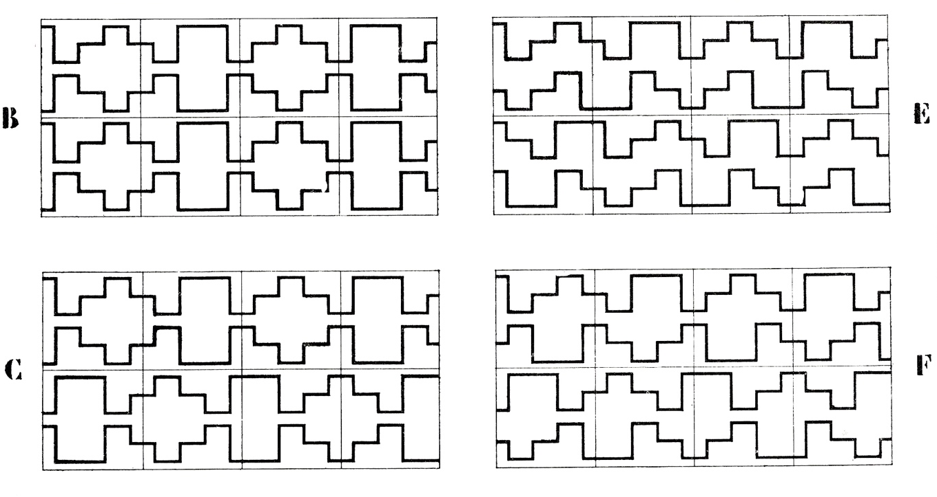

THE CITY & CARBON MODERNITY

Yale School of Architecture, Fall 2021
Seminar: Fridays, 2:00 - 4:50
Instructor: Elisa Iturbe
Contact: elisa.iturbe@yale.edu
Office hours: by appointment

“Even if we have never been modern, we still have a modernist mess on our hands.”
— Kim Fortun

COURSE DESCRIPTION

The aim of this course is to reframe the role of architecture in the climate crisis. Too often architects think of the climate crisis as a biological or ecological phenomenon, removed from the specificities of architectural form. This course argues the opposite — not only is architecture deeply embedded in the causes of climate change, but architecture, through its own language, can provide a means for understanding and mitigating the crisis.

To do so, it is necessary to reframe our understanding of energy. Humanity has moved through three energy paradigms, each of which has produced different built environments and social organizations. At each transition—from nomadic to agricultural and from agricultural to industrial—the productive capacity of human society was transformed, restructuring the existing social order and engendering a corresponding spatial and architectural paradigm. In this light, this course will study our current energy paradigm—carbon-intensive fossil fuels—as a driver of urban and architectural form. Rather than studying the technical aspects of energy, however, the course will focus on the social and spatial organizations that arise and are dependent on dense and abundant energy. Of particular interest will be the way in which society reorganized itself around the availability of abundant energy as fossil fuels established a new horizon of possibility for production. Factories and global markets emerged, reorganizing labor and economies, and giving rise to a society that was dependent on coal. As fuel technologies evolved towards oil and natural gas, these relationships continued to evolve, leading to a global network of capitalist production and intensive energy consumption. Carbon energy, then, led to changes in the realms of the social, economic, political, spatial, and ecological, forming a legible condition one might call carbon modernity. As such, the energy transition needed to mitigate our current climate crisis is not simply a technological problem, but also one of social organization, politics, and economics.

Within this context, the course will focus on the spatial expressions of carbon modernity. For example, as mechanized production led to demographic displacement, the reorganization of labor, and urban density, new urban and architectural typologies emerged: warehouses, factories, worker housing, etc. With further technological advancement, we saw the development of office towers, skyscrapers, department stores, airports, strip malls, suburbs. These urban and architectural typologies were made possible by carbon-intensive fossil fuels and became characteristic of modern society. In other words, they are social and spatial organizations specific to carbon modernity, and we will refer to them as carbon form.

Despite increasing awareness of environmental issues, architects continually build and replicate carbon form. Notwithstanding increased energy efficiency or reduced emissions, the built environment as we know it will be fundamentally unable to overcome the current energy paradigm or to address the climate crisis as long as its core is constituted by carbon form. So just as the Modern Movement proposed a new organization for the city based on the realities of industry, this moment demands new organizations based on the reality of the climate crisis—a crisis that has clearly shown our current urban system to be obsolete. Unlike in Modernism however, the energy transition to which we must respond has not yet occurred. And yet, architecture must still declare the death of carbon modernity and seek the means to overcome its material and cultural legacy. The course will interrogate the foundations of contemporary human organization in order to lay new foundations for the oncoming transitions in energy and social form.

COURSE OBJECTIVES

The goal of the course is to identify the deep connection between architecture and climate change, beyond the carbon footprint of the built environment. Architects must recognize that current modes of architectural production are insufficient to address the problem of climate. Yet even so, due to the profound correlation between energy and urban form, it will be argued in this course that architecture has an important role to play in this uncertain phase of human and geological history. Carbon modernity and carbon form serve as frameworks for treating decarbonization as a theoretical problem for architectural and urban thought.

COURSE STRUCTURE

TOPICS ASSIGNMENTS
INTRODUCTION
01: INTRO
02: FOSSIL CAPITALISM 1: TERMS & DEFINITIONS
03: FOSSIL CAPITALISM 2: ENERGY POWER & SPACE
Reading responses
04: ENERGY TRANSITION 1: THE RISE OF AGRICULTURE
05: ENERGY TRANSITION 2: THE BIRTH OF CARBON MODERNITY
CASE STUDIES
06: CARBON FORM AS PROJECT: MODERNISM
Assignment #1 (Analyzing)
07: CARBON FORM AS ECONOMY: THE SUBURBS
08: CARBON FORM AS ECONOMY: NEOLIBERALISM
ALTERNATIVES
09: THE DECENTRALIZED GRID
10: LAND OWNERSHIP
Assignment #2 (Overcoming)
11: MOBILITY
12: POST-WORK

13: FINAL REVIEW

ASSIGNMENTS:

Assignments will consist of readings, reading responses, and a final collaborative assignment.

Readings will be discussed in class, participation is required. Reading responses will be due on Thursdays, the evening before class, at 9 pm. A minimum of 500 words. The reading response should include the following:

01: Your Name, Title of the text, Author
02: What is the main critical point / argument that the author is making?
03: What are the key terms being discussed in the text?
04: What questions do you have regarding this text?
05: How does this text contribute to your understanding of carbon form?

In addition to readings, students will select a precedent to analyze and draw throughout the semester. Work will be presented in class, over the course of several class sessions (see Course Structure).

ASSIGNMENT #1: Carbon Form Analysis
Students are to select an urban proposal that they identify as carbon form. The drawings should:

01: Identify the project’s salient formal and social ideas
02: Identify the project’s salient architectural elements and spatial dispositions
03: Identify the project’s underlying relationship to energy beyond matters of fuel and
technology. This should include an analysis of labor, food, production, ideology, etc.
04: Argue why the project should be considered a carbon form.

ASSIGNMENT #2: Overcoming Carbon Form
If the premise of the first assignment is to understand carbon form as a project of spatial organization, the premise of the second is to question how alternative spatial organizations might create opportunities and make space for a different relationship to energy. This assignment will take place alongside readings and lectures that outline alternative energy grids, land ownership models, modes of production, and networks of mobility that will serve as fodder for this assignment. The final form of this assignment will be a diptych that shows the precedent as a carbon form, alongside its possible reorganization. Work will be presented in-class (see Course Structure) for feedback and comments, then revised and presented again during the final review.

COURSE SCHEDULE

01: Introduction: Overcoming Carbon Form SEPT 03

02: Fossil Capitalism SEPT 10
In class: lecture & discussion

Readings: Andreas Malm, Fossil Capital: The Rise of Steam Power and the Roots of Global
Warming, (London: Verso, 2016) pp 1-19.
Raj Patel and Jason W. Moore, Introduction, in A History of the World in Seven
Cheap Things (Oakland: University of California Press, 2017) pp 1-43.
Optional: Nancy Fraser, “Climates of Capital: For a Trans-Environmental Eco-Socialism”
New Left Review 27 (Jan Feb 2021) pp 94-127.

03: Energy & Power & Space SEPT 17
In class: lecture, discussion

Readings: Andreas Malm, Fossil Capital: The Rise of Steam Power and the Roots of Global
Warming, (London: Verso, 2016) pp 37-57, 298-309.
Timothy Mitchell, “Carbon Democracy,” Economy & Society 38:3, pp 399-432,
with special emphasis on pp 400-409 and 415-423.
Cara New Daggett, The Birth of Energy: Fossil Fuels, Thermodynamics, and the
Politics of Work, (Durham: Duke University Press, 2019) pp 51-82.
Optional: Dominic Boyer, “Energopower: An Introduction,” Anthropology Quarterly 87
(2014) pp 309-333.

04: Energy Transition 1: the Rise of Agriculture SEPT 24
In class: lecture, discussion

Readings: Mario Liverani, Uruk: The First City, trans. Zainab Bahrani and Marc Van De
Mieroop, (Sheffield, UK: Equinox, 2006) pp 15-52.
James C. Scott, Against the Grain (New Haven: Yale University Press, 2017)
pp 116-149.

05: Energy Transition 2: The Birth of Carbon Modernity (travel week) OCT 01
In class: lecture, discussion

Readings: Elisa Iturbe, “Architecture & the Death of Carbon Modernity,” Log 47 (Fall 2019),
pp 11-23.
Leonardo Benevolo, “The age of reorganization and the origins of modern town-
planning,” History of Modern Architecture, Volume 1: The Tradition of Modern
Architecture, trans. HJ Landry." (Cambridge, MA: MIT Press, 1977) pp 38-60.
Sibyl Moholy-Nagy, “Clusters and the End of Origins,” Matrix of Man: An
Illustrated History of Urban Environment (New York: Frederick A Praeger,
1969) pp 241-282.

Optional: Lewis Mumford, The City in History: Its Origins, Its Transformations, and Its
Prospects (San Diego: Harcourt, Inc, 1961).
Mimi Sheller, “The Origins of Global Carbon Form,” Log 47 (Fall 2019), pp 56-68.

06: Carbon Form as a Project: Modernism OCT 08
In class: lecture, discussion
Assignment #1: Analysis

Readings: Hilde Heynen, Architecture & Modernity: A Critique (Cambridge, MA: MIT Press,
1999) pp 2-24.
Le Corbusier, The City of Tomorrow and its Planning, trans. Frederick Etchells,
(New York: Dover Publications, 1987) xxi-xxiv, 5-12, 163-194.
Le Corbusier, The Radiant City, (New York: Orion Press, 1964), pp 28-70, 187-
197, 240-261.
Ludwig Hilberseimer, The New City, (Chicago: Paul Theobald, 1949) pp 45-74.

07: Carbon Form as Economy: the suburbs OCT 15
In class: lecture, discussion
Assignment #1: Analysis

Readings: Kenneth T. Jackson, “The Drive-In Culture of Contemporary America,” Crabgrass
Frontier: The Suburbanization of the United States (New York: Oxford University
Press, 1985) pp 246-271.
Louise Mozingo, Pastoral Capitalism: A History of Suburban Corporate Landscapes
(Cambridge, MA: MIT Press, 2011) pp 1-18.
Laurence Lumley, “The Invisible Bituminous Desert,” Log 47 (Fall 2019) pp 25-30.
Optional: Dolores Hayden, “What is Suburbia? Naming the Layers in the Landscape, 1820-
2000,” Smart Growth: Form and Consequences (Cambridge, MA: Lincoln
Institute of Land Policy, 2002).

• NO CLASS: MIDTERMS OCT 22

08: Carbon Form as Economy: neoliberalism OCT 29
In class: lecture, discussion
Assignment #1: Analysis

Readings: Reinhold Martin, “Real Estate Agency,” Art of Inequality. pp 92-104.
Douglas Spencer, “Island Life: The Eco-Imaginary of Capitalism,” Log 47 (Fall
2019) pp 167-174.
Sam Stein, Capital City: Gentrification & the Real Estate State (London; Brooklyn,
NY: Verso, 2019 pp. 41-65.
Optional: Neil Brenner, Jamie Peck, and Nik Theodore, “After Neoliberalization?” Critique
of Urbanization: Selected Essays (Berlin: Bauverlag Gütersloh, 2017) pp 158-185.
Tahl Kaminer, “An Introduction to Newark: The Continuous Crisis of the Obsolete
City,” Urban Asymmetries: Studies and Projects on Neoliberal Urbanization
(Rotterdam: 010 Publishers, 2011), pp 192-207.

09: Alternatives: The De-centralized Grid NOV 5
In class: lecture, discussion,
Assignment #2

Readings: Gretchen Bakke, The Grid (New York, NY: Bloomsbury, 2017) pp 25-56.
Giovanni Frigo, “Energy Ethics, homogenization, and hegemony: A reflection on
the traditional energy paradigm” Energy Research & Social Science 30 (2017) pp
7-17.
Selections from Fueling Culture: 101 Words for Energy and Environment (New
York: Fordham University Press, 2017)
“Grids,” Cymene Howe
“Off-grid,” Michael Truscello
“Solar,” Amanda Boetzkes
“Energy,” Vivian Soni

10: Alternatives: Land & Property NOV 12
In class: lecture, discussion
Assignment #2

Readings: Pier Vittorio Aureli, “Islands: The Settlement from Property to Care,” Log 47 (Fall
2019) pp 175-199.
William Cronon, Changes in the Land: Indians, Colonists, and the Ecology of New
England, rev. ed. (New York: Hill and Wang, 2003) pp 19-33, 54-81.
Gary Fields, Enclosure: Palestinian Landscapes in a Historical Mirror (Oakland,
California: University of California Press, 2017) pp 23-44.
Optional: John Emmeus Davis, “Origins and Evolution of the Community Land Trust in the
United States,” The Community Land Trust Reader, 3-47.

11: Alternatives: Mobility NOV 19
In class: lecture, discussion
Assignment #2

Readings: Lewis R. Binford Willow Smoke and Dogs' Tails: Hunter-Gatherer Settlement
Systems and Archaeological Site Formation’ in: American Antiquity, vol. 45
(January 1980), pp. 451-540.
Ross Exo Adams, Circulation & Urbanization (Los Angeles: Sage, 2019) pp 38-72.
Jesse LeCavalier, The Rule of Logistics: Walmart and the architecture of
Fulfillment (Baltimore, Md.: Project MUSE, 2015) pp 63-104.
Optional: Mimi Sheller, Mobility Justice (London; Brooklyn, NY: Verso, 2018).
Paul Virilio, Speed & Politics (London; New York: Routledge, 2007).

12: Alternatives: Post-Work DEC 05
In class: lecture, discussion
Assignment #2

Readings: Cara New Daggett, The Birth of Energy: Fossil Fuels, Thermodynamics, and the
Politics of Work (Durham: Duke University Press, 2019) pp 83-103.

Massimo de Angelis, “Mobilising Social Labor for commoning,” Omnia Sunt
Communia, (London: Zed Books, 2017) pp 201-221.
James Suzman, Work: A Deep History from the Stone Age to the Age of Robots
(New York: Penguin Press, 2021) pp145-171.
Optional: Marshall Sahlins, Stone Age Economics (New York: Aldine Publishing Co., 1972)

13: FINAL REVIEW TBD

POLICIES

Attendance is mandatory.
Reading responses will be read and evaluated.
Drawings will be evaluated in class.
A failing grade may result from more than two unexcused absences, or from incomplete assignments. Please refer to the School Handbook for the complete set of rules and regulations.

