National STOL Series at
Sodbusters STOL Competition

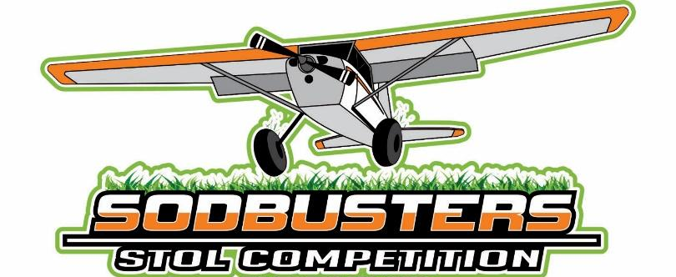
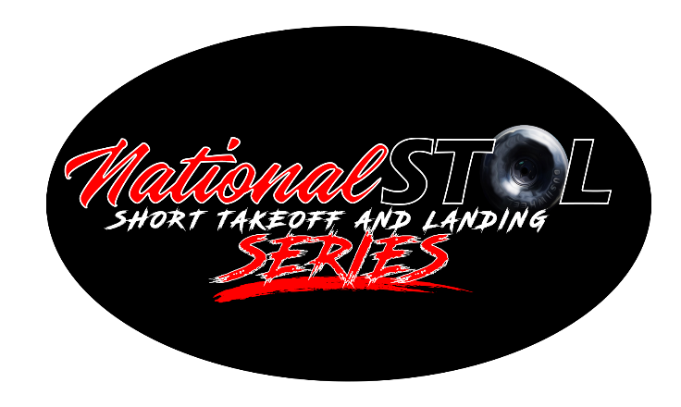

Sponsorship & Vendor Information
5/22/2020

Summary
The National Short Takeoff and Landing Series (STOL) is an organized competition series for bush pilots nationwide, competing in a series of rounds for the shortest distances. National STOL’s most recent event was the Lonestar STOL held in Gainesville, Texas, in which we revolutionized the STOL world with a fully featured live broadcast and the largest cash and prizes of any competition to date.
Each National STOL series event takes place over three days on a Friday, Saturday, and Sunday. Friday incorporates practice runs, “fly outs” (where attendees can travel to various local destinations in their airplanes), seminars, and dinner. Saturday is the semifinals of the takeoff and landing competition with all competitors (up to 150) participating in a multi-round configuration. On Sunday, the top 5 from each class participate in the multi-round Finals, followed by a trophy presentation and awards show.
National STOL has two remaining events this year: Sodbusters in Brainerd, Minnesota (July 2020) and Sun-N-Fun in Lakeland, Florida (October 2020). The 2021 STOL schedule will contain at least 5 events, including Oregon, Minnesota, Florida, North Carolina, and a finals invitational in Gainesville, Texas. The series could be expanded in the future based on demand. Multiple sponsorship opportunities exist at varying price points and levels of exposure.
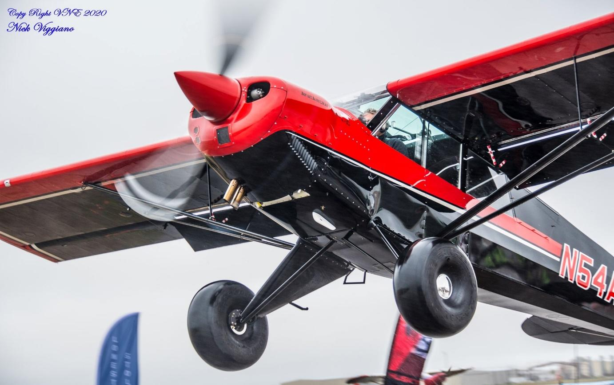
The National STOL Series is capped at 150 competitors but attracts a large viewership and audience. These audience members are pilots who fly in on their own planes or fly in commercially to watch the competition and stay for the weekend. Many more attendees travel by car. Due to the unique nature of our competition, we have a great reach in our attendance. We expect over 5,000 attendees this year at the Sodbusters STOL in Minnesota, due to the increased demand for summer events and great summer weather that Minnesota is known for!
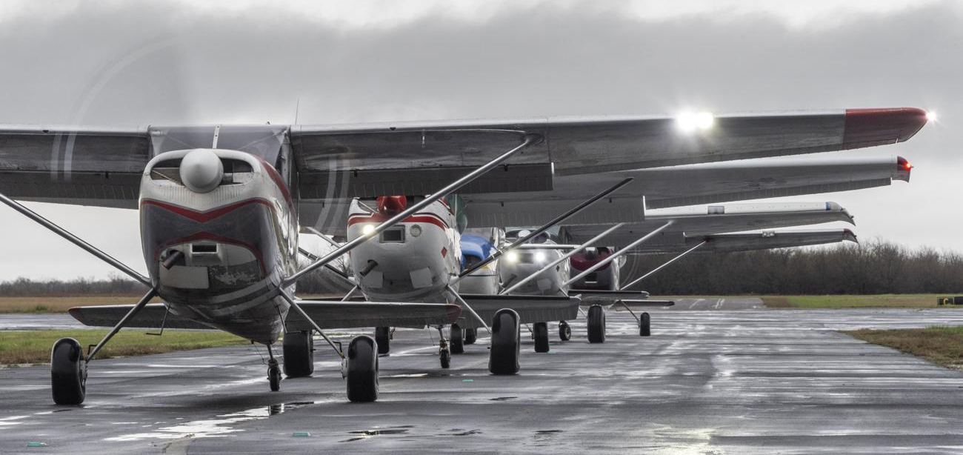

Demographics
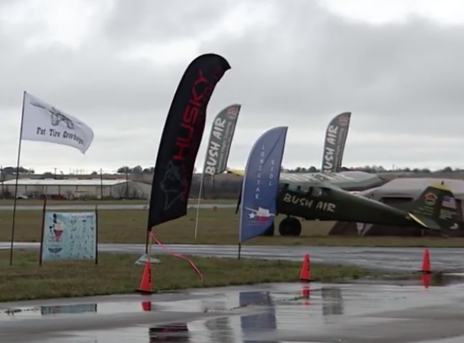
The primary audience for STOL is 65% male, over the age of 30, and an average family income of $100,000+. Lonestar STOL had an in-person audience of approximately 500 due to cold, cloudy and wet conditions. Current impressions from the event video breakdowns are over 180,000 views. The livestream had 75,000 views on YouTube & Facebook, with an average watch time of 23 minutes on YouTube and 12 minutes on Facebook. Video demographics were 93% male, with 85% of the audience over the age of 25. 20% over the age 65, 20% 55-64. The total watch time for both YouTube and Facebook exceed 4000 hours on YouTube and 370 hours on the Facebook livestream. The top viewing locations were Texas, England, California, Florida, Ontario (Canada), Ohio, Washington State and Georgia.

Upcoming Events
National STOL has partnered with Jeff Pohl of Sodbusters STOL for its second-year event. This year, Sodbusters STOL will be held near Brainerd, MN the weekend of July 24-26. For this upcoming event, National STOL has arranged for an airshow TV production company to provide a live broadcast, creating multiple sponsorship opportunities with a large online audience including but not limited to commercials, spots, underwritings, telematics, and camera sponsorships.
Sodbusters STOL’s initial event last year in Milaca MN, had an in-person audience of 3,000 attendees for a 1-day event. This event previously had little to no marketing, which we hope to increase by incorporating into our series. This year we are expanding it to a 3-day event to increase attendance and are moving the competition to a larger airport, Brainerd (BRD), which allows for better access for pilots, tourists, things to do for the family, and more vendor space.

Sponsorship Opportunities
We are currently entertaining sponsorship opportunities for Sodbusters STOL in Brainerd, MN for the July 24-26 weekend.
Multiple sponsorship opportunities are available at different price points and varying levels of exposure, as well as “add on” opportunities to uniquely represent your company.
Title Sponsorship (Inquire)
Our highest-level sponsorship is incorporated into everything we do. It is branded as our event name, includes integration into every aspect, and becomes our main theme for our event. Each time our event name is mentioned, it becomes the “Title – Sodbusters STOL” for example. This reinforces the branding with our guests and attendees. Additionally, the Title Sponsorship logo is attached to the main competition logo, and every piece of marketing, every display or banner has the Title Sponsor natively included in it.
Additionally, it includes:
- At least two Underwritings during our live broadcasts, as well as during the public address
- Mentions on social media and custom posts to introduce your product
- Two 30-second spots or commercials on our livestream (provided by your company)
- A banner advertisement on the Sodbusters STOL website, in line with our page and styling
- A logo listing with slogan and link to your website on the Sponsors page
- Up-front Vendor Space at the Site, at least 50x30’ (larger spaces available upon request); priority placement with the highest foot traffic
- Placement of your company banners around the event space
- Company name and logo included in advertisements and other banners
Diamond Level Sponsorships ($10,000)
Our second highest-level sponsorship includes the company’s name on the header of the event’s main logo with a “Presented by” tagline. Additionally, it includes:
- At least two Underwritings during our live broadcasts, as well as during the public address
- Mentions on social media and custom posts to introduce your product
- Two 30-second spots or commercials on our livestream (provided by your company)
- A banner advertisement on the Sodbusters STOL website, in line with our page and styling
- A logo listing with slogan and link to your website on the Sponsors page
- Vendor Space at the Site, at least 20x30’ (larger spaces available upon request); priority placement with the highest foot traffic
- Placement of your company banners around the event space
- Company name and logo included in advertisements and other banners
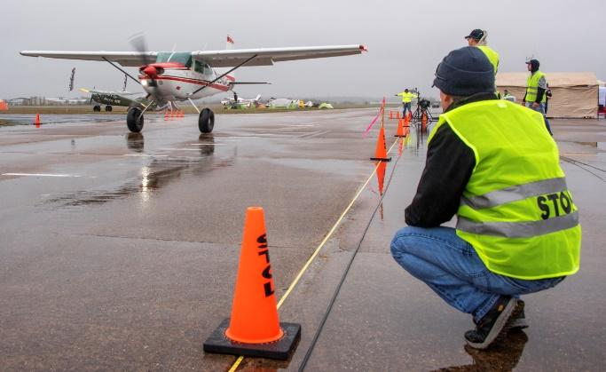
Platinum Level Sponsorships ($7,500) A well-rounded sponsorship package with excellent exposure to our audience.
- Mention of your company and products on our live broadcast and public address system
- Mentions on social media of your products and company.
- One 30-second spot on our livestream or replay footage (provided by your company)
- A logo listing with slogan and link to your website on the Sponsors page
- Vendor Space at the Site, at least 20x20’ (larger spaces available upon request and pending availability)
- Company name or logo included in advertisements and other banners
Gold Level Sponsorships ($5,000)
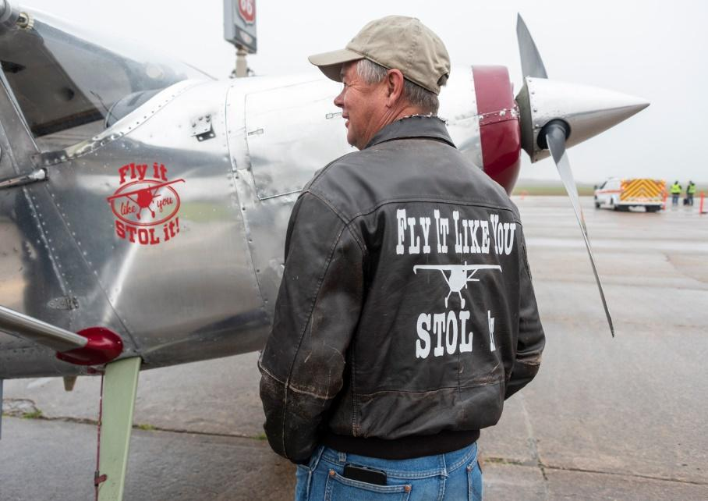
- Mention of your company on our live steam and public address system
- Casual mention of your products and how they work with our event/STOL.
- Mentions on social media with a hashtag
- A logo listing with slogan and link to your website on the Sponsors page
- Vendor Space at the Site, at least 20x10’ (larger spaces available upon request and pending availability)

Bronze and Silver sponsorships are also available at a lesser cost. Please see the chart below for inclusions.
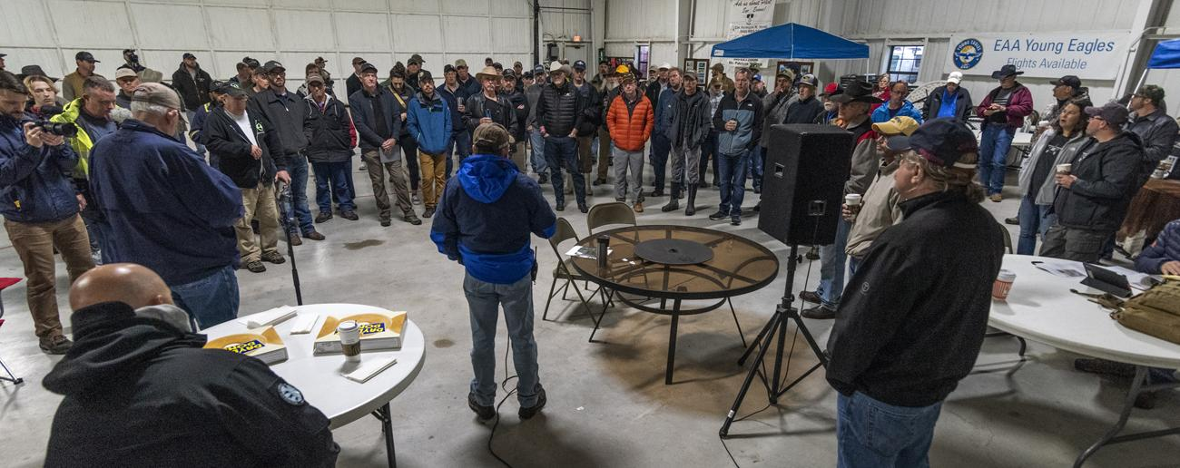

Sponsorship Guide
Level | Bronze | Silver | Gold | Platinum | Diamond | Title
Included in the main logo |  |  |  |  | ✓ (Presented By Tagline) | ✓
Vendor Space | 10x10 | 10x10 | 20x10* | 20x20* | 20x30* | 50x50
Vendor Space Placement |  |  |  | Vendor selected placement | Priority Placement | Priority Placement
Listing On our Website | ✓ | With Image & URL | With Image & URL | Image, URL & Tagline/Motto | Image, URL, & Tagline/Motto | Large Image with URL, Tagline & Motto
Advertisement Banner on our Website |  |  |  |  | ✓ | ✓
Advertisement Banners at the event |  |  | ✓ | ✓ | ✓ | ✓
30 second Commercials Included in the event |  |  |  | 1 | 2 | 2
Mentions during the event livestream |  | ✓ | Company with tagline | Products & company with tagline | Products, company & underwriting | Products, company & underwriting
Mentions during the public address |  |  | Company with tagline | Products & company with tagline | Underwriting | Underwriting
Social Media Posts |  |  | Mentions | Mentions of company & products | Mentions of company, products & Custom Posts | Mentions of company, products & Custom Posts
Sponsorship Cost | $500 | $1,500 | $5,000 | $7,500 | $10,000 | Inquire

Additional sponsorship opportunities available include:
- sponsoring infrastructure (cones or the start/finish line)
- specialty camera angles
- replay
- telematics data
- a competitor banquet or lunch
- trophy presentation
- pilot lounge
- hospitality area
- underwritings
- commercials
- sponsorship banners on the website
- Social media posts
Pilots and their aircraft are welcome to seek their own direct sponsors, much like racing teams. We can help broker these for you with a specific pilot that can represent your company.

Conclusion
The National Short Takeoff and Landing Series is an up and coming aviation event that pits competitors against each other in a battle to take off and land in the shortest distances possible. Pilots use a variety of techniques and styles of aircraft to achieve the shortest distance. Our events attract a large number of participants and spectators to each location across the country. Numerous sponsorship opportunities exist, and sponsors can be creative in their requests.
More information can be found:
National STOL website: nationalstol.com
Lonestar STOL Full Length Live Stream: youtube.com/watch?v=eq8CH43YHsQ
Lonestar STOL Highlights: youtube.com/watch?v=CDrOzPHpEK8

