## horizontal line

Placeholder image

Sponsorship Opportunities

A Journey To Africa

An African Concert of Music and Dance

Presented By:

Lydore Music

2019

# Organization Overview - *Who We Are*

Founded in 2018 by Lydia and Oreoluwa Fawole in New York, Lydore Music Network is an entertainment company that promotes African music and musicians in the western world by staging concerts to feature new and original music and compositions with an emphasis on African cultural and choral music. We are currently gearing up to present the first of its kind, a musical concert tagged **‘A Journey to Africa’** that will take the people of the city of New York through a unique musical journey to Africa. This year, a vast majority of music and dancing will be focusing on Nigeria. Nigeria happens to be a multi-ethnic and linguistically diversified nation with many tribes and cultures as well as languages. There are 520 languages in Nigeria, which are unique and different in every way. We will be exploring a few of their culture and music which will reflect language, dressing, and dancing. In Africa, these cultural traits vary from country to country and from culture to culture, and we aim to present this mesmerizing diversity on the American stages. We are a passionate and experienced African Music concert organizers.

Here is a list of past music concerts we have been involved in. Youtube videos can be viewed at this link :

<https://www.youtube.com/watch?v=G6DcFsj48qg>

<https://www.youtube.com/watch?v=KkDDqQgCDs0>

# Goals - *Why We Do What We Do*

The main goal of Lydore Music is to promote African Music and its composers in the Western World. We believe that African music should continue to have the same recognition around the world as any music from Germany, Italy or any other non-English speaking country. We also want the lost tribe of the African people to enjoy the beauty of African culture through music, drama and dancing, without thinking of the stigma that has been survived through slavery. African Music and Culture is beautiful and unique in every way and everyone, irrespective of where they come from deserves to enjoy and appreciate it.

# About The Concert - *What We Are About To Do*

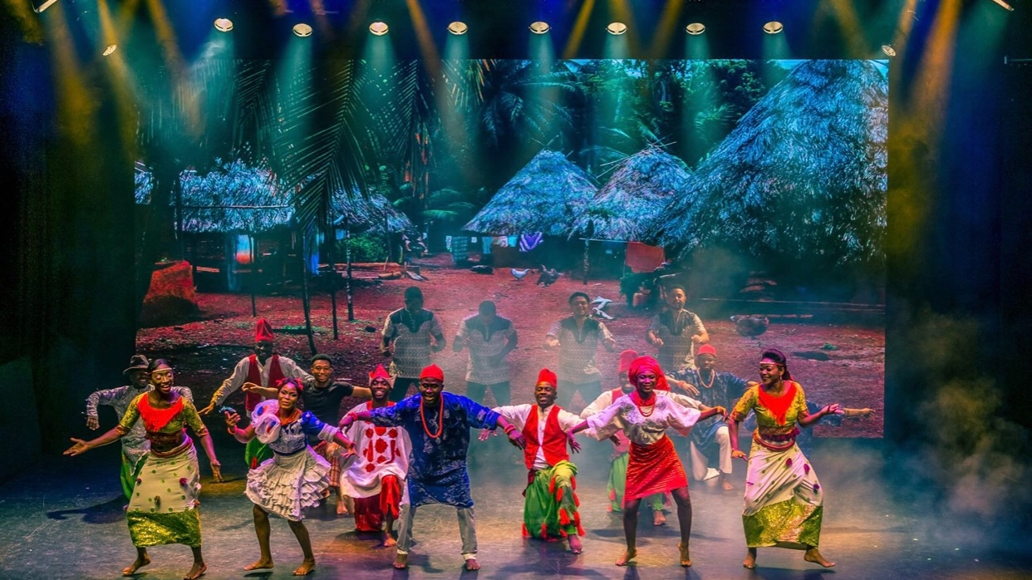

**‘A Journey To Africa’** Music Concert will feature a wonderful, talented 20-30 choral members, supported by excellent professional musicians who will present a set list of beautiful African choral music. A beautiful rendition of cultural music that is bound to move every audience member in soul and spirit. Because there are so many countries in Africa and so many cultures and languages within a country, it will be impossible to perform every African music in a two hour concert. For this reason, our main focus for August 24, 2019 concert will be on Nigerian music. We will be exploring some of the major languages and cultures of Nigeria, which are Hausa, Yoruba, Igbo, Urhobo,Ibibio,Edo,Ijaw, and English.

Our niche target audience of attendees will include lovers of culture and eclectic music, youth, students, seniors, young and old, male and female, a very diverse mix of racial and age demographics. Our goal is to have several African music concerts throughout the year, performing and telling African stories and culture through music, dancing, and drama.

In this proposal, you'll discover the sponsorship opportunities that you can benefit from towards the success of “A Journey To Africa” music event. We would love to partner with you as sponsors/partners to make this concert a success.

**Event Information**  
**Venue**  
JEANNE RIMSKY THEATER  
232 Main St, Port Washington, NY 11050

**Date and Time**  
SATURDAY, AUGUST 24 2019  
6:00 PM — 8:00 PM  
**Expected Guest Attendance**  
425

# Concert Needs - *What We Need Sponsors For*

* Venue & Sound System
* Musicians
* Costumes
* African Percussion Instruments
* Rehearsal space
* Production
* Hospitality, Food, and Beverage
* Advertising and Media, Marketing
* Graphic Design and Printing

# Sponsorship Options - *How You Can Help*

We realize how important our sponsors are to an event's success that is why we have made the options simple and straightforward.

**Cash Sponsorship (Four Levels, see below)**  
Cash Sponsorships help cover the costs of producing the event and translate into more benefits depending on your financial commitment level. However, all sponsors will reach a broad audience of individuals and families who will be at the event to enjoy good music and who love the African culture. Sponsorship levels are $5,000, $2,500, $1,000, and $500 respectively.

**Ad Placement**

You may place a half-sized ad for $ 200 or full page ad for $400 in our concert program that will be distributed to our concert attendees.

We also welcome all in-kind product and Service Related Sponsorships including but not limited to Catering services, Print services, and Promotions etc.

# Sponsorship Benefits - *What You Get*

* Opportunities to promote your business nationally, internationally, regionally, or locally within the United States and Canada
* Product association with quality entertainment programming
* Name recognition with a highly recognizable group of individuals
* Opportunities to create interest in your company’s products & services

***Brand Recognition Deliverables for the four levels of Cash Sponsorship include***

**$5,000 - Continent Level -** *This sponsorship package is great for local businesses who want full-on visibility for their brands*

* Your business signage at the event entrance
* Logos on printed tickets
* Full page Ad Space in Event program
* Name/Business Name Listed on Sponsors Page in Event Program
* Social media mentions
* Access to Email List of Guests
* Shout Out/Mentions from the stage on concert day

**$2,500 - Country Level -** *This package is perfect for businesses or individuals*

* Logos on printed tickets
* Name/Business Name Listed on Sponsor Page in Event Program
* Half Page Ad Space in Event programs/Brochures
* Social media mentions
* Access to Email List of Guests
* Shout Out/Mentions from the stage on concert day

**$1,000 - State Level -** *This package is perfect for small businesses and individuals*

* Quarter Page Ad Space in Event programs/Brochures
* Name/Business Name Listed on Sponsor Page in Event Program
* Social media mentions
* Shout Out/Mentions from the stage on concert day

**$500 - City Level -** *This package is perfect for businesses and individuals passionate about supporting a great event*

* Name/Business Name Listed on Sponsor Page in Event Program
* Social media mentions
* Shout Out/Mentions from the stage on concert day

To become a sponsor for ‘ A Journey To Africa’ , simply choose a sponsorship package and email us at

**Contact Information**

Lydia Fawole**-** 908-444-3913

Oreoluwa Fawole-908-405-1778, Email - [lydoremusicnetwork@gmail.com](mailto:lydoremusicnetwork@gmail.com)

**____________________________________**

**______________________________________**

**______________________________________**

Dear Sir/Ma,

**SPONSOR ‘A JOURNEY TO AFRICA’**

**or**

**ADVERTISE IN OUR EVENT PROGRAM**

Lydore Music Network is a registered US company that promotes African music to the world through events and concerts that will contribute immensely to cultural knowledge and entertainment in the Americas. We are planning our first ever concert taking place on August 24, 2019 from 6pm to 8pm. We invite you to join us and support our efforts by placing an “Ad” in the Concert Program.

We sincerely request your support and look forward to your “Ad” in our concert program which will be distributed to an expected guest of 425 at the JEANNE RIMSKY THEATER in New York. By placing an ad, you will enjoy an excellent opportunity to receive local, national and International exposure as well as the benefit of supporting a well-intentioned cultural community event.   
  
As part of our core ideas to entertain, socialize and network, Lydore Music wishes to introduce the event program that will feature information about the concert and its sponsors to concert attendees that are coming from all walks of life and surrounding states and cities of the USA and Canada.

Please do not hesitate to contact us, we look forward to answering any questions you may have regarding your ad placement/sponsorship and ad specifications. Full page costs $400, half page costs $200.

Please consider becoming a sponsor of this amazing concert. We look forward to partnering with you.

Thank you for your support,

Sincerely,  
  
  
  
Lydia Fawole   
Planning Committee   
A Journey To Africa