4th Annual ARTWORLD

2019 EXECUTIVE SUMMARY

WHAT IS ARTWORLD?
ArtWorld is an outdoor Arts Festival that celebrates all genres of the visual & performing arts. The event features live entertainment, family-friendly attractions, retail & food vendors, family resource booths, and a silent auction “Art Walk”.

WHEN & WHERE
Sunday July 28, 2019 >> 1pm - 8pm >> Lancaster American Heroes Park

MISSION & OBJECTIVE
MISSION:
ArtWorld is a festival designed to ignite creativity in the community, by collectively celebrating our culture through the visual and performing arts.

OBJECTIVE:
ArtWorld proceeds will serve as a fundraiser for a Community Arts Center expansion, and for an AV Young Adult Arts Scholarship Fund.

HOW DOES ARTWORLD BENEFIT THE AV?
ArtWorld provides family-friendly entertainment, promotes community partnerships, and attracts AV & Los Angeles area visitors and pedestrian traffic to nearby BLVD businesses. ArtWorld provides a platform for our AV youth to express themselves in a positive & creative manner.

WHO WE ARE
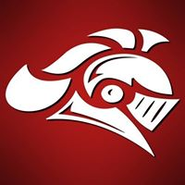
Renaissance: A Creative Arts Movement
Renaissance is a creative arts movement powered by three engines:
Renaissance Church, Renaissance Arts Center, and Renaissance Entertainment.
Our mission is to tear down religious and secular walls by igniting an artistic resurgence in the Body of Christ (B.O.C) that will liberate the community and the entertainment industry, reestablishing the B.O.C. as the dominating culture in artistic expression, so that she may obtain the influence needed to draw the lost to the light.

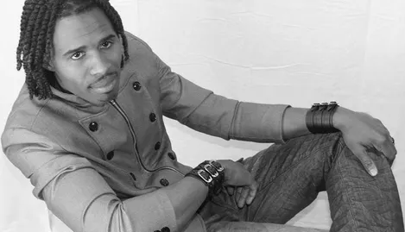
ArtWorld Creator: Pastor John "Revelator" Irving
John "Revelator" is the Senior Pastor, founder & owner of Renaissance: A Creative Arts Movement (Renaissance Church, Renaissance Arts Center, & Renaissance Entertainment). Born and raised in Houston, Texas, John lives with his wife of 16 years, and four children in Lancaster, CA.
John has an extensive education, including his Bachelor of Fine Arts in Acting from the prestigious California Institute of the Arts, and his MA degree in Practical Theology from Advantage College. He is a talented actor, gifted author & playwright, and brilliant director. He wrote, directed, and erected an original LPAC play in 2016. He also has an accompanying book on the way.
John adores teaching and mentoring young adults. He taught with LACOE for 8 years, with most of those years at Challenger Probation Camp in Lancaster, CA. His class received a high award at the 2010 Los Angeles Academic Bowl, and John received the LACOE Probation Teacher of the Year award. He continues to work as a Community Partner with school districts such as LACOE, EUSD, and PSD. He has assisted in several LACOE events and projects -- including RTSA Project-based learning curriculum enhancement, and LA County Probation via behavioral therapy art courses.
John stays incredibly active as a role model in his community. As a degreed Public Speaker, Teacher, Business Owner, Artist, Husband and Father, youth from all over the Antelope Valley flock to him for mentorship.

Renaissance Production Team
Renaissance staff represent over 20 years of experience in the Entertainment, Educational, Ministerial & Vocational Industries. We have serviced LACOE probation camps since 2012, and have coordinated dozen of entertainment events & mini-tours. We are proud to be Alumni from the following schools:

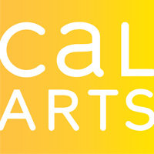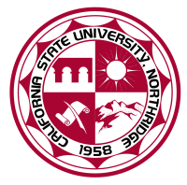
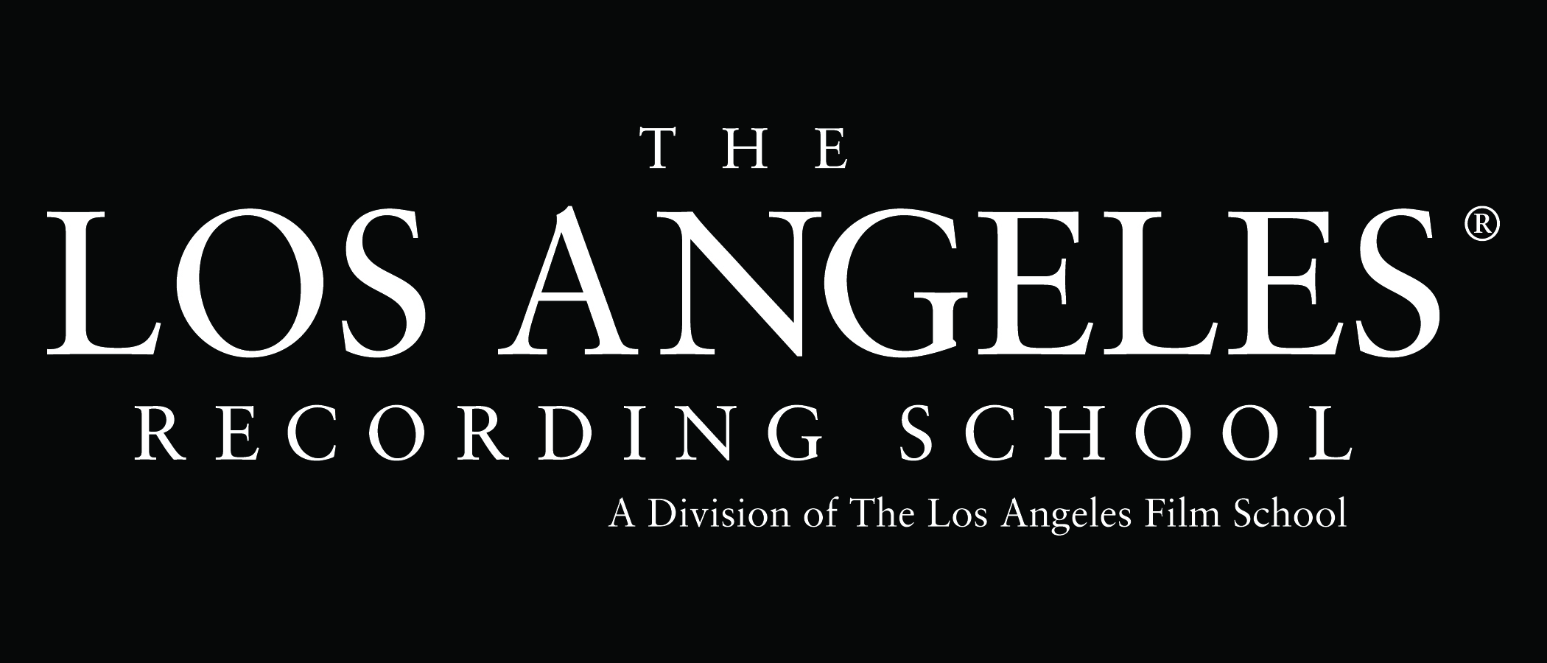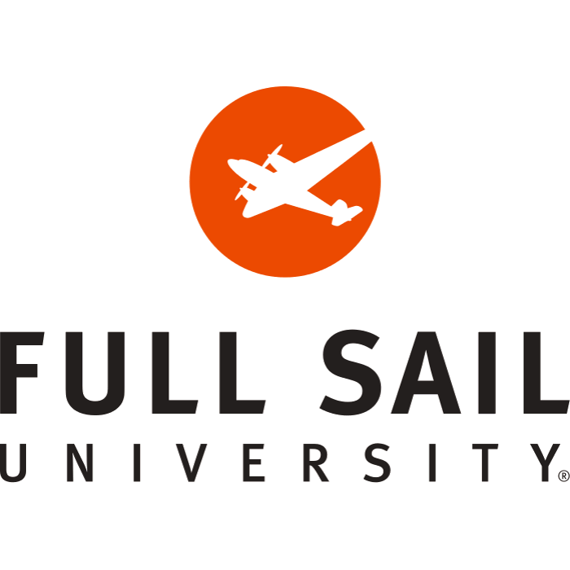

ARTWORLD HISTORY & SUCCESSES
This year’s event will be our 3rd Annual ArtWorld Festival. We have seen our event grow from 200 attendees in 2016, to 600 in 2017, to 1000 in 2018 - and we anticipate this year will be even greater! We hosted ArtWorld for the first 2 years on the newly renovated Lancaster Blvd - shutting down the BLVD from Date to Cedar street, directly in front of our offices at 606 W. Lancaster Blvd. It has always been on 4th of July weekend, while most AV families are looking for family entertainment, and the event has attracted many artists, families, & locals. We want to move our event to American Heroes Park to encourage continued growth, but also, to transition the event into a gated/ticketed event.

SPONSORS & PARTNERS
Each year we have received the support of these major sponsors: Kids Charities (GraceFest), Grace Chapel, Bishop Henry Hearns, Mayor R. Rex Parris, Deputy Mayor Darrell Dorris, Harley Davidson, First 5 LA, Best Start Community Partnership, Los Angeles County Office of Education, UAV, and AVPH. Additional supporters and participants this year: Life Church, Living Faith Cathedral, Living Stone Cathedral of Worship, Communities for Christ, and over a dozen more local faith-based organizations.

EVENT REQUIREMENTS
ArtWorld will require the use of the majority of the softball area and field at American Heroes Park. The reason we are choosing this venue is because of the gated features of the park. In the past, we have not been able to create a ticketed event due to a non-gated venue. In order to monetize our event this year, we must create a gated atmosphere. We will have a full production team (including several production rentals like a large stage & outdoor sound), which means that we will need access to electricity and side-gate passage for load-in/break-down. We also have family attractions and vendors that will require a water hook-up. Chairs, tables, trash cans, and vendor tents will be utilized. Renaissance will provide our own insurance, and also make sure that the entire event and all vendors are properly permitted. We are looking forward to meeting and partnering with the City of Lancaster to work out logistics and ensure a smooth event.

MARKETING & TICKETING
We will market ArtWorld to our target audience of families, artists, community partners, and faith-based organizations. We will advertise via social media platforms, Citywide printed promotions, posters, and flyers.
ArtWorld will manage ticket sales through physical ticketing, an on-site ticket booth, and a website. Ticket prices will remain affordable for a fun-filled family day out:

Adult (Age 18+) | $20
Youth (Age 11-17) | $10
Children (Age 10 & below) | FREE

