**SPONSORSHIP PROPOSAL**

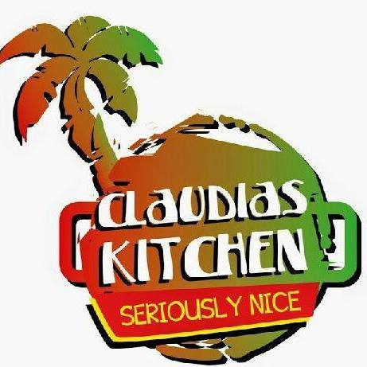

[**http://www.claudiaskitchenuk.co.uk**](http://www.claudiaskitchenuk.co.uk)

[**http://www.claudiayapevents.co.uk**](http://www.claudiayapevents.co.uk)

**2 NIGHT SUMMER CARIBBEAN WEEKENDER**

**GRAND PIER, WESTON SUPER MARE**

**Prepared by Claudia Yap**

Claudia Yap Director of Claudias Kitchen UK, and Claudia Yap Events Birmingham based , are hosting a 2 night Caribbean Weekender at one of the UK’s most famous seaside resort of the Grand Pier.

Claudia Yap has partnered with the Grand Pier to host this exciting weekender at the seaside of coast of Western Super Mare. This is our first event and the event is advertised on a number of social media platforms . The Caribbean Weekender is being hosted in the Regency Suite of the Pier and can hosts up to 350 people.

The tickets are currently sold at £20.00 including Caribbean Buffet, or £10.00 without buffet on our official ticket outlet <http://www.tickettailor.com> The Grand Pier has full alcohol license, and has the acquired risk assessments, public liability. Our aim is to host the Caribbean Weekender with a inclusion of offering Rum Tastings and Cocktails as a twice yearly event.

The Pier has full alcohol license, and has the acquired risk assessments, public liability. Our aim is to host the Caribbean Weekender with a inclusion of offering Rum Tastings and Cocktails as a twice yearly event

Claudia Yap has extensive experience in the entertainment industry and has hosted events in the UK and Jamaica and was the adopted daughter of the late Laurel Aitken a Jamaican reggae and ska artistes whom had hits in the 50’s and hits in the UK. Claudia has grown up in the music industry since the age of 5 years and met several artistes and bands whom her late father was part of,

**Achievements**

Awarded Business Award for Business Enterprise

Food Producer & Distributor of Claudias Kitchen Mr Jamaican Jerk Pork Crackling

Claudia Yap’s is a trained Chef and was Lead Chef at London Olympic 2012 in the Caribbean section. She has a wealth of experience including events managements, branding and PR

**The Grand Pier** 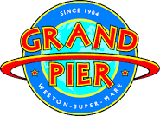

**http://www.grandpier.co.uk**

The Caribbean Weekender is currently housed in the Regency Suite and is the ultimate 21st Century indoor theme park. balcony with panoramic views The Regency bar has fully accessible disabled indoor theme park.

We are open every day, except Christmas Day, so come hail, rain or shine, you’ll always get a warm welcome here at the Grand Pier. Whatever the weather is doing outside, it’s still fun, fun, fun on the inside.

We offer our visitors some world-class rides and attractions and fun for all the family.

There is something here for everyone, young and old alike – from the arcade machines to thrilling rides, or a relaxing traditional afternoon tea in our exquisite Edwardian-style tea rooms.

The Pier boasts function rooms, Wedding venues, state-of-the-art conferencing facilities, entertainment and event sp

Investment considerations

* **There is no other festival Caribbean Weekender & Rum Festival**
* **Claudia Yap Events brings together a wide variety of musical genres and with it a unique audience that is drawn from many music tastes**
* **Claudia Yap has the ability to reach out to audiences that don't normally attend festivals**

**Demand**

* **The number of people attending festivals has reduced significantly over the last two years because of the additional costs associated with travelling to and from out of town events. Claudia Yap Events offers the opportunity to attend a musically well-respected festival without having to incur the costs of attending out of town festivals.**
* **There is no other Midlands based festival celebrating the cultural diversity in the seaside town of Weston Super Mare**
* **The musical diversity will attract people from many different music audiences.**

Location

* **Grand Pier, Weston Super Mare is a popular Theme Park in the seaside town of Somerset.**
* **The Regency Suite is a newly refurbished bar with staging and brilliant wooden dance floor**
* **There is a onsite Amusement Park and gaming facilities.**
* **The venue is easily accessible by car and public transport**
* **Attractive surrounds with amazing views of beach**

**Experienced Management**

* **Management team with extensive knowledge of the relevant areas of the music industry**
* **Management experience of promoting and delivering underground musical events**

**Market Research**

**After doing a poll survey and the instrumental of ticket sales currently generated, our demographics target market shows there is a demand in the areas with strong sales from Bristol, Cardiff, Newport, and the Midlands**

**Our sponsored survey from various social media platforms suggests the ages of 18 - 60 years of age we have found the following results:**

* **62.5% had attended a festival in last 12 months**
* **75% use the social media platform Facebook**
* **50% use the social media platform Twitter**
* **On average people are willing to pay £20.00 for a one day ticket**
* **On average people are willing to pay £45.00 for a two day ticket**
* **On average people would plan to spend £25.00 on drinks at the bar**

Other outcomes reflected a genuine interest in the idea of a 2-day festival this included offering a Caribbean Buffet where strong ticket sales states that it was value for money. A very small amount suggested just tickets entry to the door without buffet.

**Marketing and PR Plan/2016/17**

Once the strategy has been agreed the marketing plan needs to cover  
some but not all types of promotion listed below:

* National Press
* Music Press
* Life Style media
* Music Listings
* Ethnic media
* Regional media
* Social media
* Online campaign
  + Major listing websites
  + Twitter
  + Facebook
  + Website database and newsletters
  + E-Flyers
  + Exclusive content (free downloads, interviews etc.).
* Online competitions
* Work on joint promotions with sponsors
* Work with artists to tap into their fan bases
* Advertising
  + Facebook
  + Google
  + Ad banners on relevant websites

Street team

* + Flyers
  + Posters
  + Stickers/Radio

**PARTNERSHIP & BENEFITS**

**Pre Events – Grand Pier Weston Super Mare 12 & 13 August 2016**

**Promotion**

* **Company name & Logo on Website**
* **Sponsor Page Advertisement on website**
* **Posts on Social Media (facebook, all social media platforms eg the Pier has 33,000 likes**
* **Logo on inclusion on posters**
* **Radio Mentions**
* **Onsite promotion**
* **Your banner advertising**
* **Stage Announcements by DJ’s**
* **Sponsored activity**
* **Twitter mentions**
* **Dedicated area for advertising rum tastings and a percentage of ticket sales for rum festival.**

**Partners**

**Grand Pier, Weston Super Mare**

**Pontins Sand Bay, Weston Super Mare**

**Western Mercury Post Weston Super Mare**

**Wowchers**

**Groupon**

We are looking for sponsorship in the following area: radio, dj’s/bands/artistes posters, and other areas of assistance where the sponsor feels they can make a contribution.