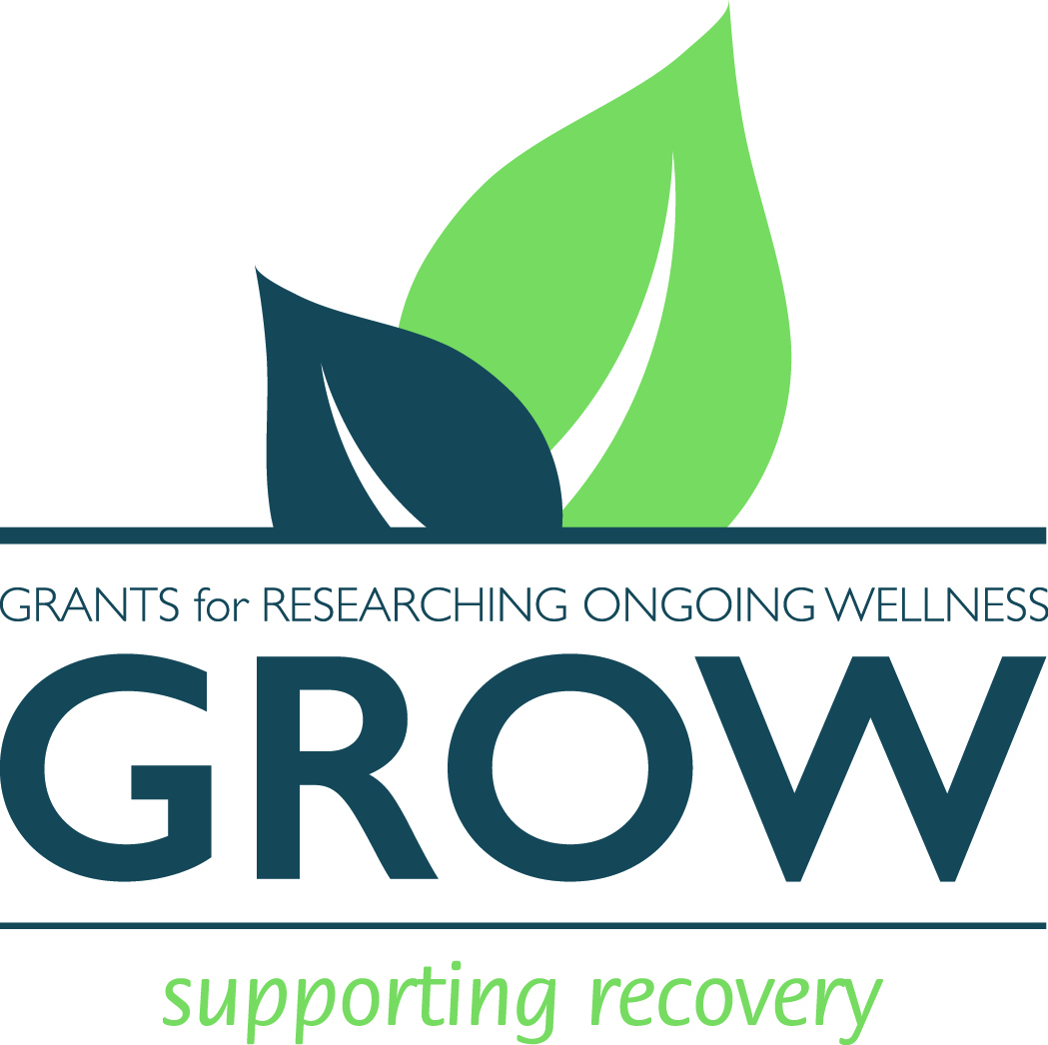
GROW Foundation
Grants for Researching Ongoing Wellness
729 Orchard Ln
Franklin Lakes, NJ 07417

Brief:
GROW Together Launch Event
My name is Aaron Mandelbaum. I am a serial entrepreneur, award-winning business plan writer, and recovering addict. The GROW Foundation 501(c)(3) came about after successfully raising funds for charity 5 years ago while celebrating having 15 years in recovery.
This event will be the official, public launch of the GROW Foundation (Grants for Researching Ongoing Wellness). We have secured a world-class venue (Webster Hall), an amazing musical act (http://www.brotherjoscephus.com/)
and an MC with over 500,000 social media followers/ contacts (jeffreymarsh.com).
Our goal is to raise over $50,000 and begin planning the next event. We have already received requests for grants from us and our team is reviewing them now.

Full Story:
In January of 1997 the DEA finally had enough evidence to arrest me. 6 months of phone taps, surveillance, and informant intel culminated with my face on the hood of a car, gun to my head, surrounded by 15 unmarked cars protecting 30 or so agents with shotguns and pistols aimed in my direction. I watched my 15 year old sister get arrested, shotgun to her back, as they cuffed me. This was supposed to be a quick deal on my way to visit my mother in the hospital. Instead, my father was called to bail his children out while at his wife's bedside watching her recover from a collapsed lung she suffered earlier the same day.

In the 20 years since that event I have completed two degrees including an MBA in strategic management, won an international business plan competition, built and sold multiple companies, and traveled the world. All without drugs. My path to recovery began with a rehab facility and 12-step work to impress the judge. What really kept me out of trouble was the new connections I made. People my age with similar interests who were having fun (more fun than I thought I was having) and who remembered it all.

These connections have lasted all these years and grown to friends, colleagues, teachers, and sources of inspiration across the world. Since I started on this journey, many new forms, methods, and best practices have been uncovered and furthered by experts in the field. Advances in technology, psychology, and communication have allowed for many to help many. Both in person and long-distance healing is available now thanks to the tireless curiosity, research, and experimentation of people across the world.

In 2012, I hosted a party to celebrate having 15 years clean. We raffled off some donated items and raised over $5,000 for an NGO working on addiction prevention and treatment. Since then, addiction and drug abuse has grown across the world. In planning a party to celebrate 20 years clean I realized we had an opportunity to beat that contribution and committed to raise $50,000. This amount can certainly help an NGO and they would be grateful. My research of a viable recipient showed I could help more people with many small donations vs one large one. Thus, The GROW Foundation was born. We will continuously be raising funds and vetting NGOs to determine their value and use of funds. As technology and treatment options continue to change we will stay up to date and ensure our impact is palpable.

Our journey will begin on April 8th, 2017 at the famous Webster Hall in NYC.
GROW Together Launch Event

Fundriasing Goal- $50,000+
MC- Jeffrey Marsh (http://www.jeffreymarsh.com/)
Opening Band- Rick Sorkin (https://open.spotify.com/artist/5UR9UIUNU0rm90WaLiJY9f)
Headliner – Brother Josscephus and the Love Revolution (http://www.brotherjoscephus.com/)
Venue- Webster Hall (websterhall.com)

