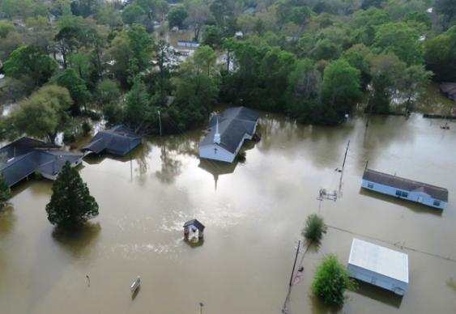
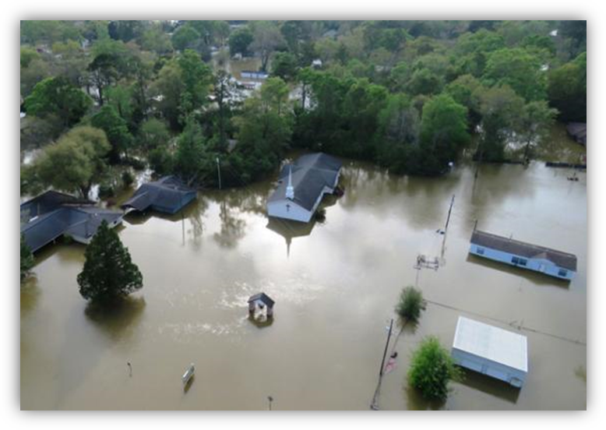
The Tohubohu Project Sponsorship request 2016

“Nine-in-10 global consumers have a more favorable impression of a company after learning of its disaster recovery efforts.”
-Cone Communications

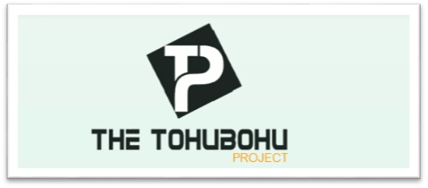

About the Tohubohu Project
Texas Disaster Recovery and Relief of Dallas TX will host its first crowdfunding campaign, formally named “The Tohubohu Project”, to raise funds in an effort to help needy families devasted by recent floods, tornadoes, forest fires, and major disaster worldwide.
The organizations assist families, individuals, businesses, religious groups and organizations affected by recent disasters. The organization is founded and directed by a team of disaster managers, experts, certified counselors, and licensed insurance professionals with over 30 years of combined experience.
The Tohubohu Project and its principles help those impacted by disaster recover by offering support and assistance in the following ways:
- The purchase and installation of storm shelters for homes in tornado prone regions
- Relocation, temporary housing & home repairs
- Re-employment, counseling, housing modification-flood proofing

These services help to give hope and some sense of unequivocal assurance that is definitive to a successful outcome in times of uncertainty.
Proactively, the group helps with preparedness and community outreach events, symposium and workshops offering survival information guides, kits and resources.
Our Sponsorship Funding Objective
In an effort to counter the cost associated with a crowdfunding campaign and to create a platform for sponsor and funder branding across spectrums, “The Tohubohu Project” is looking to corporate sponsors to close the gap on campaign development, as well as help fund the mission which ultimately funds the necessary work being performed on a daily basis.

Target Market Demographics
Global demographic trends suggest that more people are living in areas vulnerable to sudden-onset natural disasters even as scientists predict that the frequency and intensity of these disasters are likely to increase as a result of the effects of climate change. These trends, coupled with recent high-profile mega-disasters create a growing need for disaster relief and recovery. (Trends in Natural Disaster Response and the Role of Regional Organizations, 2013)
According to the 2013 Cone Communications Disaster Relief Trend Tracker, nearly nine-in-10 global consumers believe companies must play a role in natural disaster response – in part because the majority (69%) thinks corporations are better able to effectively respond.
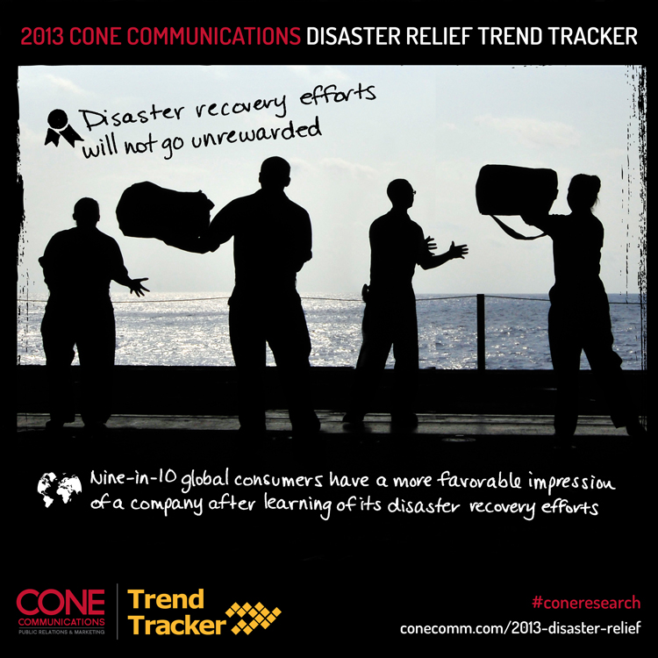
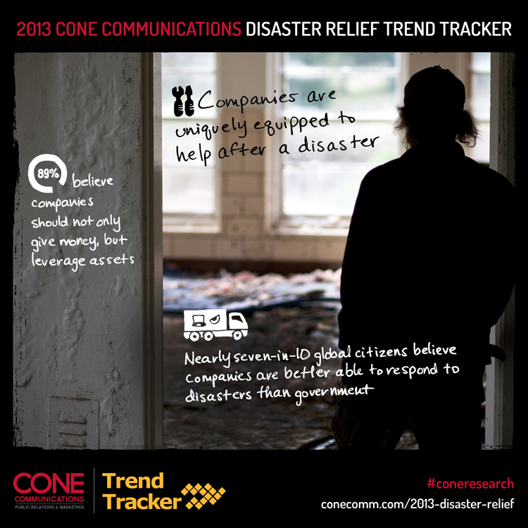
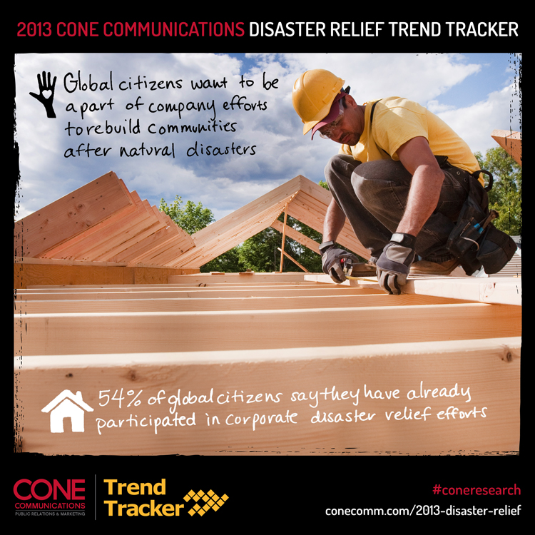

Sponsorship Opportunities
We would like to ask that you consider becoming one of our 2016 sponsors. The Tohubohu Project sponsors benefit from robust social media engagement with a segmented audience, target market engagement opportunities, through robust public relations channels including print, TV, radio & blogs & exposure to disaster victims post trauma as they are looking for vendors to help rebuild their lives.
What follows are sponsorship levels in which your company can engage, taking advantage of visibility in an impactful segment of the industry, strong consumer base and corresponding target audience.

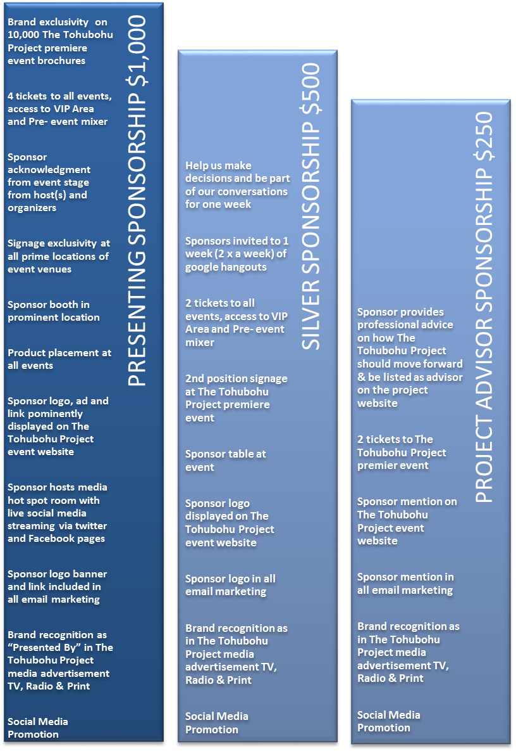
Benefits to Sponsorship
Partnering with The Tohubohu Project on sponsorship provides a number of benefits including the following:
- Access to a captive target audience matching that of your company
- Access to segmented TV and newspaper
- Positioning your organization as a staunch state and community supporter
- Infusing your company’s branding across multiple mediums including event signage, web, social media and print
- Supporting the relief efforts with meaningful education
- A sense of making America better

Sponsorship opportunities are limited, with category exclusivity. With that, please contact C. Noami Covington, Founder at Info@disasterrelieftexas.org to further discuss.

Works Cited
Trends in Natural Disaster Response and the Role of Regional Organizations. (2013, April 22). Retrieved from Brookings: http://www.brookings.edu/events/2013/04/22-natural-disaster-trends

