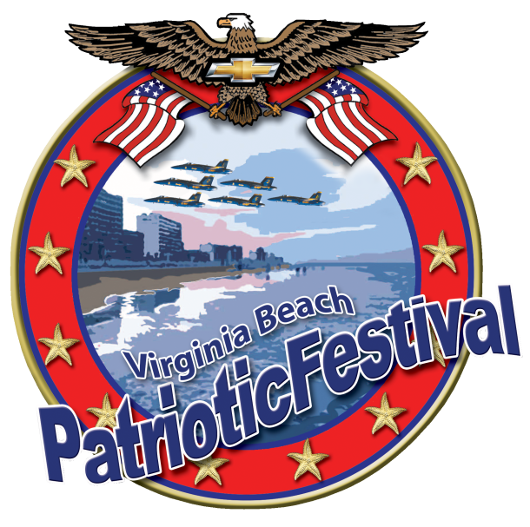

PATRIOTIC FESTIVAL A 501C3 NON-PROFIT ORG.

The City of Virginia Beach is proud to host the Patriotic Festival for the 14th consecutive year. The Annual Patriotic Festival celebrates our military at The Virginia Beach Oceanfront for three days full of activities including National Concerts, Military Zone, Mobile Tour Displays and Performances.

Hampton Roads, Virginia is home of the largest concentrations of military bases in the United States, Virginia Beach is the largest resort city on the east coast and Parade magazine listed Virginia Beach as the #1 most patriotic city in America!

We would like you to be a part of this weekend to salute our troops, serving now and in the past. Remember the men and women of the United States Military and Armed Forces for their heroism and the sacrifices they make for Americans.

America’s most popular Artists & Air Show Performers have performed at the Patriotic Festival, such as Sam Hunt, Jason Aldean, Zac Brown Band, Miranda Lambert, Rascal Flatts, Carrie Underwood, Darius Rucker, Beach Boys, Michael McDonald, Huey Lewis & The News, Daryl Hall & John Oates, Little Big Town, Justin Moore, Jake Owen, Alabama, Lynyrd Skynyrd, Lee Brice, Chris Young, Old Dominion and US Navy Blue Angels Jet Squadron, US Air Force F22 Raptor,

The Patriotic Festival is the largest regional Military Celebration and is the City of Virginia Beach’s primary event of the summer season attracting over 100,000 visitors to Va Beach Oceanfront. You may view Patriotic Festival history by visiting wwwPatrioticFestival.com .

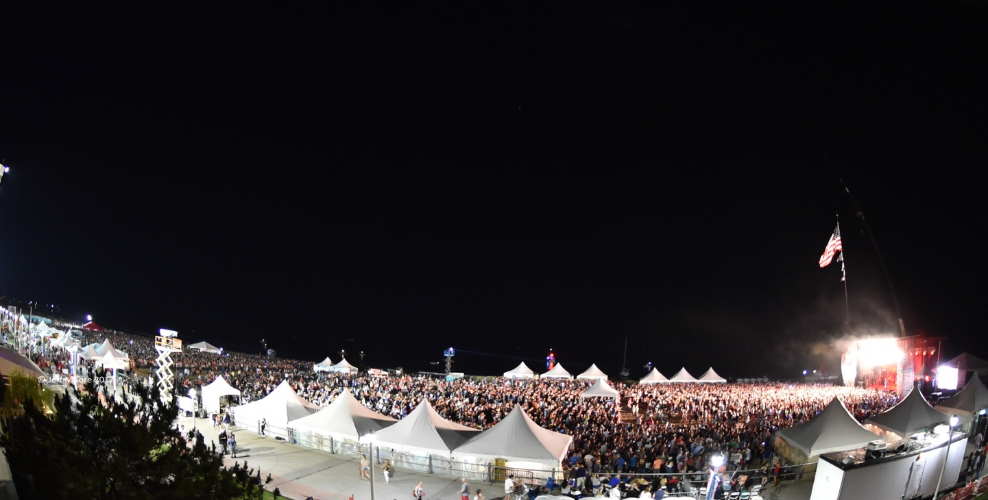
Concert Site: Oceanfront 5th- 7th Street

PATRIOTIC FESTIVAL CONCERTS:

Friday, June 1 - Saturday, June 2 - Sunday, June 3, 2018

The PATRIOTIC FESTIVAL features three concerts Friday, Saturday & Sunday at Fifth Street / Oceanfront on the beach, a VIP reserved close up section with private Corporate Chalets, VIP Seating / VIP Pit- front of stage (standing) zone and Corporate Sponsor Boardwalk Display Zone. ( site map page 5 )

CONCERT SCHEDULE:

FRIDAY, JUNE 1 BRETT ELDREDGE

SATURDAY, JUNE 2 BRANTLEY GILBERT

SUNDAY, JUNE 3 COLE SWINDELL

I. RESPONSIBILITIES CONCERT ZONE:

Patriotic Festival agrees to provide the following benefits to Partnering company at the MILITARY ZONE
Friday JUNE 1 - Sunday JUNE 3, 2018 (3 days).

1. DISPLAY SPACE: primary space on boardwalk 5-7th Street for on site promotion: hand out of branded items & to acquire lead data.
2. CHALET TICKETS TO WHISPER CONCERTS CORPORATE CHALET: 10 tickets to Private Chalet 5th & Oceanfront on the Beach Show Center Zone, up close elevated viewing, carpeted deck, a peak canopy with food & beverage served. (total 30 tickets)

3. VIP TICKETS CONCERT ZONE: 20 Tickets to show center Zone on the beach in a Reserved section in front of the stage. (total of 60 tickets).

4. BANNER PLACEMENT: Corporate banner displayed at exhibit location.

5.STAGE MENTIONS: two live mentions as corporate sponsor prior to the headlining artist performance by emcee at all three concerts 5:00 pm - 8:30 pm.

6. CORPORATE COMMERCIAL OR LOGO: minimum of 20 played commercial or logo displayed on two large 9 X 15 LED stage video screens during the afternoon and prior to headlining Artist between 12:00 noon - 8:30 pm

7. CORPORATE LOGO: to appear on Patriotic Festival website with link to sponsor website.

8. RADIO MENTIONS: as sponsor on recorded commercials to air in Hampton Roads / Richmond/ Outer Banks NC area WUSH, WNOB-WAFX, WNOR, WCMS, WCXL, WKHK,WGH .

9 MILITARY CONCERT SERIES: provide benefits for one (1) 2018 Military Concert including display space – VIP tickets – Chalet tickets stage mentions – logo on website – radio ID .

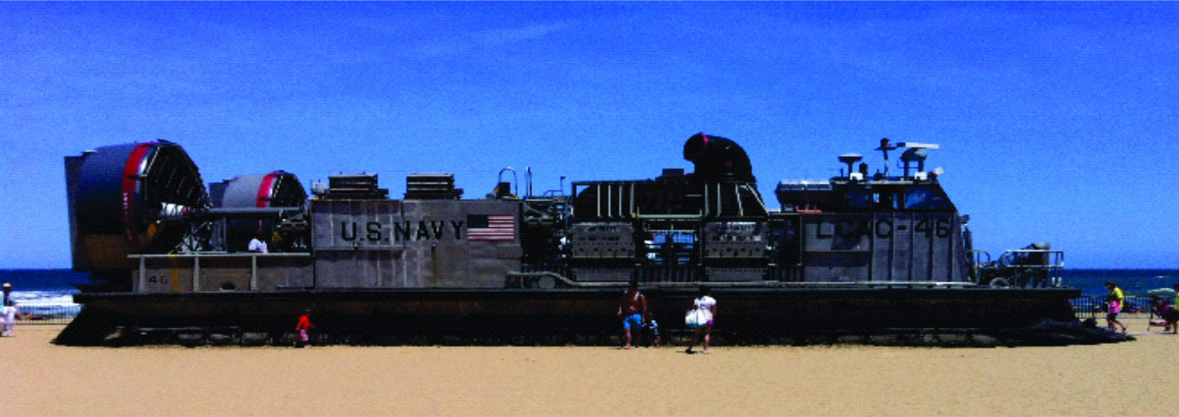
MILITARY EXPO VILLAGE AT 17th STREET, VA BEACH - LCAC

PATRIOTIC FESTIVAL / USO MILITARY ZONE:

Friday, June 1 - Saturday, June 2 - Sunday, June 3, 2018

The Military Zone will showcase the Mission, Equipment and personnel of the Military through exhibits, demonstrations and displays on Friday, Saturday & Sunday 13th – 20th Street with. All branches of the military, Army, Navy, Air Force, Marines & Coast Guard will be participating.

The Military Zone: Features LCAC (landing craft air cushion)
Military Vehicles, Monster Energy Freestyle MX Tour, UDT Seal Team Ultimate Challenge, Air Force Performance Mobile Tour , Ride 2 Recovery Memorial Challenge, US Marine Corp Mobile Tour, US Marine Silent Drill Team, USO Show Troupe,Chevrolet Vehicle Tour visit: http://www.patrioticfestival.com/happenings/

IV. Partnering company agrees to provide the following Sponsorship to The Patriotic Festival II :
Partnering company Agrees to Pay Fifteen Thousand Dollars, ($15,000.00) sponsorship fee for Patriotic Festival, payable to Patriotic Festival by February 1, 2018.

Entire Agreement

This agreement contains the entire understanding between the parties hereto relating to the subject matter contained herein and supersedes any and all prior agreements, arrangements, or representation whether oral or written. This agreement may not be amended, altered, modified or changed except by a written amendment signed by both parties hereto.

Please sign & return Sponsorship Agreement to Whisper Concerts Inc - 3212 Stapleford Chase, Virginia Beach, VA 23452 - Fax 757 486 7177 – or scan & email by January 15,2018

FOR: PATRIOTIC FESTIVAL INC FOR : Partnering Company

BY: WHISPER CONCERTS INC. BY:

X _______________________________________ X_____________________________________
DATE:

CONCERT ZONE:
