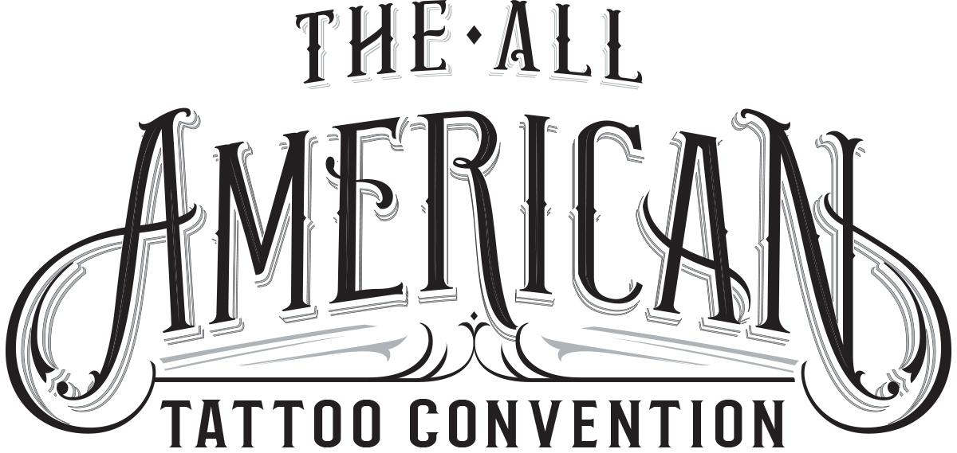
The All American Tattoo Convention
2712 Skye Dr Fayetteville NC 28303
910-850-2566
www.allamericantattooconvention.com

For Immediate Release
For more information contact:

William Ryan Harrell
910-494-8878
ryan@allamericantattooconvention.com

All American Tattoo Convention Is Coming To Fayetteville NC!
For the first time ever a large scale tattoo convention will be held in Fayetteville

Fayetteville, NC (June 6, 2016) - The All American Tattoo Convention, will be held April 14th-16th 2017 at the Crown Exposition Center. This convention will feature world famous & local tattoo artists aimed at showing their appreciation for our nation's military.

The All American Tattoo Convention can confirm Spike TV personalities Joey Tattoo from Tattoo Rescue, Madison Loftis from Ink Master Season 3, and Kristel Oreto who was Selected by Rebel Ink Magazine as one of the "20 most wanted" tattoo artists will be in attendance. Spike TV’s Half Pint Brawlers will also be performing a show Friday & Saturday nights. More nationally recognized tattoo artists and TV personalities have agreed to come and will be announced as final agreements have been reached.

The convention will have live tattooing by all of the 120+ tattoo artists, a pin-up beauty contest, a burlesque show, tattoo contests and live music. On Sunday there will be an Easter egg hunt and the Fayetteville Rogue Rollergirls will perform a noodle race & meet & greet for the kids.

Leading up to and during the event the event's organizers will be raising money for local organizations that help soldiers with PTSD and their families. These organizations will be announced later as the agreements have been finalized.

The All American Tattoo Convention is being promoted by William Ryan Harrell of Creative Champion in conjunction with Veteran Tattoo Artist Robert “Chop” Francis of Chop Shop Tattoos. Both men have been in business in Fayetteville for 10+ years.

Booth information, sponsorship opportunities, volunteer information and additional contact information can be found at www.allamericantattooconvention.com or contact Ryan Harrell at 910-850-2566.

###

