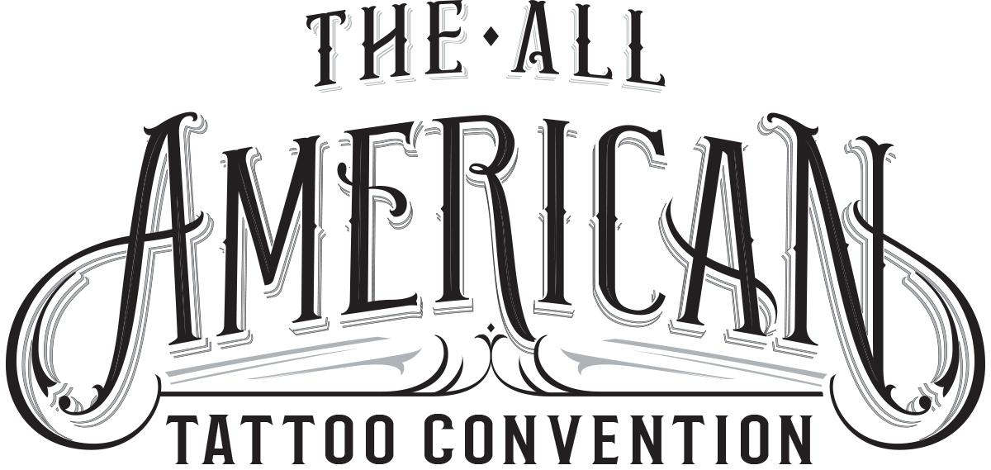
The All American Tattoo Convention
2712 Skye Dr Fayetteville NC 28303
910-850-2566
www.allamericantattooconvention.com

For Immediate Release
For more information contact:

William Ryan Harrell
910-494-8878
ryan@allamericantattooconvention.com

Operation Tattooing Freedom To Benefit From All American Tattoo Convention
Helping soldiers with PTSD through tattooing has been their #1 priority.

Fayetteville, NC (June 10, 2016) - One of the purposes of the upcoming All American Tattoo Convention is to raise awareness and money for soldiers suffering from PTSD. Through the non-profit Operation Tattooing Freedom the All American Tattoo Convention hopes to help ease the issues of PTSD through tattoo therapy.

“Tattoos have been used for medicinal purposes for centuries. People find closure, a new beginning, a paradigm shift and want to memorialize that on their bodies.” says Dr. Gabe Crenshaw Ph.D. “We hope to use this to help veterans heal the scars of war.” says Lewis Hunt a US Navy Veteran and founder of Operation Tattooing Freedom. Lewis founded Operation Tattooing Freedom after a long tattoo session after which he says he felt a weight had been lifted off his shoulders. After research he discovered the benefits of tattooing and relieving some effects of PTSD.

Operation Tattooing Freedom and the All American Tattoo Convention will be raffling off a custom built AR-15 leading up to the convention in April to raise money to help more veterans participate in the program.

The All American Tattoo Convention is being promoted by William Ryan Harrell of Creative Champion in conjunction with Veteran Tattoo Artist Robert “Chop” Francis of Chop Shop Tattoos. Both men have been in business in Fayetteville for 10+ years.

Leading up to and during the event the event's organizers will be raising money for local organizations that help soldiers with PTSD and their families. These organizations will be announced later as the agreements have been finalized.

Booth information, sponsorship opportunities, volunteer information and additional contact information can be found at www.allamericantattooconvention.com or contact Ryan Harrell at 910-850-2566.

###

