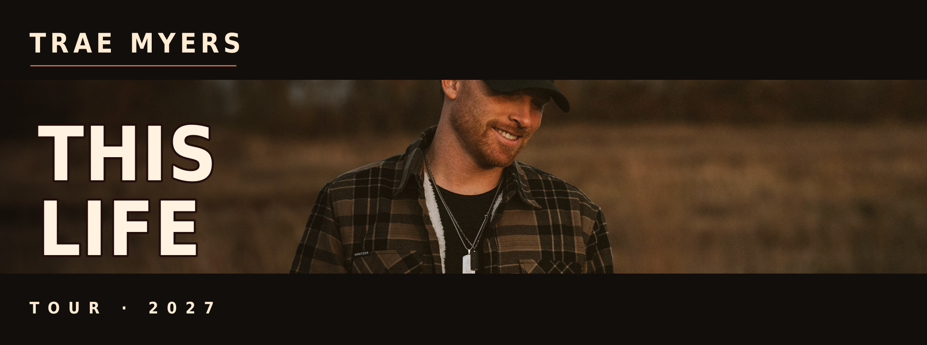
SPONSORSHIP PROSPECTUS
Presented by The Distance Agency

What Is This About
The This Life Tour is a 21-day run by country/rock artist Trae Myers, taking his band from Columbus, Ohio down through Kentucky, Tennessee, Georgia, and Florida and back, with 21 full band shows and 9 acoustic daytime sets along the way. The tour is a celebration of what the title says, the love and grind of building a life around music, family, and the people who make it worth doing, timed right as Trae heads into marriage and continues raising his daughters.
Across the full run, the tour reaches an estimated 5,000 live attendees, plus Trae's existing following of over 30,000 on Instagram and almost 8,000 monthly Spotify listeners, giving sponsors real face time with a built-in country/Americana audience alongside consistent digital visibility throughout the tour. Sponsors get logo placement across tour marketing and signage, social content throughout the run, and for top-tier partners, on-stage product visibility and food/drink partnerships at venues along the way.

About Trae Myers
Trae Myers is a country/rock artist who gained strong attention with his single "Bad," which resonated widely with listeners and became a standout release in his catalog. He has opened for and shared the stage with artists including Kane Brown, Chase Rice, Russell Dickerson, Kip Moore, and Chris Young, continuing to build momentum through live performances and new releases. Trae delivers high-energy, emotionally driven performances that connect instantly with audiences, performing both solo acoustic and full band sets that adapt seamlessly to intimate venues, festivals, and high-energy stages. Known for strong stage presence and relatable songwriting, he creates a memorable live experience from start to finish. Offstage, Trae is preparing to get married and is a devoted father to his daughters, the people he points to as the reason behind everything he does, themes that sit at the center of The This Life Tour itself. That mix of grit and heart is what fans connect with, and what makes this tour a natural fit for brands that want to be part of a genuine, growing story rather than just a logo placement.

Tour Snapshot
Detail | Info
Tour dates | March 1 - March 21, 2027
Route | Columbus OH -> KY -> TN -> GA -> FL -> back through GA/NC/WV/OH to Columbus
Total shows | 30 (21 full band night shows + 9 acoustic daytime sets)
Estimated live attendance | ~5,000 across the tour
Instagram following | Over 30,000
Spotify monthly listeners | Almost 8,000
All dates, routing, and venues listed in this document are projected and subject to change. Nothing is finalized yet.

Sponsorship Tiers
Tier | Price | Audience | Slots | Deadline
Backroad Sponsor | $500 | 35,000+ | 10 | Jan 15, 2027
Highway Sponsor | $1,750 | 43,000+ | 8 | Jan 15, 2027
This Life Headline Sponsor (category exclusive) | $7,000 | 43,000+ | 2 | Jan 15, 2027
Backroad Sponsor includes:
Logo on tour poster and digital marketing, logo in 1 tour announcement Instagram post, name listed on tour webpage.
Highway Sponsor includes:
Everything in Backroad, plus logo on all 30 show-day social graphics, banner/signage at the 7 anchor venues, stage shoutout at anchor shows, inclusion in behind-the-scenes tour content, and Spotify profile bio link/logo.
This Life Headline Sponsor includes:
Everything in Highway, plus Trae and the band visibly using the branded product on stage at all 30 shows, venue food/drink partnership at all 21 full band shows, logo on the official tour key art, full category exclusivity, 5 dedicated Instagram posts plus 3 reels featuring the product, and Spotify cover/promo art placement.

A La Carte Add-Ons
For sponsors who want a specific, lower-commitment placement rather than a full tier.
Item | Price | Slots | Audience
On-stage product placement (single show) | $200 | 10 | 100-300
Anchor venue banner (single city) | $300 | 7 | 250-350
Stage shoutout (single show) | $150 | 10 | 100-300
Social Spotlight (digital only) | $600 | 10 | 30,000

Why Sponsor This Tour
This tour blends real, in-person audience touchpoints across nine markets with consistent, ongoing digital visibility through an artist who is actively growing his following. Sponsors aren't buying a single placement, they're buying a month of continuous presence across live shows, social content, and on-stage integration, at a price point built for regional and emerging brands rather than national touring budgets.

Looking Ahead: A National Tour
The This Life Tour is being run as a warm-up for a potential national tour as Trae's career continues to build. Sponsors who come on board for This Life Tour get first right of refusal on discounted, premium placement for that national run, meaning early partners lock in both the best available spots and better pricing before the opportunity opens up more broadly.

Live & Behind the Scenes
A look at Trae on stage and on the road, the energy sponsors' branding will sit alongside.
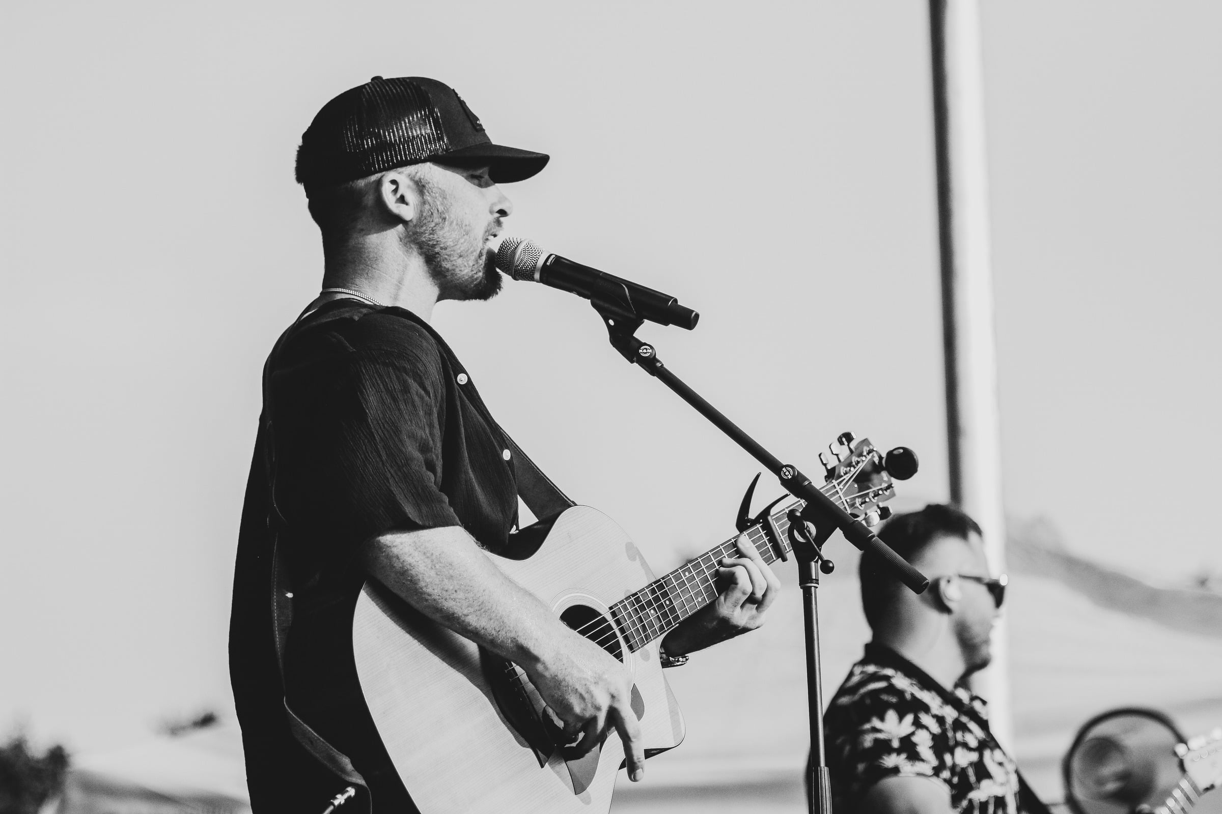
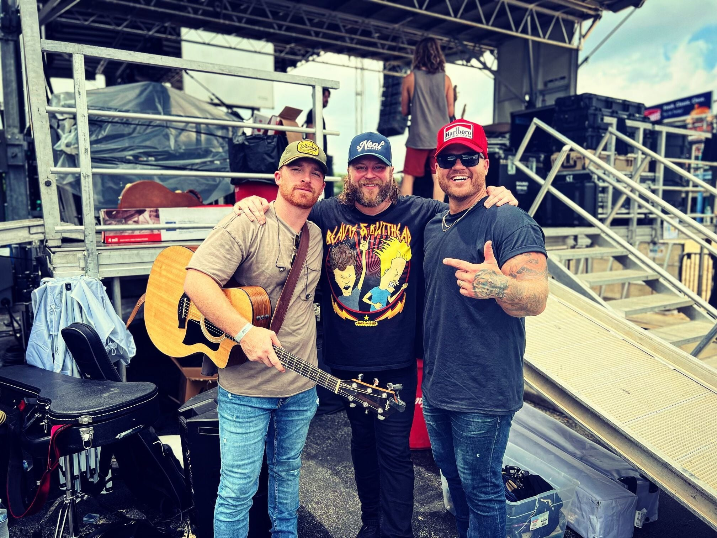 | 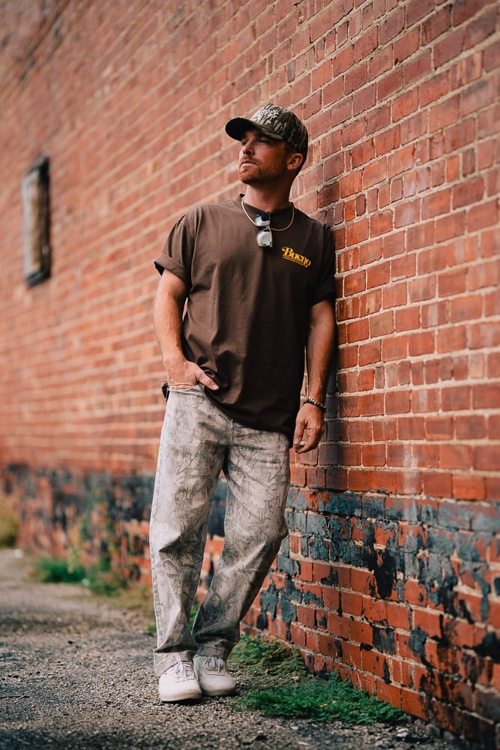

Contact
The Distance Agency
Pat Brady, Live Music Manager & Booking Coordinator
info@thedistanceagency.com

