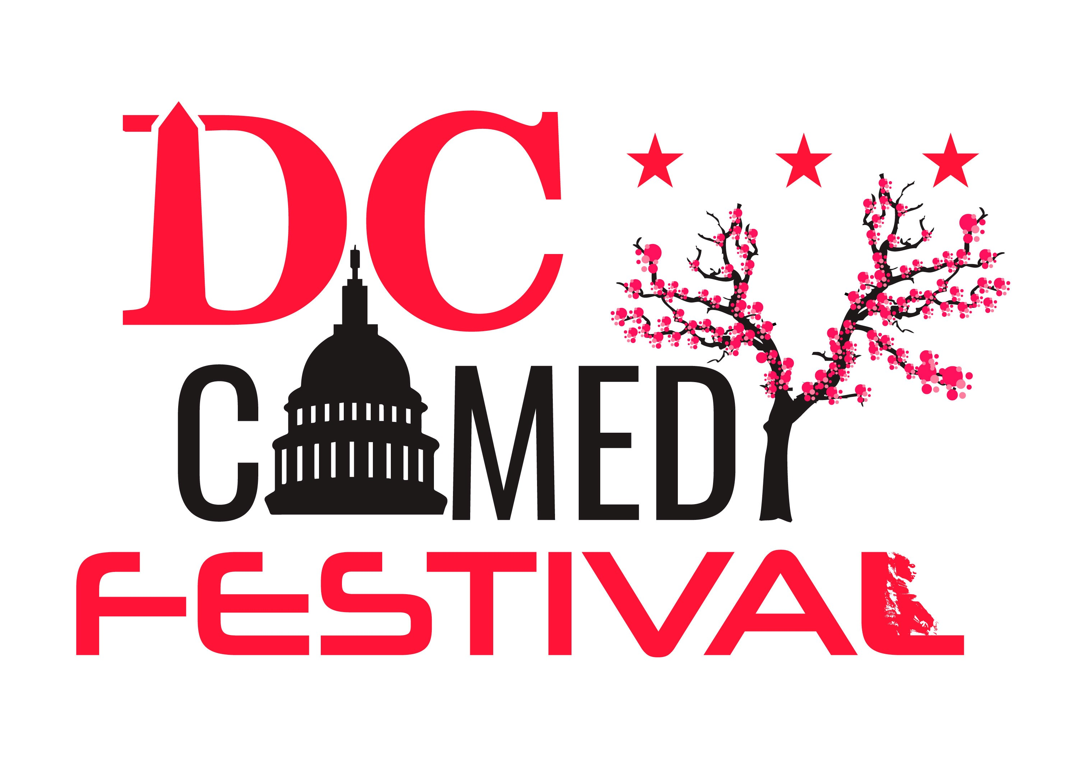

SPONSORSHIP PROPOSAL

1 | P a g e

OVERVIEW

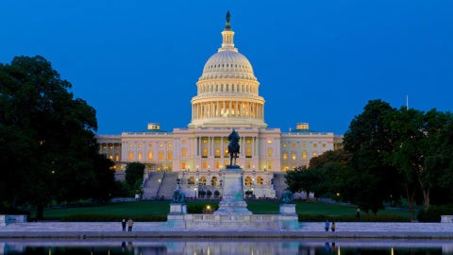
Businesses searching for creative and interactive ways to reach new, loyal and active customers are invited to partner with DC Comedy Festival (DCF), a new comedy festival to take place throughout the Washington
D.C. area April 10th through April15th.

By partnering with DCF, you can increase your business exposure with comedy audiences and D.C. residents as well as enhance your customer base.

In exchange, you will help support a comedy festival dedicated to showcase the
D.C. Comedy Scene. While bringing top-notch performers to the Washington DC area.
The cross-marketing opportunities will benefit your business and strengthen your roots in the community and surrounding areas. We offer many sponsorship opportunities that can be tailored to fit your marketing goals and budget an get face to face with thousands of new customers.
ABOUT DC COMEDY FESTIVAL
The cross-marketing opportunities will benefit your business and strengthen
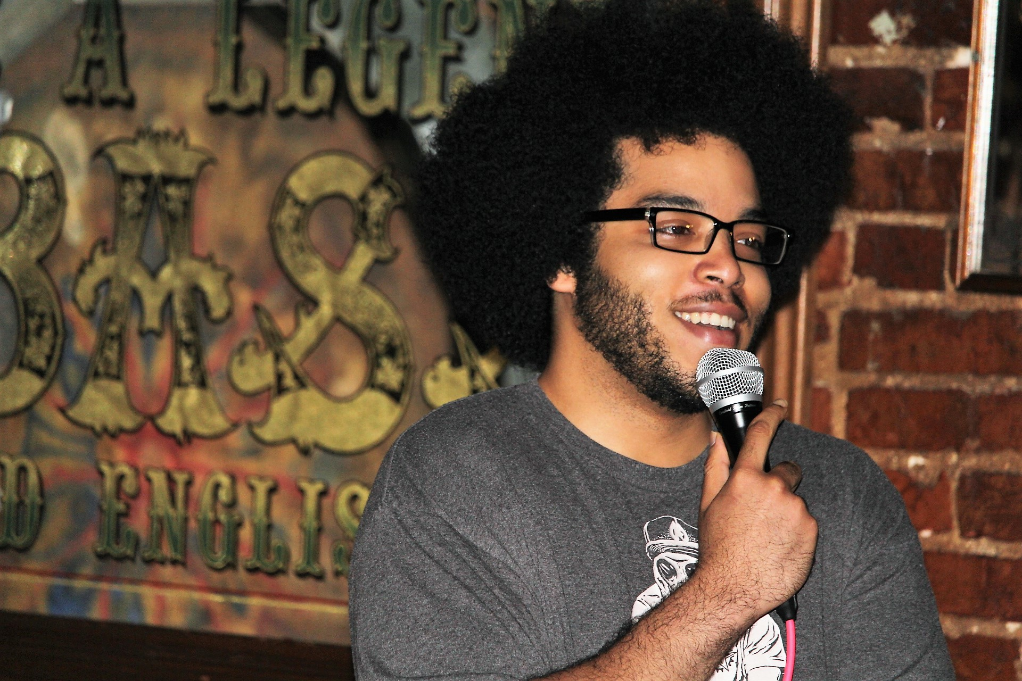DC Comedy Festival will take place at various venues throughout the Nations Capital April 10-15, 2018. Featuring Stand Up Comedy, Improv, and Interactive Concept Shows. All shows performed as part of DCF will be produced by local show runners. Most of whom produce multiple shows throughout the

.
  - area and other cities. The purpose of this festival is to showcase the D.C. Comedy Scene as a whole. As well as connect audiences to shows in their Area

SPONSORSHIP BENEFITS & DETAILS
The following Is a break down of our Sponsorship opertunities for your business recognition across all DC Comedy Festival shows and will put your company’s name, logo and link in front of thousands of comedy audience members.

We aim to provide value to sponsors by:

    - marketing your services to our audience
    - become actively involved in community events that benifits the DC public
    - enhance your profile as an active supporter of a worthwhile initiative that promotes arts and entertainment in the Nations Capital.

Platinum |  | Gold | Silver | Bronze
Value | $6,000 | $2,000 | $1,000 | $500
Sponsorships Available | 1 | 3 | 6 | Unlimited
Naming Rights | Festival  Name Share | Corridor  Name Share | Show  Name Share
Name and logo placement:
DC Comedy Festival website | Linked Logo on Home  Page | Linked Logo on Home  Page | Linked Logo on Sponsors  Page | Linked Name on Sponsors  Page
DCF social media | Logo on  Cover Photo | Logo on  Cover Photo
DCF and DMVComedy E-newsletter | Linked  Logo | Linked  Logo | Linked  Name | Linked  Name
Festival show passes | Logo | Logo | Name | Name
Festival t-shirts | Logo | Logo | Name | Name
Festival branded apparel &  products (where applicable) | Logo | Logo | Name | Name
Festival signage | Logo | Logo | Name | Name
Festival feedback forms | Logo | Logo
Festival program | Logo | Logo | Name | Name
Promotion:
Social Media postings | ! | ! | ! | !
Media promotion and press releases | ! | ! | !
Social Media Ad placement | ! | !
Hard Copy Advertisment | ! | ! | ! | !
Festival Benefits:
Ability to place items in the festival performer/audience swag bags | Unlimited | 2 item | 1 Item | 1 Item
Local radio/podcast interviews mentions | ! | ! | !
Complimentary VIP all festival  passes good to every show | 30 | 20 | 15 | 10

Platinum Gold Silver Bronze
Year Long Benefits:
Invitation to be on DCF  planning committee | !
Invitation to our sponsor  appreciation event | ! | ! | ! | !

OTHER OPPORTUNITIES
IN-KIND OPPORTUNITIES
Many of our sponsors are able to provide us with great products and services in exchange for sponsorship recognition. If you are interested in adding in-kind value to your cash sponsorship or providing a full in-kind sponsorship, please contact Info@dccomedyfestival.com.
OTHER IDEAS
Are you interested in providing support to DC Comedy Festival with something that is not mentioned in this proposal? Do you have a unique idea of how you can partner your business with DCF? Sponsorship proposals can be customized to meet your business needs by contacting:
Eddie Liles
COO/ DC Comedy Festival llc. Eddieliles@DCComedyFestival.com (202)491-7707

MEDIA REACH
DCComedy Festival provides wide exposure through a variety of media outlets and marketing channels. Please use the below information as a basic guide to the types of advertising, public and community relations opportunities afforded by a series sponsorship.
    - Website – www.DCComedyFestival.com
    - Social Media
      - Facebook: facebook.com/DCComedyFestival
      - Twitter: twitter.com/DCComedyFestival
      - Instagram: instagram.com/DCComedyFestival
      - Facebook/Instagram Video and print advertisement
      - Twitter Video and print advertisement.
      - Influencer Promotions
    - DCF E-Newsletter
    - Print Advertising
      - Express
      - The Hill
      - Politico
      - Sun Gazette paper
      - Stars and Stripes
      - The Washington Post
      - The Washington TimesOnline Advertising
    - TV Promotion
      - Done on local DC TV stations before festival
    - Radio Promotion
      - Done on local DC radio stations before festival
    - Podcasts
      - Done on local and national podcasts before festival
    - Posters
      - 2000 plastered locally and throughout Washington DC
    - Flyers
      - 10,000 distributed locally and throughout Washington DC
    - Event Programs
      - 20,000 distributed to festival performers and audience members
    - Festival Passes
      - Distributed to festival performers and festival passholders
    - Event Signage
      - Street signage On Corridors 2 weeks before the event
      - Booth signage
      - Onstage signage
      - Tabletop signage

SPONSORSHIP FORM

Please fill-out the following form to confirm your chosen sponsorship level.

Completed forms and payment can be returned to DCComedyFestival.com with payment processed online. Hard copy and payment can be picked up in person.

Please don’t hesitate to contact us with any questions at (202) 491-7707.

CONTACT INFORMATION:

_________________________________
Company Name (as you wish to be acknowledged)

_________________________________
Company Email Address

_________________________________
Address

SPONSORSHIP OPPORTUNITIES:
____ $10,000 Platinum Sponsor

____ $2,500 Gold Sponsor

____ $12,500 Silver Sponsor

____ $500 Bronze Sponsor

PAYMENT INFORMATION:
____ Please send me an invoice.

____ I have enclosed a check made payable to Bird City Comedy Festival, LLC.

____ Please charge my credit card:
Card Type: Visa / MC / AmEx / Discover

_________________________________
Contact Person’s Name

_________________________________
Contact Phone Number

_________________________________
City/State/Zip Code
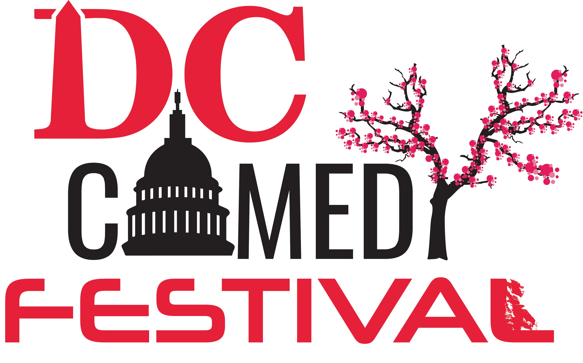

Once we receive your completed sponsorship form, a member of Bird City staff will contact you to discuss event arrangements, sponsorship benefits and recognition.
Please send your high-resolution color and black-and-white logos (.EPS or vector preferred) to DCComedyfestival@gmail.com.
All materials will be sent for your approval before going to print.

Card Number Expiration Date Security Code
$ ________________________ _______________________________________
Total Sponsorship Commitment Authorized Sponsor Signature

Thank You.

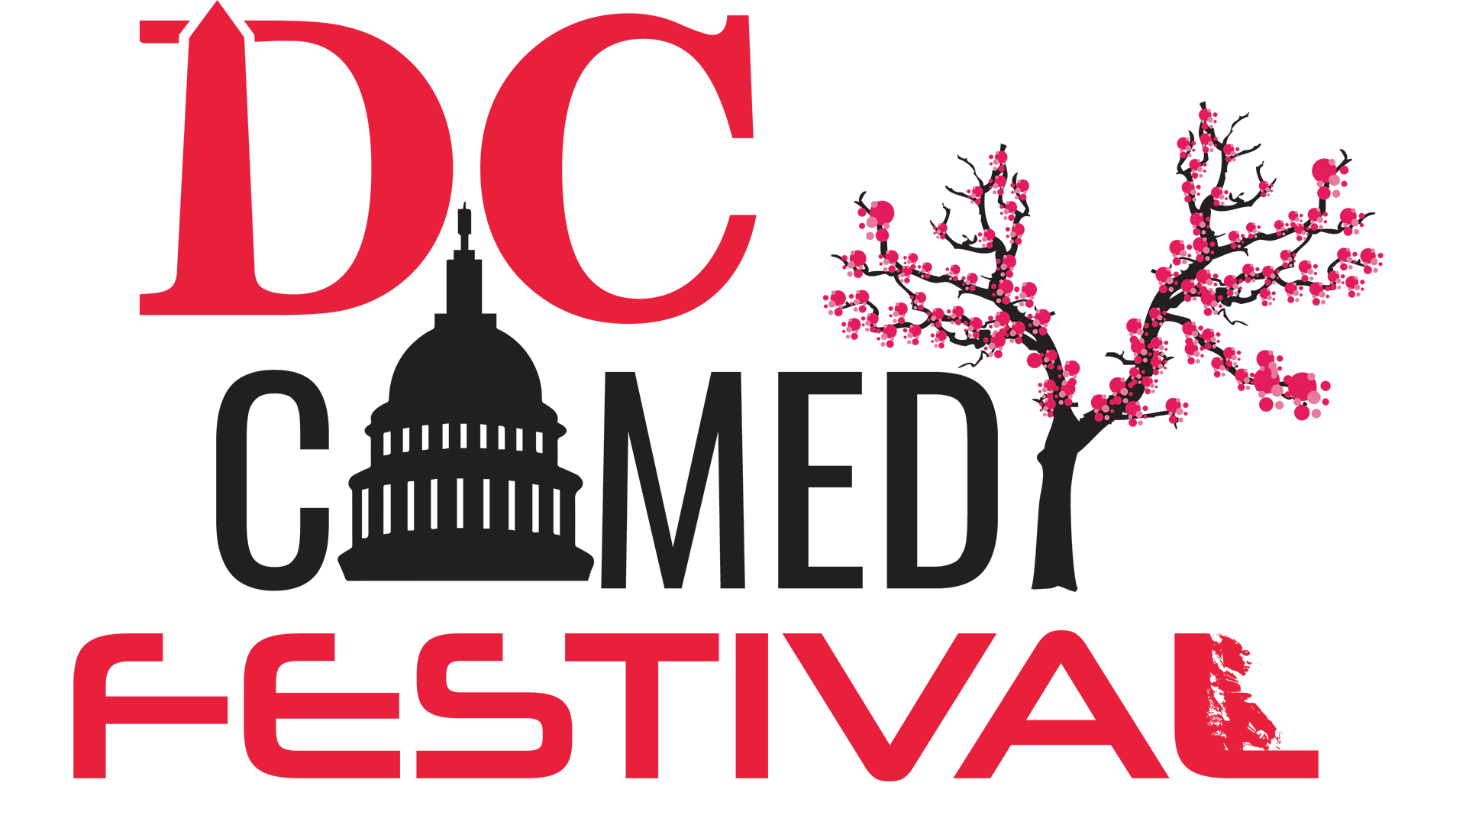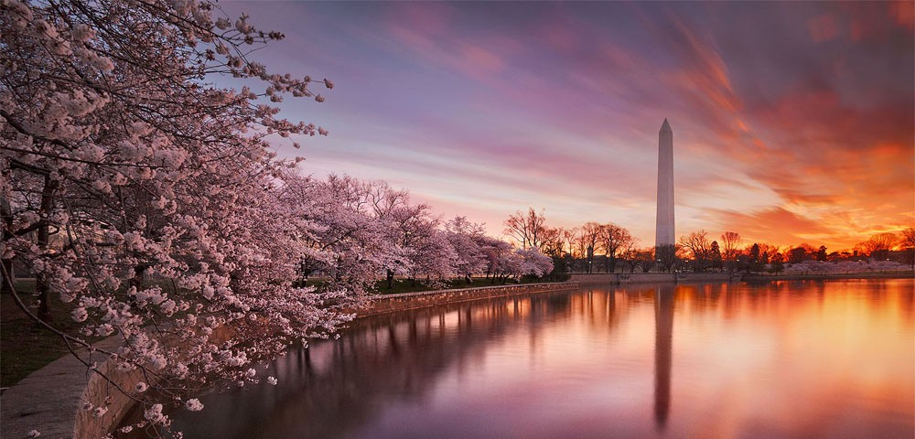
www.DCcomedyfestival.com | DVDCCOMEDYFESTIVAL@gmail.com

7 | P a g e

