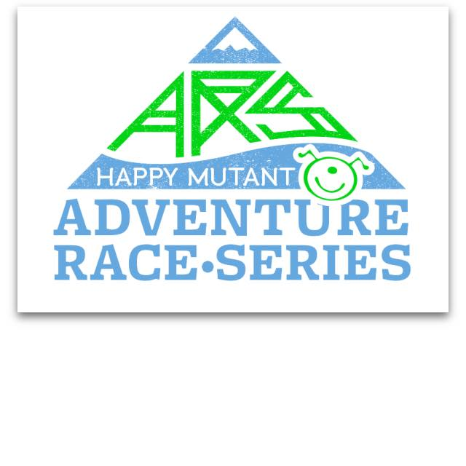
Toby Evans, Series Director/CEO
319.331.4788 (o)
310.433.6856 (m)
www.thehappymutant.com
Happymutant3 :SKYPE
@hmarseries :Twitter/instagram
Happy Mutant Adventure Race Series
The 2017 Happy Mutant Adventure Race Series will offer an unprecedented approach in creating a sustainable model for the sport here in the United
States. By taking the multi-discipline, back country sport that we love and applying three simple principles, the HM crew will restore adventure racing as the premier endurance sport in the country.
AFFORDABLE ACCESSIBLE ADVENTURE
- Social and Digital Media Exposure (25,000 unique impressions per event)
- The ONLY national adventure race series in the US
- International competitive field at each event
- Qualifying events for the Adventure Racing World Series (pending); the North American Adventure Race Series and the United States Adventure Racing Association
After years of planning, scouting, and mapping a dozen potential race locations nationwide we are ready to launch a revolutionary adventure racing series. Our three guiding principles served as the deciding factors in of 2017 event locations. Each race will take place within a reasonable drive from a major city and taking place on a traditional holiday weekend we anticipate 200 racers per event. With an individual entry fee comparable to comparable endurance events the series will draw from a wide population base.
The HMARS events will range from 30-hour races to five-day expedition events. These parameters provide events for all experience and skill levels. Disciplines will include navigation, mountain biking, paddling, trail running/hiking, canyoneering, ropes and activities specific to the region. Our series will visit Nevada, Arizona, California, Iowa, New Mexico, Virginia, Vermont, Mexico (Baja) and Puerto Rico throughout the year and will bring an estimated $30,000-40,000.00 in local hospitality revenue at each of the stops. Mainstream media exposure from magazines (print and on-line), webcasts, radio, newspaper and television.

Our Vision
Provide a platform to increase accessibility to pursue all endurance sports, specifically adventure racing, appealing to the innate sense of adventure and challenge across a broad spectrum of amateur and professional athletes. Be reminded of the historic trade and migration routes that shaped the United States. Build on the belief that adventure and exercise in the outdoors is essential to healthy living.

Unprecedented Broadcast Capabilities
Utilizing current technology, The Happy Mutant Broadband Network provides coverage for endurance sports on a grander platform than ever before.
- Episodic coverage of the Happy Mutant Adventure Racing Series in a matter of days not months. Up to 20 hours of edited footage per event.
- Live streaming from each race course.
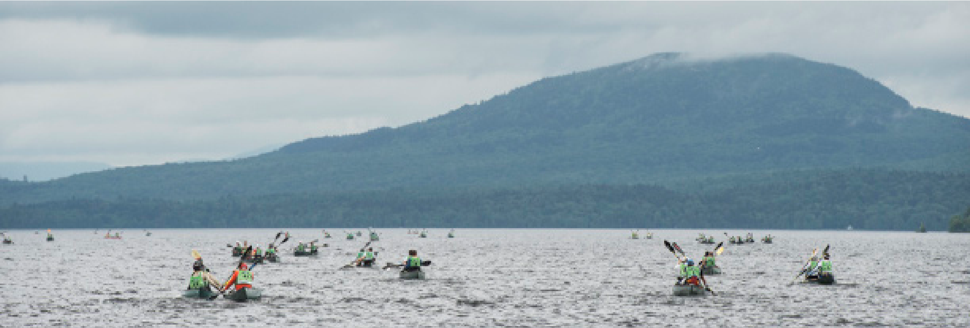
- Dedicated team specific channels with same day race footage upload. Teams will have the ability to upload to their channel for increased ROI.
- Separate channels for product reviews, adventure travel, non-Happy Mutant events, video blogs
- Current social media averages 1,500 visits daily (Facebook, Instagram, Twitter, YouTube) 201 HMAR Series Schedule
February 2-6 Laughlin, NV
May 13 Ottumwa, Iowa
June 2-4 Taos, NM
July 14-16 Amherst, VA
September 1-4 Vermont
October Baja, Mexico
December Puerto Rico

Endurance Sports Overview
Participation in endurance sports saw record growth in 2014. Seven of the top-10 activities for Americans age 18-55 are endurance sports. The average growth over the past three years is 14.7%

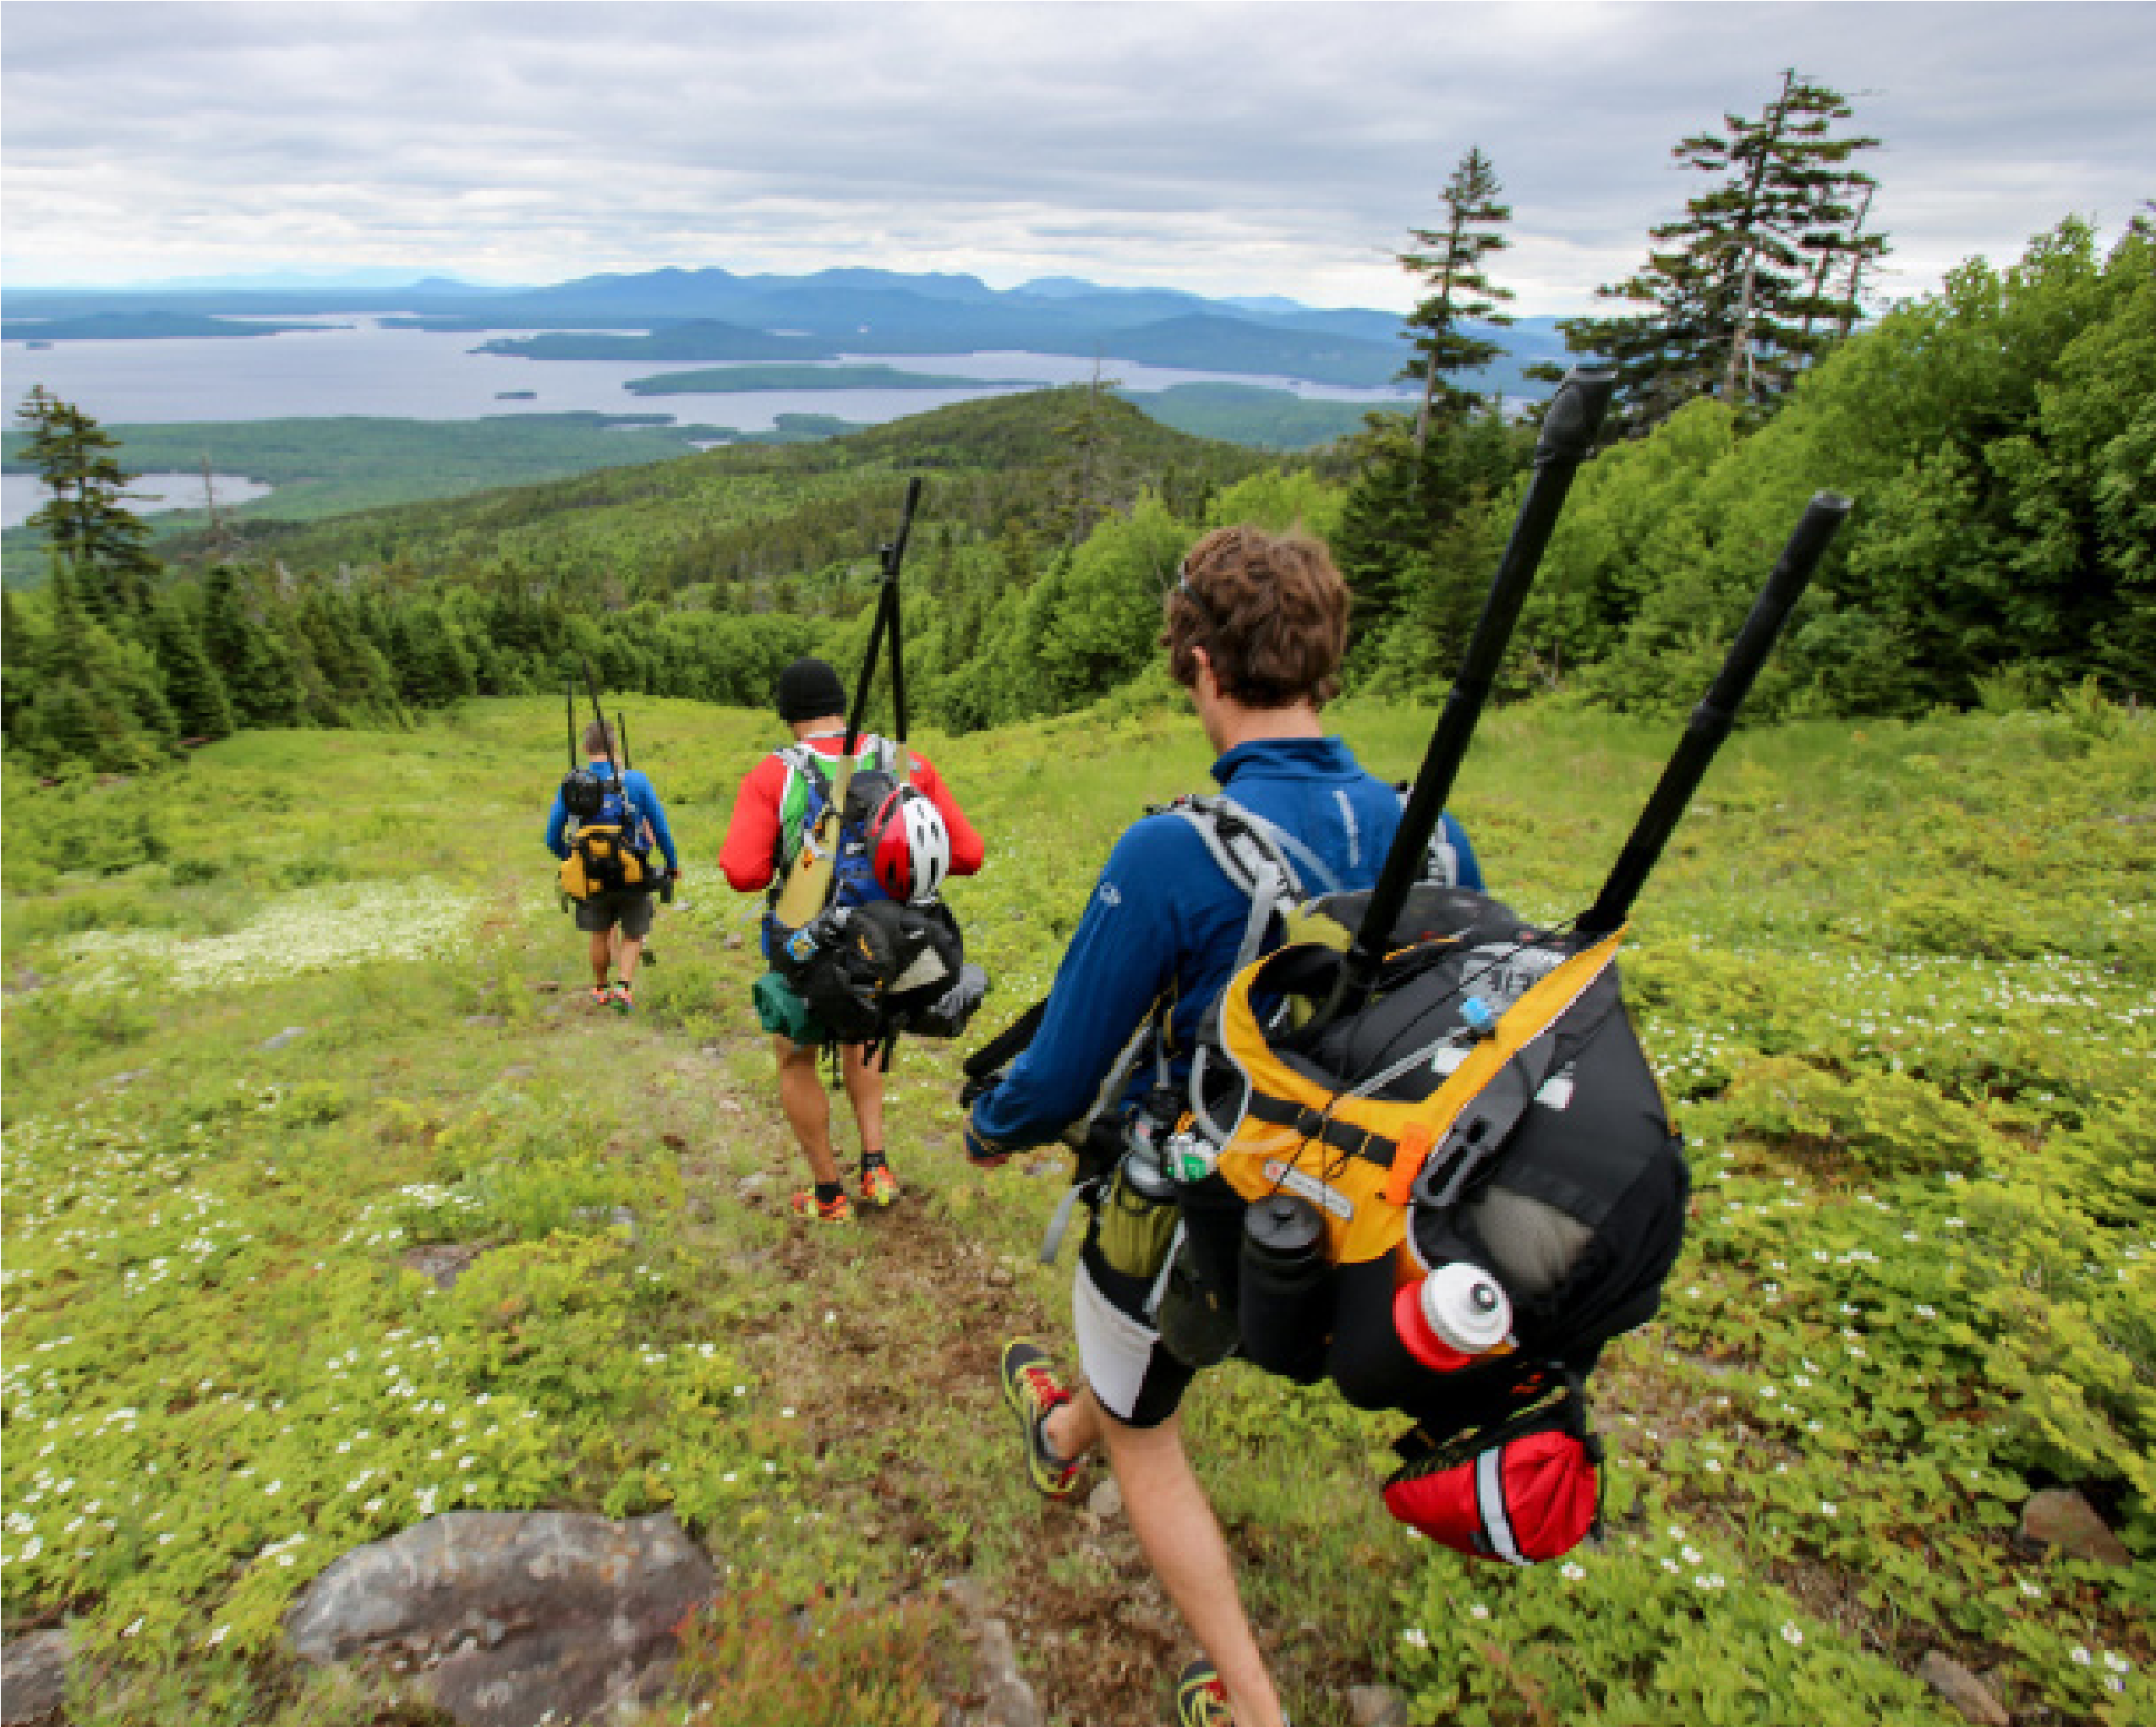
Demographic Data for Adventure Racing
Adventure Racing, Trail Running, Hiking, Obstacle Racing, Mountain Biking,
Kayaking, Road Cycling, Mountaineering, Rock Climbing, Orienteering
- Age 25-55
- 55% male/45% female
- Income >$100k

