Miss Fashion Week New York
  - Sponsorship Proposal

2017 NEW YORK FASHION WEEK FINALE
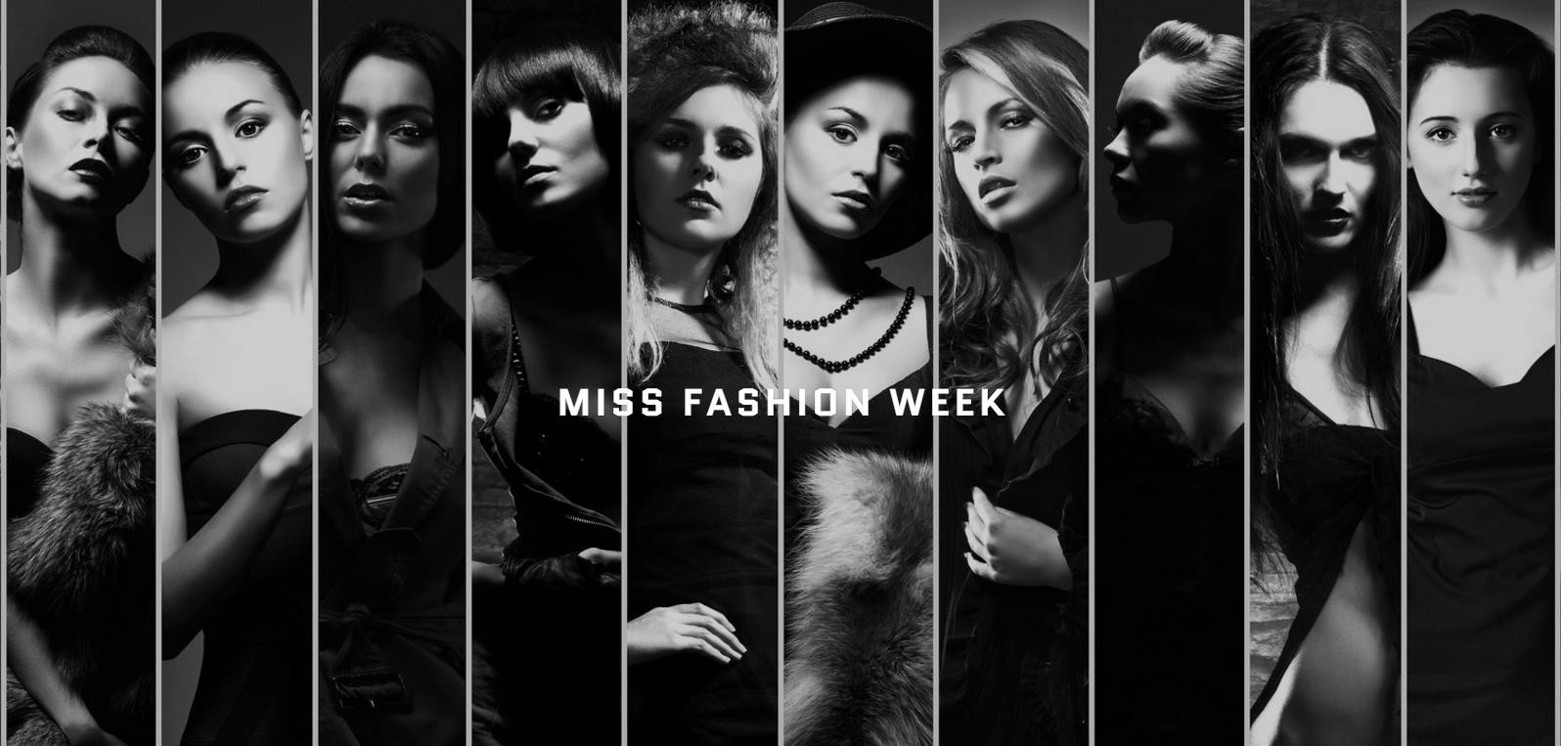

About Us
Miss Fashion Week New York is a division of Miss Fashion Week which is an international model contest for all models. There are three categories a model can compete in: petite, plus and runway. The contest will be judged in 5 sub-categories: Runway walk, Photoshoot (images), Swimwear, Overall appearance/look and Interview. Miss Fashion Week receives hundreds of model contestants looking to compete for titles in all categories.
Miss Fashion Week New York will officially launch in February 2017 with multiple audition dates for contestants from the New York City area.
Miss Fashion Week New York is not just another modeling competition or pageant. We are creating opportunities for aspiring models to gain exposure in the modeling industry through strategic partnerships.
Sponsorship and Advertising Opportunity
Miss Fashion Week New York would like to partner with YOUR COMPANY to host the 2017 Miss Fashion Week New York Finale Fashion Show on September 9, 2017 (Tentative)during New York Fashion Week. During the finale we will select one winner for the Runway, Plus and Petite category.
New York Fashion Week events are attended by thousands of fashion enthusiast, celebrities, bloggers and influencers with a passion for style, hair and beauty trends. All global Fashion Week events reach millions of consumers through digital platforms. While all New York Fashion Week shows are “invite only” The Miss Fashion Week Finale will be open to the public to purchase tickets.
YOUR COMPANY would be named as an official sponsor of Miss Fashion Week New York. YOUR LOGO would be added to all printed and digital marketing materials.
A representative from YOUR COMPANY will attend the Miss Fashion Week Finale as one our judges. A representative from YOUR COMPANY will also be photographed with the Miss Fashion Week New York finalists and Director on the red carpet and throughout the event.
Miss Fashion Week New York would announce the partnership to the press and on social media upon confirmation.

The Venue
The finale fashion show will be held at the Metropolitan Pavilion in Manhattan.
Metropolitan Pavilion preserves intimacy and style for events of prestige and grandeur. It opened in 1998 as a skillful integration of two adjacent structures in the Ladies’ Mile Historic District of the Chelsea and Flatiron neighborhoods.
The renown B. Altman Department Store of 1896 lends Beaux-Arts elegance. Simultaneously, upper-story industrial lofts of 1929 impart Art Deco refinement. Finally, modern renovations and enhancements provide contemporary Manhattan sophistication throughout.
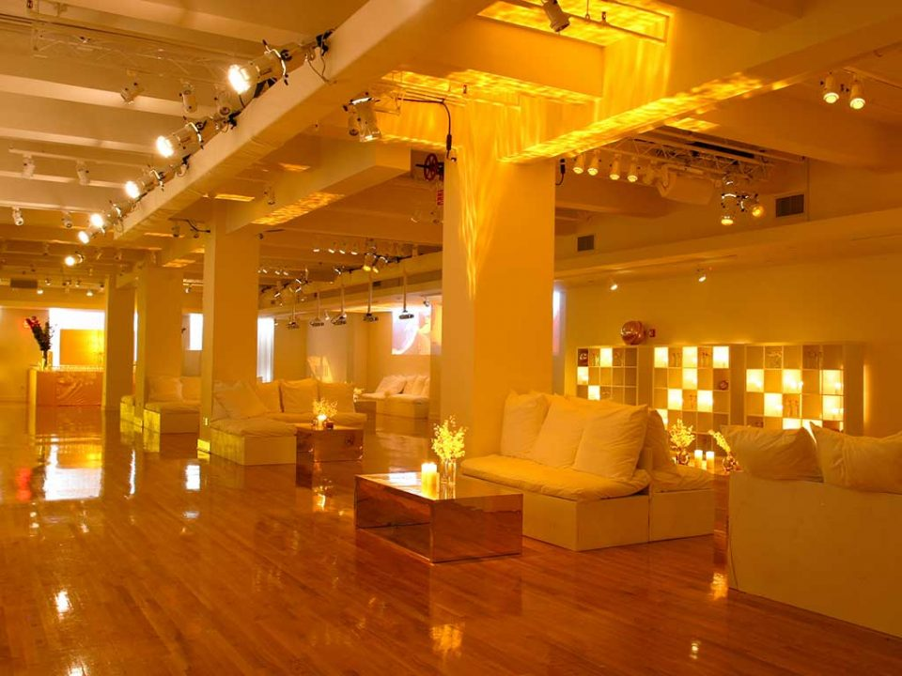
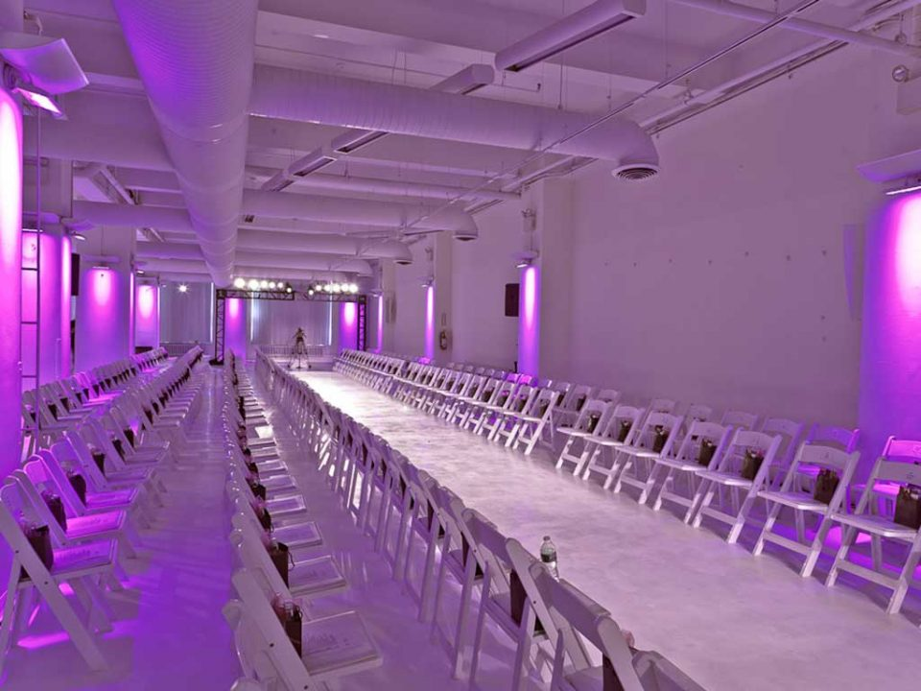

Event Details and Sponsorship Level

Date: September 9, 2017
Time: 5:00pm – 9:00pm
Attendees: 300
Tentative Schedule
5:00pm: Red Carpet
6:00pm: VIP Cocktail Reception
7:00pm: Fashion Show
8:00pm: Winners Announced
8:15pm – 9:00pm: Photo Ops
Sponsorship Levels & Amenities | Silver $2,500 | Gold $5,000 | Platinum $10,000 | Signature $20,000
Opportunity for a member of your organization speak (2min) |  |  |  | X
Our contact list - Names and emails of  all guests |  |  |  | X
Limousine Transportation to and from event (20 mile radius) |  |  |  | X
Opportunity to send a judge to the event |  |  | X | X
Event film coverage will include logo on the video banner |  |  | X | X
Video with Company Logo playing at the event |  | X | X | X
Recognition in press release |  | X | X | X
Inclusion in all advertisement |  | X | X | X
Recognition with news, magazines, and reporters at the event |  | X | X | X
Logo added to the step and repeat (backdrop) for the photos |  | X | X | X
Logo on all event banners |  | X | X | X
Formal announcement of sponsors at event |  | X | X | X
Receive a copy of images and film footage of event |  | X | X | X
One year inclusion in email campaigns to guests |  | X | X | X
Mentioned in printed program available at event |  | X | X | X
Logo featured in all advertisements and printed material |  | X | X | X
Company Information and/or merchandise in VIP Gift Bags |  | X | X | X
Title and linkage on all websites affiliated with the event | X | X | X | X
Vendor table to promote your company | X | X | X | X
V.I.P. Seating and access to V.I.P. areas | 1 | 2 | 3 | 4

We are excited for the opportunity to partner with you and look forward to speaking further.
Thank You so much for considering.
Danielle Ellis
Owner/Director
Miss Fashion Week New York
Phone: 917-804-8260 Website: Missfashionweekny.com
Email: Danielle@missfw.com

